**Rogue Servitor: Optimization of Pampering Life and Warfare**

By: u/Jules-the-Programmer, Julia-Makes-Games

### Abstract:

I got bored one day, and decided to make a program to calculate the ideal number of Sanctuary Arcologies in comparison to Foundry Arcologies on an Ecumenopolis for Rogue Servitors. In the following pages I go into detail about the optimal ratio of arcologies for each planet size going from size 6 (the locust swarm gaia world) to size 33 expanded ocean paradise with orbital rings and mastery of nature, for a total of size 39. In this document you will see the findings of my research, as in the resources produced and the resources consumed to maximize the output of fabricators. This is NOT a calculation to be the most resource efficient, this program calculates the ratio of districts to maximize alloy production.

### Assumptions:

This assumes every job is filled, you have the tier 3 production bonus tech, a fully upgraded alloy building, a Resource Processing Center, and that stability is at 50% (accounting for variance in stability would make the charts borderline unreadable). As for upkeep, it assumes standard upkeep for bio pops (food and consumer goods) and minerals for alloys. To go to a specific world size, click through the links in the following page or scroll through.

### Errors:

There are a few sources of potential error, albeit small ones. First of all, floating point math sucks and I had to limit the digits, and that means you could be producing +/- 0.1 alloys per month per planet and consuming +/- 0.1 minerals per planet, as well as not taking into account the stability of the planet, which would provide a much larger range of error.

## Table of Contents

Size 6

Size 7

Size 8

Size 9

Size 10

Size 11

Size 12

Size 13

Size 14

Size 15

Size 16

Size 17

Size 18

Size 19

Size 20

Size 21

Size 22

Size 23

Size 24

Size 25

Size 26

Size 27

Size 28

Size 29

Size 30

Size 31

Size 32

Size 33

Size 34

BONUS:

Size 39

Ringworld (For comparison)

Functions/Code Explanation

## Size 6

Orbital Ring + Efficient Processors

Optimal: 0

|  |  |  |  |  |
| --- | --- | --- | --- | --- |
| Sanctuary Districts | Alloys | Minerals | Food | Consumer Goods |
| 0 | 651 | 954.8 | 0 | 0 |
| 1 | 646.8 | 862.4 | 15 | 15 |
| 2 | 630 | 770 | 30 | 30 |
| 3 | 600.6 | 677.6 | 45 | 45 |
| 4 | 558.6 | 585.2 | 60 | 60 |
| 5 | 504 | 492.8 | 75 | 75 |
| 6 | 436.8 | 400.4 | 90 | 90 |
| 7 | 357 | 308 | 105 | 105 |
| 8 | 264.6 | 215.6 | 120 | 120 |
| 9 | 159.6 | 123.2 | 135 | 135 |
| 10 | 42 | 30.8 | 150 | 150 |

Orbital Ring Only

Optimal: 0

|  |  |  |  |  |
| --- | --- | --- | --- | --- |
| Sanctuary Districts | Alloys | Minerals | Food | Consumer Goods |
| 0 | 629.3 | 954.8 | 0 | 0 |
| 1 | 627.2 | 862.4 | 15 | 15 |
| 2 | 612.5 | 770 | 30 | 30 |
| 3 | 585.2 | 677.6 | 45 | 45 |
| 4 | 545.3 | 585.2 | 60 | 60 |
| 5 | 492.8 | 492.8 | 75 | 75 |
| 6 | 427.7 | 400.4 | 90 | 90 |
| 7 | 350 | 308 | 105 | 105 |
| 8 | 259.7 | 215.6 | 120 | 120 |
| 9 | 156.8 | 123.2 | 135 | 135 |
| 10 | 41.3 | 30.8 | 150 | 150 |

Efficient Processors Only

Optimal: 0

|  |  |  |  |  |
| --- | --- | --- | --- | --- |
| Sanctuary Districts | Alloys | Minerals | Food | Consumer Goods |
| 0 | 342 | 501.6 | 0 | 0 |
| 1 | 316.8 | 422.4 | 15 | 15 |
| 2 | 280.8 | 343.2 | 30 | 30 |
| 3 | 234 | 264 | 45 | 45 |
| 4 | 176.4 | 184.8 | 60 | 60 |
| 5 | 108 | 105.6 | 75 | 75 |
| 6 | 28.8 | 26.4 | 90 | 90 |

Base Production

Optimal: 0

|  |  |  |  |  |
| --- | --- | --- | --- | --- |
| Sanctuary Districts | Alloys | Minerals | Food | Consumer Goods |
| 0 | 330.6 | 501.6 | 0 | 0 |
| 1 | 307.2 | 422.4 | 15 | 15 |
| 2 | 273 | 343.2 | 30 | 30 |
| 3 | 228 | 264 | 45 | 45 |
| 4 | 172.2 | 184.8 | 60 | 60 |
| 5 | 105.6 | 105.6 | 75 | 75 |
| 6 | 28.2 | 26.4 | 90 | 90 |

## Size 7

Orbital Ring + Efficient Processors

Optimal: 1

|  |  |  |  |  |
| --- | --- | --- | --- | --- |
| Sanctuary Districts | Alloys | Minerals | Food | Consumer Goods |
| 0 | 714 | 1047.2 | 0 | 0 |
| 1 | 716.1 | 954.8 | 15 | 15 |
| 2 | 705.6 | 862.4 | 30 | 30 |
| 3 | 682.5 | 770 | 45 | 45 |
| 4 | 646.8 | 677.6 | 60 | 60 |
| 5 | 598.5 | 585.2 | 75 | 75 |
| 6 | 537.6 | 492.8 | 90 | 90 |
| 7 | 464.1 | 400.4 | 105 | 105 |
| 8 | 378 | 308 | 120 | 120 |
| 9 | 279.3 | 215.6 | 135 | 135 |
| 10 | 168 | 123.2 | 150 | 150 |
| 11 | 44.1 | 30.8 | 165 | 165 |

Orbital Ring

Optimal: 1

|  |  |  |  |  |
| --- | --- | --- | --- | --- |
| Sanctuary Districts | Alloys | Minerals | Food | Consumer Goods |
| 0 | 690.2 | 1047.2 | 0 | 0 |
| 1 | 694.4 | 954.8 | 15 | 15 |
| 2 | 686 | 862.4 | 30 | 30 |
| 3 | 665 | 770 | 45 | 45 |
| 4 | 631.4 | 677.6 | 60 | 60 |
| 5 | 585.2 | 585.2 | 75 | 75 |
| 6 | 526.4 | 492.8 | 90 | 90 |
| 7 | 455 | 400.4 | 105 | 105 |
| 8 | 371 | 308 | 120 | 120 |
| 9 | 274.4 | 215.6 | 135 | 135 |
| 10 | 165.2 | 123.2 | 150 | 150 |
| 11 | 43.4 | 30.8 | 165 | 165 |

Efficient Processors

Optimal: 0

|  |  |  |  |  |
| --- | --- | --- | --- | --- |
| Sanctuary Districts | Alloys | Minerals | Food | Consumer Goods |
| 0 | 396 | 580.8 | 0 | 0 |
| 1 | 376.2 | 501.6 | 15 | 15 |
| 2 | 345.6 | 422.4 | 30 | 30 |
| 3 | 304.2 | 343.2 | 45 | 45 |
| 4 | 252 | 264 | 60 | 60 |
| 5 | 189 | 184.8 | 75 | 75 |
| 6 | 115.2 | 105.6 | 90 | 90 |
| 7 | 30.6 | 26.4 | 105 | 105 |

Base Production

Optimal: 0

|  |  |  |  |  |
| --- | --- | --- | --- | --- |
| Sanctuary Districts | Alloys | Minerals | Food | Consumer Goods |
| 0 | 382.8 | 580.8 | 0 | 0 |
| 1 | 364.8 | 501.6 | 15 | 15 |
| 2 | 336 | 422.4 | 30 | 30 |
| 3 | 296.4 | 343.2 | 45 | 45 |
| 4 | 246 | 264 | 60 | 60 |
| 5 | 184.8 | 184.8 | 75 | 75 |
| 6 | 112.8 | 105.6 | 90 | 90 |
| 7 | 30 | 26.4 | 105 | 105 |

## Size 8

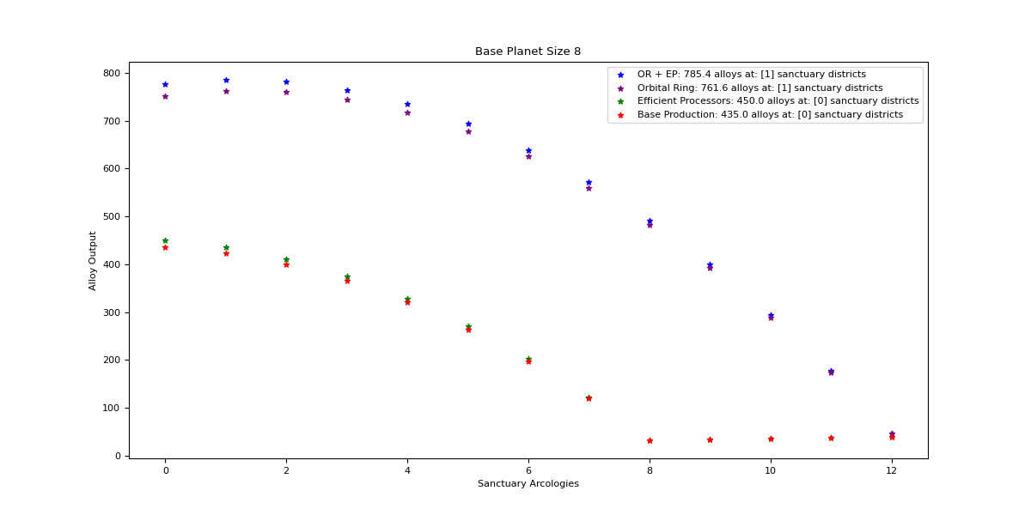

Orbital Ring + Efficient Processors

Optimal: 1

|  |  |  |  |  |
| --- | --- | --- | --- | --- |
| Sanctuary Districts | Alloys | Minerals | Food | Consumer Goods |
| 0 | 777 | 1139.6 | 0 | 0 |
| 1 | 785.4 | 1047.2 | 15 | 15 |
| 2 | 781.2 | 954.8 | 30 | 30 |
| 3 | 764.4 | 862.4 | 45 | 45 |
| 4 | 735 | 770 | 60 | 60 |
| 5 | 693 | 677.6 | 75 | 75 |
| 6 | 638.4 | 585.2 | 90 | 90 |
| 7 | 571.2 | 492.8 | 105 | 105 |
| 8 | 491.4 | 400.4 | 120 | 120 |
| 9 | 399 | 308 | 135 | 135 |
| 10 | 294 | 215.6 | 150 | 150 |
| 11 | 176.4 | 123.2 | 165 | 165 |
| 12 | 46.2 | 30.8 | 180 | 180 |

Orbital Ring

Optimal: 1

|  |  |  |  |  |
| --- | --- | --- | --- | --- |
| Sanctuary Districts | Alloys | Minerals | Food | Consumer Goods |
| 0 | 751.1 | 1139.6 | 0 | 0 |
| 1 | 761.6 | 1047.2 | 15 | 15 |
| 2 | 759.5 | 954.8 | 30 | 30 |
| 3 | 744.8 | 862.4 | 45 | 45 |
| 4 | 717.5 | 770 | 60 | 60 |
| 5 | 677.6 | 677.6 | 75 | 75 |
| 6 | 625.1 | 585.2 | 90 | 90 |
| 7 | 560 | 492.8 | 105 | 105 |
| 8 | 482.3 | 400.4 | 120 | 120 |
| 9 | 392 | 308 | 135 | 135 |
| 10 | 289.1 | 215.6 | 150 | 150 |
| 11 | 173.6 | 123.2 | 165 | 165 |
| 12 | 45.5 | 30.8 | 180 | 180 |

Efficient Processors

Optimal: 0

|  |  |  |  |  |
| --- | --- | --- | --- | --- |
| Sanctuary Districts | Alloys | Minerals | Food | Consumer Goods |
| 0 | 450 | 660 | 0 | 0 |
| 1 | 435.6 | 580.8 | 15 | 15 |
| 2 | 410.4 | 501.6 | 30 | 30 |
| 3 | 374.4 | 422.4 | 45 | 45 |
| 4 | 327.6 | 343.2 | 60 | 60 |
| 5 | 270 | 264 | 75 | 75 |
| 6 | 201.6 | 184.8 | 90 | 90 |
| 7 | 122.4 | 105.6 | 105 | 105 |
| 8 | 32.4 | 26.4 | 120 | 120 |

Base Production

Optimal: 0

|  |  |  |  |  |
| --- | --- | --- | --- | --- |
| Sanctuary Districts | Alloys | Minerals | Food | Consumer Goods |
| 0 | 435 | 660 | 0 | 0 |
| 1 | 422.4 | 580.8 | 15 | 15 |
| 2 | 399 | 501.6 | 30 | 30 |
| 3 | 364.8 | 422.4 | 45 | 45 |
| 4 | 319.8 | 343.2 | 60 | 60 |
| 5 | 264 | 264 | 75 | 75 |
| 6 | 197.4 | 184.8 | 90 | 90 |
| 7 | 120 | 105.6 | 105 | 105 |
| 8 | 31.8 | 26.4 | 120 | 120 |

## Size 9

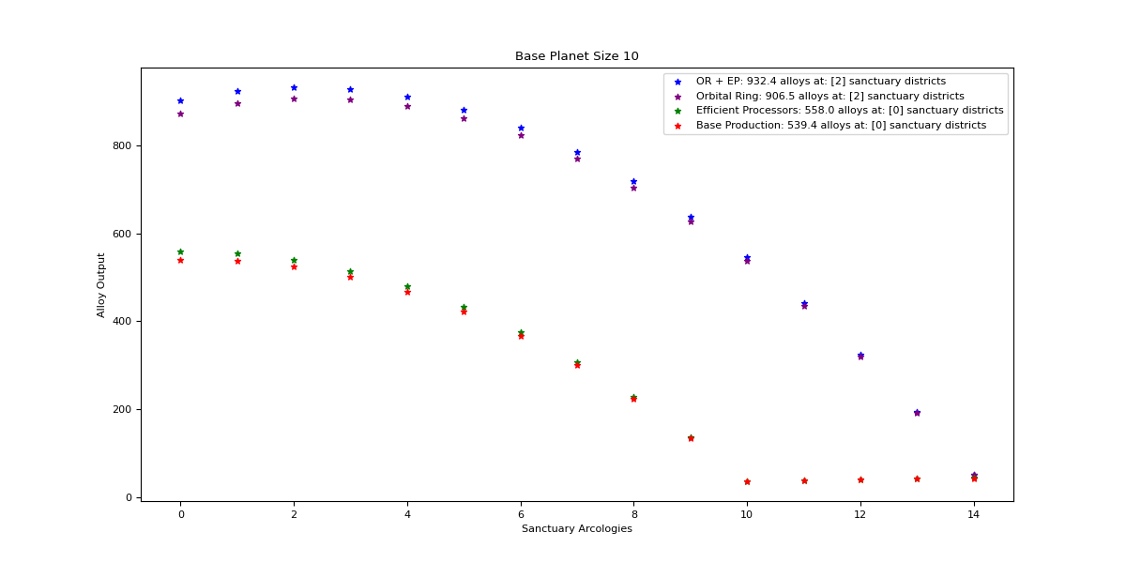

Orbital Ring + Efficient Processors

Optimal: 2

|  |  |  |  |  |
| --- | --- | --- | --- | --- |
| Sanctuary Districts | Alloys | Minerals | Food | Consumer Goods |
| 0 | 840 | 1232 | 0 | 0 |
| 1 | 854.7 | 1139.6 | 15 | 15 |
| 2 | 856.8 | 1047.2 | 30 | 30 |
| 3 | 846.3 | 954.8 | 45 | 45 |
| 4 | 823.2 | 862.4 | 60 | 60 |
| 5 | 787.5 | 770 | 75 | 75 |
| 6 | 739.2 | 677.6 | 90 | 90 |
| 7 | 678.3 | 585.2 | 105 | 105 |
| 8 | 604.8 | 492.8 | 120 | 120 |
| 9 | 518.7 | 400.4 | 135 | 135 |
| 10 | 420 | 308 | 150 | 150 |
| 11 | 308.7 | 215.6 | 165 | 165 |
| 12 | 184.8 | 123.2 | 180 | 180 |
| 13 | 48.3 | 30.8 | 195 | 195 |

Orbital Ring

Optimal: 2

|  |  |  |  |  |
| --- | --- | --- | --- | --- |
| Sanctuary Districts | Alloys | Minerals | Food | Consumer Goods |
| 0 | 812 | 1232 | 0 | 0 |
| 1 | 828.8 | 1139.6 | 15 | 15 |
| 2 | 833 | 1047.2 | 30 | 30 |
| 3 | 824.6 | 954.8 | 45 | 45 |
| 4 | 803.6 | 862.4 | 60 | 60 |
| 5 | 770 | 770 | 75 | 75 |
| 6 | 723.8 | 677.6 | 90 | 90 |
| 7 | 665 | 585.2 | 105 | 105 |
| 8 | 593.6 | 492.8 | 120 | 120 |
| 9 | 509.6 | 400.4 | 135 | 135 |
| 10 | 413 | 308 | 150 | 150 |
| 11 | 303.8 | 215.6 | 165 | 165 |
| 12 | 182 | 123.2 | 180 | 180 |
| 13 | 47.6 | 30.8 | 195 | 195 |

Efficient Processors

Optimal: 0

|  |  |  |  |  |
| --- | --- | --- | --- | --- |
| Sanctuary Districts | Alloys | Minerals | Food | Consumer Goods |
| 0 | 504 | 739.2 | 0 | 0 |
| 1 | 495 | 660 | 15 | 15 |
| 2 | 475.2 | 580.8 | 30 | 30 |
| 3 | 444.6 | 501.6 | 45 | 45 |
| 4 | 403.2 | 422.4 | 60 | 60 |
| 5 | 351 | 343.2 | 75 | 75 |
| 6 | 288 | 264 | 90 | 90 |
| 7 | 214.2 | 184.8 | 105 | 105 |
| 8 | 129.6 | 105.6 | 120 | 120 |
| 9 | 34.2 | 26.4 | 135 | 135 |

Base Production

Optimal: 0

|  |  |  |  |  |
| --- | --- | --- | --- | --- |
| Sanctuary Districts | Alloys | Minerals | Food | Consumer Goods |
| 0 | 487.2 | 739.2 | 0 | 0 |
| 1 | 480 | 660 | 15 | 15 |
| 2 | 462 | 580.8 | 30 | 30 |
| 3 | 433.2 | 501.6 | 45 | 45 |
| 4 | 393.6 | 422.4 | 60 | 60 |
| 5 | 343.2 | 343.2 | 75 | 75 |
| 6 | 282 | 264 | 90 | 90 |
| 7 | 210 | 184.8 | 105 | 105 |
| 8 | 127.2 | 105.6 | 120 | 120 |
| 9 | 33.6 | 26.4 | 135 | 135 |

## Size 10

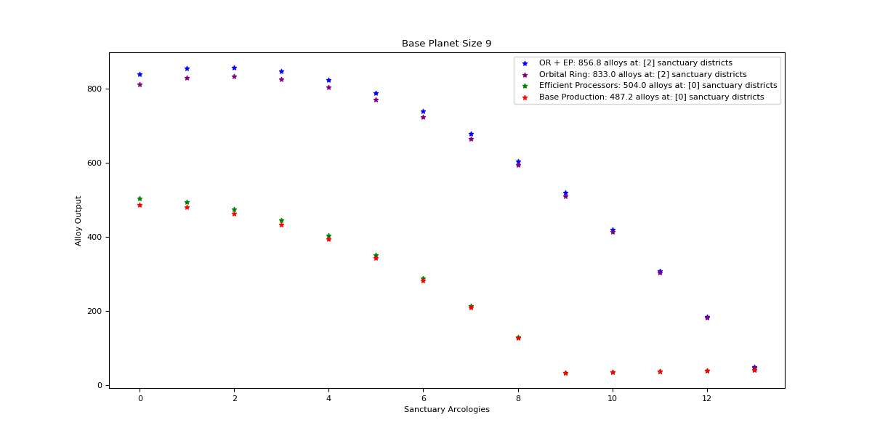

Orbital Ring + Efficient Processors

Optimal: 2

|  |  |  |  |  |
| --- | --- | --- | --- | --- |
| Sanctuary Districts | Alloys | Minerals | Food | Consumer Goods |
| 0 | 903 | 1324.4 | 0 | 0 |
| 1 | 924 | 1232 | 15 | 15 |
| 2 | 932.4 | 1139.6 | 30 | 30 |
| 3 | 928.2 | 1047.2 | 45 | 45 |
| 4 | 911.4 | 954.8 | 60 | 60 |
| 5 | 882 | 862.4 | 75 | 75 |
| 6 | 840 | 770 | 90 | 90 |
| 7 | 785.4 | 677.6 | 105 | 105 |
| 8 | 718.2 | 585.2 | 120 | 120 |
| 9 | 638.4 | 492.8 | 135 | 135 |
| 10 | 546 | 400.4 | 150 | 150 |
| 11 | 441 | 308 | 165 | 165 |
| 12 | 323.4 | 215.6 | 180 | 180 |
| 13 | 193.2 | 123.2 | 195 | 195 |

Orbital Ring

Optimal: 2

|  |  |  |  |  |
| --- | --- | --- | --- | --- |
| Sanctuary Districts | Alloys | Minerals | Food | Consumer Goods |
| 0 | 872.9 | 1324.4 | 0 | 0 |
| 1 | 896 | 1232 | 15 | 15 |
| 2 | 906.5 | 1139.6 | 30 | 30 |
| 3 | 904.4 | 1047.2 | 45 | 45 |
| 4 | 889.7 | 954.8 | 60 | 60 |
| 5 | 862.4 | 862.4 | 75 | 75 |
| 6 | 822.5 | 770 | 90 | 90 |
| 7 | 770 | 677.6 | 105 | 105 |
| 8 | 704.9 | 585.2 | 120 | 120 |
| 9 | 627.2 | 492.8 | 135 | 135 |
| 10 | 536.9 | 400.4 | 150 | 150 |
| 11 | 434 | 308 | 165 | 165 |
| 12 | 318.5 | 215.6 | 180 | 180 |
| 13 | 190.4 | 123.2 | 195 | 195 |

Efficient Processors

Optimal: 0

|  |  |  |  |  |
| --- | --- | --- | --- | --- |
| Sanctuary Districts | Alloys | Minerals | Food | Consumer Goods |
| 0 | 558 | 818.4 | 0 | 0 |
| 1 | 554.4 | 739.2 | 15 | 15 |
| 2 | 540 | 660 | 30 | 30 |
| 3 | 514.8 | 580.8 | 45 | 45 |
| 4 | 478.8 | 501.6 | 60 | 60 |
| 5 | 432 | 422.4 | 75 | 75 |
| 6 | 374.4 | 343.2 | 90 | 90 |
| 7 | 306 | 264 | 105 | 105 |
| 8 | 226.8 | 184.8 | 120 | 120 |
| 9 | 136.8 | 105.6 | 135 | 135 |
| 10 | 36 | 26.4 | 150 | 150 |

Base Production

Optimal: 0

|  |  |  |  |  |
| --- | --- | --- | --- | --- |
| Sanctuary Districts | Alloys | Minerals | Food | Consumer Goods |
| 0 | 539.4 | 818.4 | 0 | 0 |
| 1 | 537.6 | 739.2 | 15 | 15 |
| 2 | 525 | 660 | 30 | 30 |
| 3 | 501.6 | 580.8 | 45 | 45 |
| 4 | 467.4 | 501.6 | 60 | 60 |
| 5 | 422.4 | 422.4 | 75 | 75 |
| 6 | 366.6 | 343.2 | 90 | 90 |
| 7 | 300 | 264 | 105 | 105 |
| 8 | 222.6 | 184.8 | 120 | 120 |
| 9 | 134.4 | 105.6 | 135 | 135 |
| 10 | 35.4 | 26.4 | 150 | 150 |

## Size 11

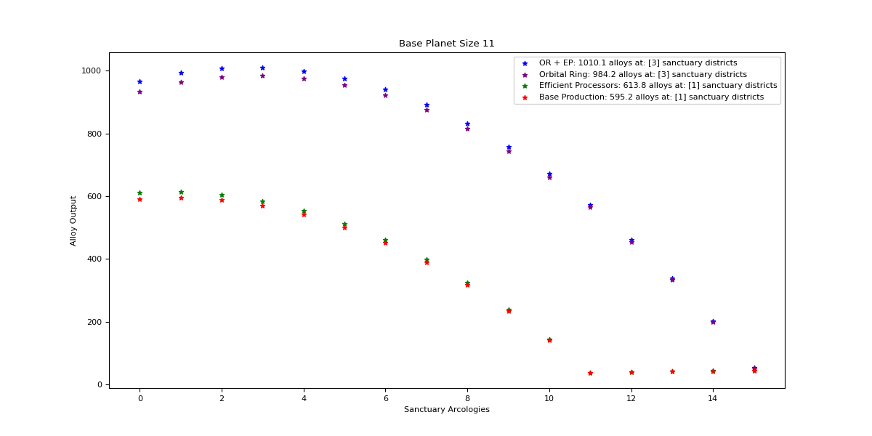

Orbital Ring + Efficient Processors

Optimal: 3

|  |  |  |  |  |
| --- | --- | --- | --- | --- |
| Sanctuary Districts | Alloys | Minerals | Food | Consumer Goods |
| 0 | 966 | 1416.8 | 0 | 0 |
| 1 | 993.3 | 1324.4 | 15 | 15 |
| 2 | 1008 | 1232 | 30 | 30 |
| 3 | 1010.1 | 1139.6 | 45 | 45 |
| 4 | 999.6 | 1047.2 | 60 | 60 |
| 5 | 976.5 | 954.8 | 75 | 75 |
| 6 | 940.8 | 862.4 | 90 | 90 |
| 7 | 892.5 | 770 | 105 | 105 |
| 8 | 831.6 | 677.6 | 120 | 120 |
| 9 | 758.1 | 585.2 | 135 | 135 |
| 10 | 672 | 492.8 | 150 | 150 |
| 11 | 573.3 | 400.4 | 165 | 165 |
| 12 | 462 | 308 | 180 | 180 |
| 13 | 338.1 | 215.6 | 195 | 195 |
| 14 | 201.6 | 123.2 | 210 | 210 |
| 15 | 52.5 | 26.4 | 225 | 225 |

Orbital Ring

Optimal: 3

|  |  |  |  |  |
| --- | --- | --- | --- | --- |
| Sanctuary Districts | Alloys | Minerals | Food | Consumer Goods |
| 0 | 933.8 | 1416.8 | 0 | 0 |
| 1 | 963.2 | 1324.4 | 15 | 15 |
| 2 | 980 | 1232 | 30 | 30 |
| 3 | 984.2 | 1139.6 | 45 | 45 |
| 4 | 975.8 | 1047.2 | 60 | 60 |
| 5 | 954.8 | 954.8 | 75 | 75 |
| 6 | 921.2 | 862.4 | 90 | 90 |
| 7 | 875 | 770 | 105 | 105 |
| 8 | 816.2 | 677.6 | 120 | 120 |
| 9 | 744.8 | 585.2 | 135 | 135 |
| 10 | 660.8 | 492.8 | 150 | 150 |
| 11 | 564.2 | 400.4 | 165 | 165 |
| 12 | 455 | 308 | 180 | 180 |
| 13 | 333.2 | 215.6 | 195 | 195 |
| 14 | 198.8 | 123.2 | 210 | 210 |
| 15 | 51.8 | 30.8 | 225 | 225 |

Efficient Processors

Optimal: 1

|  |  |  |  |  |
| --- | --- | --- | --- | --- |
| Sanctuary Districts | Alloys | Minerals | Food | Consumer Goods |
| 0 | 612 | 897.6 | 0 | 0 |
| 1 | 613.8 | 818.4 | 15 | 15 |
| 2 | 604.8 | 739.2 | 30 | 30 |
| 3 | 585 | 660 | 45 | 45 |
| 4 | 554.4 | 580.8 | 60 | 60 |
| 5 | 513 | 501.6 | 75 | 75 |
| 6 | 460.8 | 422.4 | 90 | 90 |
| 7 | 397.8 | 343.2 | 105 | 105 |
| 8 | 324 | 264 | 120 | 120 |
| 9 | 239.4 | 184.8 | 135 | 135 |
| 10 | 144 | 105.6 | 150 | 150 |
| 11 | 37.8 | 26.4 | 165 | 165 |

Base Production

Optimal: 1

|  |  |  |  |  |
| --- | --- | --- | --- | --- |
| Sanctuary Districts | Alloys | Minerals | Food | Consumer Goods |
| 0 | 591.6 | 897.6 | 0 | 0 |
| 1 | 595.2 | 818.4 | 15 | 15 |
| 2 | 588 | 739.2 | 30 | 30 |
| 3 | 570 | 660 | 45 | 45 |
| 4 | 541.2 | 580.8 | 60 | 60 |
| 5 | 501.6 | 501.6 | 75 | 75 |
| 6 | 451.2 | 422.4 | 90 | 90 |
| 7 | 390 | 343.2 | 105 | 105 |
| 8 | 318 | 264 | 120 | 120 |
| 9 | 235.2 | 184.8 | 135 | 135 |
| 10 | 141.6 | 105.6 | 150 | 150 |
| 11 | 37.2 | 26.4 | 165 | 165 |

## Size 12

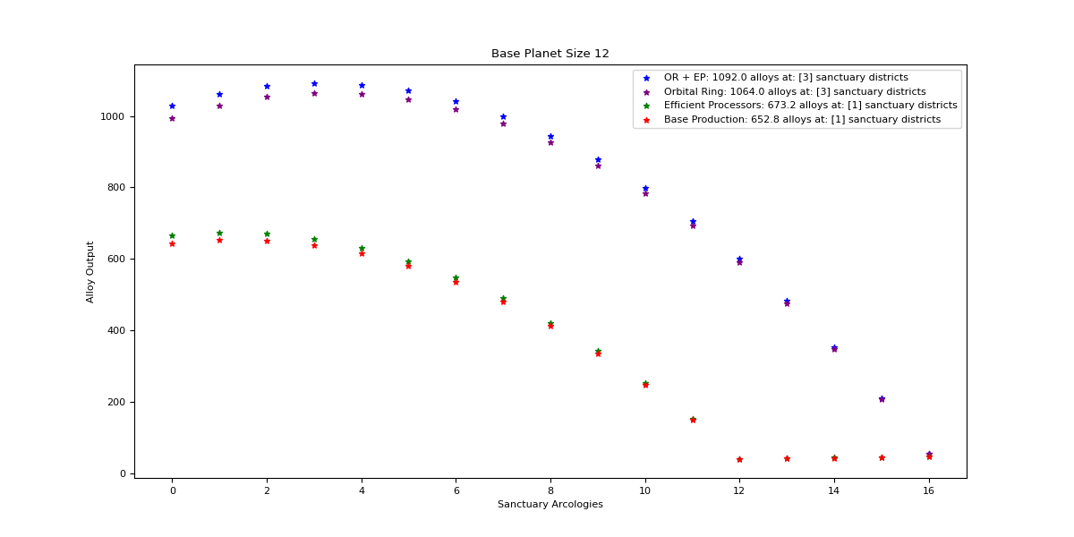

Orbital Ring + Efficient Processors

Optimal: 3

|  |  |  |  |  |
| --- | --- | --- | --- | --- |
| Sanctuary Districts | Alloys | Minerals | Food | Consumer Goods |
| 0 | 1029 | 1509.2 | 0 | 0 |
| 1 | 1062.6 | 1416.8 | 15 | 15 |
| 2 | 1083.6 | 1324.4 | 30 | 30 |
| 3 | 1092 | 1232 | 45 | 45 |
| 4 | 1087.8 | 1139.6 | 60 | 60 |
| 5 | 1071 | 1047.2 | 75 | 75 |
| 6 | 1041.6 | 954.8 | 90 | 90 |
| 7 | 999.6 | 862.4 | 105 | 105 |
| 8 | 945 | 770 | 120 | 120 |
| 9 | 877.8 | 677.6 | 135 | 135 |
| 10 | 798 | 585.2 | 150 | 150 |
| 11 | 705.6 | 492.8 | 165 | 165 |
| 12 | 600.6 | 400.4 | 180 | 180 |
| 13 | 483 | 308 | 195 | 195 |
| 14 | 352.8 | 215.6 | 210 | 210 |
| 15 | 210 | 123.2 | 225 | 225 |
| 16 | 54.6 | 30.8 | 240 | 240 |

Orbital Ring

Optimal: 3

|  |  |  |  |  |
| --- | --- | --- | --- | --- |
| Sanctuary Districts | Alloys | Minerals | Food | Consumer Goods |
| 0 | 994.7 | 1509.2 | 0 | 0 |
| 1 | 1030.4 | 1416.8 | 15 | 15 |
| 2 | 1053.5 | 1324.4 | 30 | 30 |
| 3 | 1064 | 1232 | 45 | 45 |
| 4 | 1061.9 | 1139.6 | 60 | 60 |
| 5 | 1047.2 | 1047.2 | 75 | 75 |
| 6 | 1019.9 | 954.8 | 90 | 90 |
| 7 | 980 | 862.4 | 105 | 105 |
| 8 | 927.5 | 770 | 120 | 120 |
| 9 | 862.4 | 677.6 | 135 | 135 |
| 10 | 784.7 | 585.2 | 150 | 150 |
| 11 | 694.4 | 492.8 | 165 | 165 |
| 12 | 591.5 | 400.4 | 180 | 180 |
| 13 | 476 | 308 | 195 | 195 |
| 14 | 347.9 | 215.6 | 210 | 210 |
| 15 | 207.2 | 123.2 | 225 | 225 |
| 16 | 53.9 | 30.8 | 240 | 240 |

Efficient Processors

Optimal: 1

|  |  |  |  |  |
| --- | --- | --- | --- | --- |
| Sanctuary Districts | Alloys | Minerals | Food | Consumer Goods |
| 0 | 666 | 976.8 | 0 | 0 |
| 1 | 673.2 | 897.6 | 15 | 15 |
| 2 | 669.6 | 818.4 | 30 | 30 |
| 3 | 655.2 | 739.2 | 45 | 45 |
| 4 | 630 | 660 | 60 | 60 |
| 5 | 594 | 580.8 | 75 | 75 |
| 6 | 547.2 | 501.6 | 90 | 90 |
| 7 | 489.6 | 422.4 | 105 | 105 |
| 8 | 421.2 | 343.2 | 120 | 120 |
| 9 | 342 | 264 | 135 | 135 |
| 10 | 252 | 184.8 | 150 | 150 |
| 11 | 151.2 | 105.6 | 165 | 165 |
| 12 | 39.6 | 26.4 | 180 | 180 |

Base Production

Optimal: 1

|  |  |  |  |  |
| --- | --- | --- | --- | --- |
| Sanctuary Districts | Alloys | Minerals | Food | Consumer Goods |
| 0 | 643.8 | 976.8 | 0 | 0 |
| 1 | 652.8 | 897.6 | 15 | 15 |
| 2 | 651 | 818.4 | 30 | 30 |
| 3 | 638.4 | 739.2 | 45 | 45 |
| 4 | 615 | 660 | 60 | 60 |
| 5 | 580.8 | 580.8 | 75 | 75 |
| 6 | 535.8 | 501.6 | 90 | 90 |
| 7 | 480 | 422.4 | 105 | 105 |
| 8 | 413.4 | 343.2 | 120 | 120 |
| 9 | 336 | 264 | 135 | 135 |
| 10 | 247.8 | 184.8 | 150 | 150 |
| 11 | 148.8 | 105.6 | 165 | 165 |
| 12 | 39 | 26.4 | 180 | 180 |

## Size 13

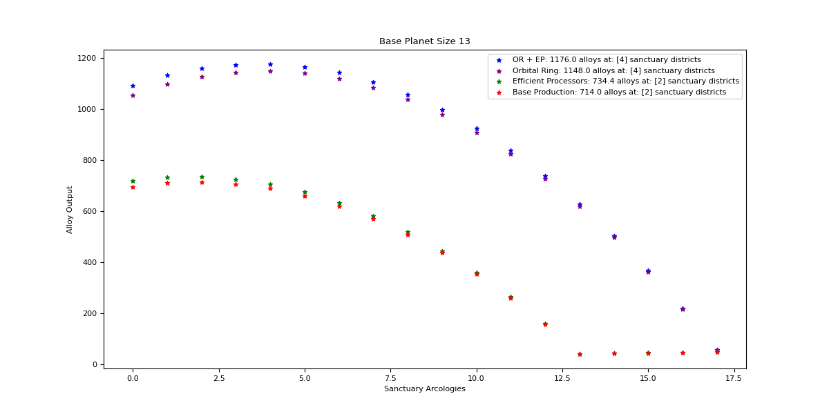

Orbital Ring + Efficient Processors

Optimal: 4

|  |  |  |  |  |
| --- | --- | --- | --- | --- |
| Sanctuary Districts | Alloys | Minerals | Food | Consumer Goods |
| 0 | 1092 | 1601.6 | 0 | 0 |
| 1 | 1131.9 | 1509.2 | 15 | 15 |
| 2 | 1159.2 | 1416.8 | 30 | 30 |
| 3 | 1173.9 | 1324.4 | 45 | 45 |
| 4 | 1176 | 1232 | 60 | 60 |
| 5 | 1165.5 | 1139.6 | 75 | 75 |
| 6 | 1142.4 | 1047.2 | 90 | 90 |
| 7 | 1106.7 | 954.8 | 105 | 105 |
| 8 | 1058.4 | 862.4 | 120 | 120 |
| 9 | 997.5 | 770 | 135 | 135 |
| 10 | 924 | 677.6 | 150 | 150 |
| 11 | 837.9 | 585.2 | 165 | 165 |
| 12 | 739.2 | 492.8 | 180 | 180 |
| 13 | 627.9 | 400.4 | 195 | 195 |
| 14 | 504 | 308 | 210 | 210 |
| 15 | 367.5 | 184.8 | 225 | 225 |
| 16 | 218.4 | 105.6 | 240 | 240 |
| 17 | 56.7 | 26.4 | 255 | 255 |

Orbital Ring

Optimal: 4

|  |  |  |  |  |
| --- | --- | --- | --- | --- |
| Sanctuary Districts | Alloys | Minerals | Food | Consumer Goods |
| 0 | 1055.6 | 1601.6 | 0 | 0 |
| 1 | 1097.6 | 1509.2 | 15 | 15 |
| 2 | 1127 | 1416.8 | 30 | 30 |
| 3 | 1143.8 | 1324.4 | 45 | 45 |
| 4 | 1148 | 1232 | 60 | 60 |
| 5 | 1139.6 | 1139.6 | 75 | 75 |
| 6 | 1118.6 | 1047.2 | 90 | 90 |
| 7 | 1085 | 954.8 | 105 | 105 |
| 8 | 1038.8 | 862.4 | 120 | 120 |
| 9 | 980 | 770 | 135 | 135 |
| 10 | 908.6 | 677.6 | 150 | 150 |
| 11 | 824.6 | 585.2 | 165 | 165 |
| 12 | 728 | 492.8 | 180 | 180 |
| 13 | 618.8 | 400.4 | 195 | 195 |
| 14 | 497 | 308 | 210 | 210 |
| 15 | 362.6 | 215.6 | 225 | 225 |
| 16 | 215.6 | 123.2 | 240 | 240 |
| 17 | 56 | 30.8 | 255 | 255 |

Efficient Processors

Optimal: 2

|  |  |  |  |  |
| --- | --- | --- | --- | --- |
| Sanctuary Districts | Alloys | Minerals | Food | Consumer Goods |
| 0 | 720 | 1056 | 0 | 0 |
| 1 | 732.6 | 976.8 | 15 | 15 |
| 2 | 734.4 | 897.6 | 30 | 30 |
| 3 | 725.4 | 818.4 | 45 | 45 |
| 4 | 705.6 | 739.2 | 60 | 60 |
| 5 | 675 | 660 | 75 | 75 |
| 6 | 633.6 | 580.8 | 90 | 90 |
| 7 | 581.4 | 501.6 | 105 | 105 |
| 8 | 518.4 | 422.4 | 120 | 120 |
| 9 | 444.6 | 343.2 | 135 | 135 |
| 10 | 360 | 264 | 150 | 150 |
| 11 | 264.6 | 184.8 | 165 | 165 |
| 12 | 158.4 | 105.6 | 180 | 180 |
| 13 | 41.4 | 26.4 | 195 | 195 |

Base Production

Optimal: 2

|  |  |  |  |  |
| --- | --- | --- | --- | --- |
| Sanctuary Districts | Alloys | Minerals | Food | Consumer Goods |
| 0 | 696 | 1056 | 0 | 0 |
| 1 | 710.4 | 976.8 | 15 | 15 |
| 2 | 714 | 897.6 | 30 | 30 |
| 3 | 706.8 | 818.4 | 45 | 45 |
| 4 | 688.8 | 739.2 | 60 | 60 |
| 5 | 660 | 660 | 75 | 75 |
| 6 | 620.4 | 580.8 | 90 | 90 |
| 7 | 570 | 501.6 | 105 | 105 |
| 8 | 508.8 | 422.4 | 120 | 120 |
| 9 | 436.8 | 343.2 | 135 | 135 |
| 10 | 354 | 264 | 150 | 150 |
| 11 | 260.4 | 184.8 | 165 | 165 |
| 12 | 156 | 105.6 | 180 | 180 |
| 13 | 40.8 | 26.4 | 195 | 195 |

## Size 14

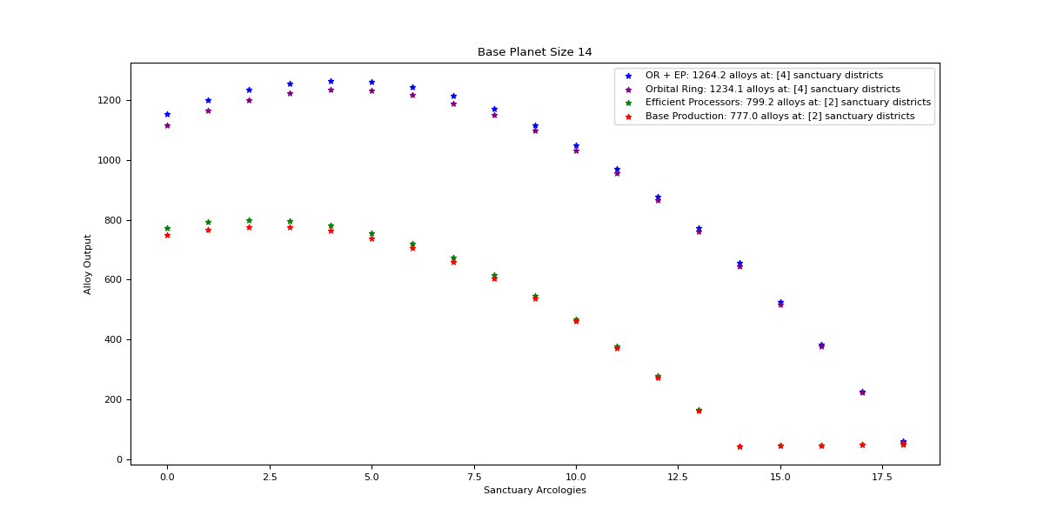

Orbital Ring + Efficient Processors

Optimal: 4

|  |  |  |  |  |
| --- | --- | --- | --- | --- |
| Sanctuary Districts | Alloys | Minerals | Food | Consumer Goods |
| 0 | 1155 | 1694 | 0 | 0 |
| 1 | 1201.2 | 1601.6 | 15 | 15 |
| 2 | 1234.8 | 1509.2 | 30 | 30 |
| 3 | 1255.8 | 1416.8 | 45 | 45 |
| 4 | 1264.2 | 1324.4 | 60 | 60 |
| 5 | 1260 | 1232 | 75 | 75 |
| 6 | 1243.2 | 1139.6 | 90 | 90 |
| 7 | 1213.8 | 1047.2 | 105 | 105 |
| 8 | 1171.8 | 954.8 | 120 | 120 |
| 9 | 1117.2 | 862.4 | 135 | 135 |
| 10 | 1050 | 770 | 150 | 150 |
| 11 | 970.2 | 677.6 | 165 | 165 |
| 12 | 877.8 | 585.2 | 180 | 180 |
| 13 | 772.8 | 492.8 | 195 | 195 |
| 14 | 655.2 | 400.4 | 210 | 210 |
| 15 | 525 | 308 | 225 | 225 |
| 16 | 382.2 | 215.6 | 240 | 240 |
| 17 | 226.8 | 123.2 | 255 | 255 |
| 18 | 58.8 | 30.8 | 270 | 270 |

Orbital Ring

Optimal: 4

|  |  |  |  |  |
| --- | --- | --- | --- | --- |
| Sanctuary Districts | Alloys | Minerals | Food | Consumer Goods |
| 0 | 1116.5 | 1694 | 0 | 0 |
| 1 | 1164.8 | 1601.6 | 15 | 15 |
| 2 | 1200.5 | 1509.2 | 30 | 30 |
| 3 | 1223.6 | 1416.8 | 45 | 45 |
| 4 | 1234.1 | 1324.4 | 60 | 60 |
| 5 | 1232 | 1232 | 75 | 75 |
| 6 | 1217.3 | 1139.6 | 90 | 90 |
| 7 | 1190 | 1047.2 | 105 | 105 |
| 8 | 1150.1 | 954.8 | 120 | 120 |
| 9 | 1097.6 | 862.4 | 135 | 135 |
| 10 | 1032.5 | 770 | 150 | 150 |
| 11 | 954.8 | 677.6 | 165 | 165 |
| 12 | 864.5 | 585.2 | 180 | 180 |
| 13 | 761.6 | 492.8 | 195 | 195 |
| 14 | 646.1 | 400.4 | 210 | 210 |
| 15 | 518 | 308 | 225 | 225 |
| 16 | 377.3 | 215.6 | 240 | 240 |
| 17 | 224 | 123.2 | 255 | 255 |
| 18 | 58.1 | 30.8 | 270 | 270 |

Efficient Processors

Optimal: 2

|  |  |  |  |  |
| --- | --- | --- | --- | --- |
| Sanctuary Districts | Alloys | Minerals | Food | Consumer Goods |
| 0 | 774 | 1135.2 | 0 | 0 |
| 1 | 792 | 1056 | 15 | 15 |
| 2 | 799.2 | 976.8 | 30 | 30 |
| 3 | 795.6 | 897.6 | 45 | 45 |
| 4 | 781.2 | 818.4 | 60 | 60 |
| 5 | 756 | 739.2 | 75 | 75 |
| 6 | 720 | 660 | 90 | 90 |
| 7 | 673.2 | 580.8 | 105 | 105 |
| 8 | 615.6 | 501.6 | 120 | 120 |
| 9 | 547.2 | 422.4 | 135 | 135 |
| 10 | 468 | 343.2 | 150 | 150 |
| 11 | 378 | 264 | 165 | 165 |
| 12 | 277.2 | 184.8 | 180 | 180 |
| 13 | 165.6 | 105.6 | 195 | 195 |
| 14 | 43.2 | 26.4 | 210 | 210 |

Base Production

Optimal: 2

|  |  |  |  |  |
| --- | --- | --- | --- | --- |
| Sanctuary Districts | Alloys | Minerals | Food | Consumer Goods |
| 0 | 748.2 | 1135.2 | 0 | 0 |
| 1 | 768 | 1056 | 15 | 15 |
| 2 | 777 | 976.8 | 30 | 30 |
| 3 | 775.2 | 897.6 | 45 | 45 |
| 4 | 762.6 | 818.4 | 60 | 60 |
| 5 | 739.2 | 739.2 | 75 | 75 |
| 6 | 705 | 660 | 90 | 90 |
| 7 | 660 | 580.8 | 105 | 105 |
| 8 | 604.2 | 501.6 | 120 | 120 |
| 9 | 537.6 | 422.4 | 135 | 135 |
| 10 | 460.2 | 343.2 | 150 | 150 |
| 11 | 372 | 264 | 165 | 165 |
| 12 | 273 | 184.8 | 180 | 180 |
| 13 | 163.2 | 105.6 | 195 | 195 |
| 14 | 42.6 | 26.4 | 210 | 210 |

## Size 15

Orbital Ring + Efficient Processors

Optimal: 5

|  |  |  |  |  |
| --- | --- | --- | --- | --- |
| Sanctuary Districts | Alloys | Minerals | Food | Consumer Goods |
| 0 | 1218 | 1786.4 | 0 | 0 |
| 1 | 1270.5 | 1694 | 15 | 15 |
| 2 | 1310.4 | 1601.6 | 30 | 30 |
| 3 | 1337.7 | 1509.2 | 45 | 45 |
| 4 | 1352.4 | 1416.8 | 60 | 60 |
| 5 | 1354.5 | 1324.4 | 75 | 75 |
| 6 | 1344 | 1232 | 90 | 90 |
| 7 | 1320.9 | 1139.6 | 105 | 105 |
| 8 | 1285.2 | 1047.2 | 120 | 120 |
| 9 | 1236.9 | 954.8 | 135 | 135 |
| 10 | 1176 | 862.4 | 150 | 150 |
| 11 | 1102.5 | 770 | 165 | 165 |
| 12 | 1016.4 | 677.6 | 180 | 180 |
| 13 | 917.7 | 585.2 | 195 | 195 |
| 14 | 806.4 | 492.8 | 210 | 210 |
| 15 | 682.5 | 400.4 | 225 | 225 |
| 16 | 546 | 308 | 240 | 240 |
| 17 | 396.9 | 215.6 | 255 | 255 |
| 18 | 235.2 | 123.2 | 270 | 270 |
| 19 | 60.9 | 30.8 | 285 | 285 |

Orbital Ring

Optimal: 5

|  |  |  |  |  |
| --- | --- | --- | --- | --- |
| Sanctuary Districts | Alloys | Minerals | Food | Consumer Goods |
| 0 | 1177.4 | 1786.4 | 0 | 0 |
| 1 | 1232 | 1694 | 15 | 15 |
| 2 | 1274 | 1601.6 | 30 | 30 |
| 3 | 1303.4 | 1509.2 | 45 | 45 |
| 4 | 1320.2 | 1416.8 | 60 | 60 |
| 5 | 1324.4 | 1324.4 | 75 | 75 |
| 6 | 1316 | 1232 | 90 | 90 |
| 7 | 1295 | 1139.6 | 105 | 105 |
| 8 | 1261.4 | 1047.2 | 120 | 120 |
| 9 | 1215.2 | 954.8 | 135 | 135 |
| 10 | 1156.4 | 862.4 | 150 | 150 |
| 11 | 1085 | 770 | 165 | 165 |
| 12 | 1001 | 677.6 | 180 | 180 |
| 13 | 904.4 | 585.2 | 195 | 195 |
| 14 | 795.2 | 492.8 | 210 | 210 |
| 15 | 673.4 | 400.4 | 225 | 225 |
| 16 | 539 | 308 | 240 | 240 |
| 17 | 392 | 215.6 | 255 | 255 |
| 18 | 232.4 | 123.2 | 270 | 270 |
| 19 | 60.2 | 30.8 | 285 | 285 |

Efficient Processors

Optimal: 3

|  |  |  |  |  |
| --- | --- | --- | --- | --- |
| Sanctuary Districts | Alloys | Minerals | Food | Consumer Goods |
| 0 | 828 | 1214.4 | 0 | 0 |
| 1 | 851.4 | 1135.2 | 15 | 15 |
| 2 | 864 | 1056 | 30 | 30 |
| 3 | 865.8 | 976.8 | 45 | 45 |
| 4 | 856.8 | 897.6 | 60 | 60 |
| 5 | 837 | 818.4 | 75 | 75 |
| 6 | 806.4 | 739.2 | 90 | 90 |
| 7 | 765 | 660 | 105 | 105 |
| 8 | 712.8 | 580.8 | 120 | 120 |
| 9 | 649.8 | 501.6 | 135 | 135 |
| 10 | 576 | 422.4 | 150 | 150 |
| 11 | 491.4 | 343.2 | 165 | 165 |
| 12 | 396 | 264 | 180 | 180 |
| 13 | 289.8 | 184.8 | 195 | 195 |
| 14 | 172.8 | 105.6 | 210 | 210 |
| 15 | 45 | 26.4 | 225 | 225 |

Base Production

Optimal: 3

|  |  |  |  |  |
| --- | --- | --- | --- | --- |
| Sanctuary Districts | Alloys | Minerals | Food | Consumer Goods |
| 0 | 800.4 | 1214.4 | 0 | 0 |
| 1 | 825.6 | 1135.2 | 15 | 15 |
| 2 | 840 | 1056 | 30 | 30 |
| 3 | 843.6 | 976.8 | 45 | 45 |
| 4 | 836.4 | 897.6 | 60 | 60 |
| 5 | 818.4 | 818.4 | 75 | 75 |
| 6 | 789.6 | 739.2 | 90 | 90 |
| 7 | 750 | 660 | 105 | 105 |
| 8 | 699.6 | 580.8 | 120 | 120 |
| 9 | 638.4 | 501.6 | 135 | 135 |
| 10 | 566.4 | 422.4 | 150 | 150 |
| 11 | 483.6 | 343.2 | 165 | 165 |
| 12 | 390 | 264 | 180 | 180 |
| 13 | 285.6 | 184.8 | 195 | 195 |
| 14 | 170.4 | 105.6 | 210 | 210 |
| 15 | 44.4 | 26.4 | 225 | 225 |

## Size 16

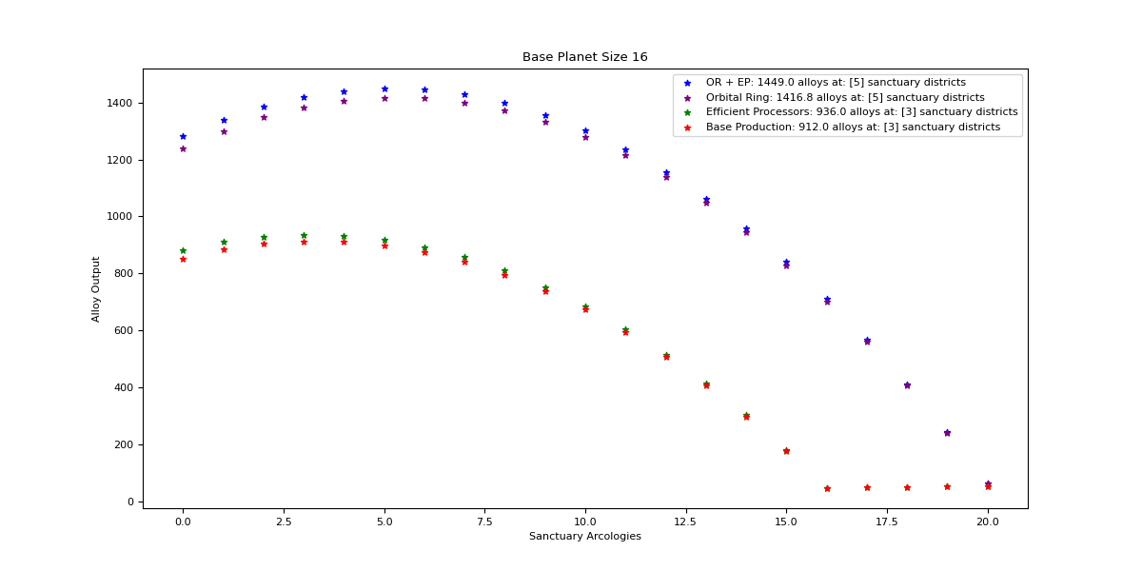

Orbital Ring + Efficient Processors

Optimal: 5

|  |  |  |  |  |
| --- | --- | --- | --- | --- |
| Sanctuary Districts | Alloys | Minerals | Food | Consumer Goods |
| 0 | 1281 | 1878.8 | 0 | 0 |
| 1 | 1339.8 | 1786.4 | 15 | 15 |
| 2 | 1386 | 1694 | 30 | 30 |
| 3 | 1419.6 | 1601.6 | 45 | 45 |
| 4 | 1440.6 | 1509.2 | 60 | 60 |
| 5 | 1449 | 1416.8 | 75 | 75 |
| 6 | 1444.8 | 1324.4 | 90 | 90 |
| 7 | 1428 | 1232 | 105 | 105 |
| 8 | 1398.6 | 1139.6 | 120 | 120 |
| 9 | 1356.6 | 1047.2 | 135 | 135 |
| 10 | 1302 | 954.8 | 150 | 150 |
| 11 | 1234.8 | 862.4 | 165 | 165 |
| 12 | 1155 | 770 | 180 | 180 |
| 13 | 1062.6 | 677.6 | 195 | 195 |
| 14 | 957.6 | 585.2 | 210 | 210 |
| 15 | 840 | 492.8 | 225 | 225 |
| 16 | 709.8 | 400.4 | 240 | 240 |
| 17 | 567 | 308 | 255 | 255 |
| 18 | 411.6 | 215.6 | 270 | 270 |
| 19 | 243.6 | 123.2 | 285 | 285 |
| 20 | 63 | 30.8 | 300 | 300 |

Orbital Ring

Optimal: 5

|  |  |  |  |  |
| --- | --- | --- | --- | --- |
| Sanctuary Districts | Alloys | Minerals | Food | Consumer Goods |
| 0 | 1238.3 | 1878.8 | 0 | 0 |
| 1 | 1299.2 | 1786.4 | 15 | 15 |
| 2 | 1347.5 | 1694 | 30 | 30 |
| 3 | 1383.2 | 1601.6 | 45 | 45 |
| 4 | 1406.3 | 1509.2 | 60 | 60 |
| 5 | 1416.8 | 1416.8 | 75 | 75 |
| 6 | 1414.7 | 1324.4 | 90 | 90 |
| 7 | 1400 | 1232 | 105 | 105 |
| 8 | 1372.7 | 1139.6 | 120 | 120 |
| 9 | 1332.8 | 1047.2 | 135 | 135 |
| 10 | 1280.3 | 954.8 | 150 | 150 |
| 11 | 1215.2 | 862.4 | 165 | 165 |
| 12 | 1137.5 | 770 | 180 | 180 |
| 13 | 1047.2 | 677.6 | 195 | 195 |
| 14 | 944.3 | 585.2 | 210 | 210 |
| 15 | 828.8 | 492.8 | 225 | 225 |
| 16 | 700.7 | 400.4 | 240 | 240 |
| 17 | 560 | 308 | 255 | 255 |
| 18 | 406.7 | 215.6 | 270 | 270 |
| 19 | 240.8 | 123.2 | 285 | 285 |
| 20 | 62.3 | 30.8 | 300 | 300 |

Efficient Processors

Optimal: 3

|  |  |  |  |  |
| --- | --- | --- | --- | --- |
| Sanctuary Districts | Alloys | Minerals | Food | Consumer Goods |
| 0 | 882 | 1293.6 | 0 | 0 |
| 1 | 910.8 | 1214.4 | 15 | 15 |
| 2 | 928.8 | 1135.2 | 30 | 30 |
| 3 | 936 | 1056 | 45 | 45 |
| 4 | 932.4 | 976.8 | 60 | 60 |
| 5 | 918 | 897.6 | 75 | 75 |
| 6 | 892.8 | 818.4 | 90 | 90 |
| 7 | 856.8 | 739.2 | 105 | 105 |
| 8 | 810 | 660 | 120 | 120 |
| 9 | 752.4 | 580.8 | 135 | 135 |
| 10 | 684 | 501.6 | 150 | 150 |
| 11 | 604.8 | 422.4 | 165 | 165 |
| 12 | 514.8 | 343.2 | 180 | 180 |
| 13 | 414 | 264 | 195 | 195 |
| 14 | 302.4 | 184.8 | 210 | 210 |
| 15 | 180 | 105.6 | 225 | 225 |
| 16 | 46.8 | 26.4 | 240 | 240 |

Base Production

Optimal: 3

|  |  |  |  |  |
| --- | --- | --- | --- | --- |
| Sanctuary Districts | Alloys | Minerals | Food | Consumer Goods |
| 0 | 852.6 | 1293.6 | 0 | 0 |
| 1 | 883.2 | 1214.4 | 15 | 15 |
| 2 | 903 | 1135.2 | 30 | 30 |
| 3 | 912 | 1056 | 45 | 45 |
| 4 | 910.2 | 976.8 | 60 | 60 |
| 5 | 897.6 | 897.6 | 75 | 75 |
| 6 | 874.2 | 818.4 | 90 | 90 |
| 7 | 840 | 739.2 | 105 | 105 |
| 8 | 795 | 660 | 120 | 120 |
| 9 | 739.2 | 580.8 | 135 | 135 |
| 10 | 672.6 | 501.6 | 150 | 150 |
| 11 | 595.2 | 422.4 | 165 | 165 |
| 12 | 507 | 343.2 | 180 | 180 |
| 13 | 408 | 264 | 195 | 195 |
| 14 | 298.2 | 184.8 | 210 | 210 |
| 15 | 177.6 | 105.6 | 225 | 225 |
| 16 | 46.2 | 26.4 | 240 | 240 |

## Size 17

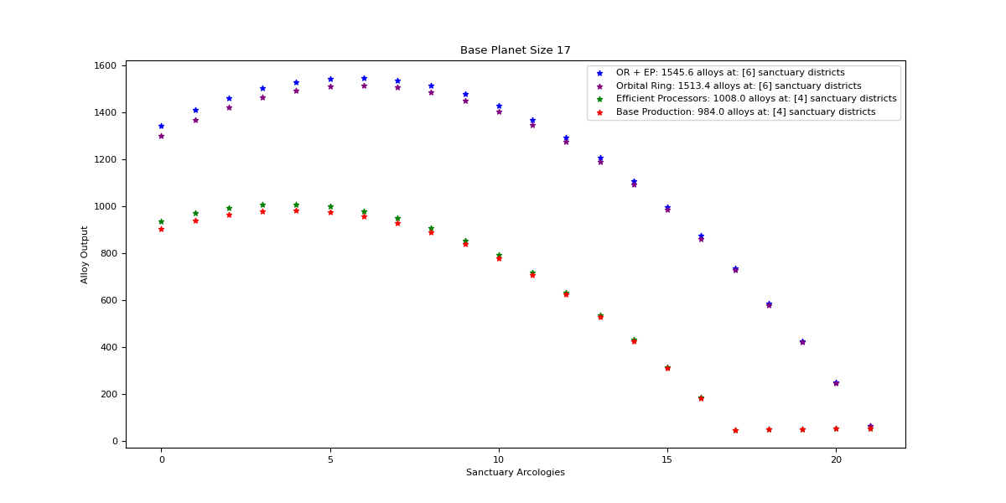

Orbital Ring + Efficient Processors

Optimal: 6

|  |  |  |  |  |
| --- | --- | --- | --- | --- |
| Sanctuary Districts | Alloys | Minerals | Food | Consumer Goods |
| 0 | 1344 | 1971.2 | 0 | 0 |
| 1 | 1409.1 | 1878.8 | 15 | 15 |
| 2 | 1461.6 | 1786.4 | 30 | 30 |
| 3 | 1501.5 | 1694 | 45 | 45 |
| 4 | 1528.8 | 1601.6 | 60 | 60 |
| 5 | 1543.5 | 1509.2 | 75 | 75 |
| 6 | 1545.6 | 1416.8 | 90 | 90 |
| 7 | 1535.1 | 1324.4 | 105 | 105 |
| 8 | 1512 | 1232 | 120 | 120 |
| 9 | 1476.3 | 1139.6 | 135 | 135 |
| 10 | 1428 | 1047.2 | 150 | 150 |
| 11 | 1367.1 | 954.8 | 165 | 165 |
| 12 | 1293.6 | 862.4 | 180 | 180 |
| 13 | 1207.5 | 770 | 195 | 195 |
| 14 | 1108.8 | 677.6 | 210 | 210 |
| 15 | 997.5 | 585.2 | 225 | 225 |
| 16 | 873.6 | 492.8 | 240 | 240 |
| 17 | 737.1 | 400.4 | 255 | 255 |
| 18 | 588 | 308 | 270 | 270 |
| 19 | 426.3 | 215.6 | 285 | 285 |
| 20 | 252 | 123.2 | 300 | 300 |
| 21 | 65.1 | 30.8 | 315 | 315 |

Orbital Ring

Optimal: 6

|  |  |  |  |  |
| --- | --- | --- | --- | --- |
| Sanctuary Districts | Alloys | Minerals | Food | Consumer Goods |
| 0 | 1299.2 | 1971.2 | 0 | 0 |
| 1 | 1366.4 | 1878.8 | 15 | 15 |
| 2 | 1421 | 1786.4 | 30 | 30 |
| 3 | 1463 | 1694 | 45 | 45 |
| 4 | 1492.4 | 1601.6 | 60 | 60 |
| 5 | 1509.2 | 1509.2 | 75 | 75 |
| 6 | 1513.4 | 1416.8 | 90 | 90 |
| 7 | 1505 | 1324.4 | 105 | 105 |
| 8 | 1484 | 1232 | 120 | 120 |
| 9 | 1450.4 | 1139.6 | 135 | 135 |
| 10 | 1404.2 | 1047.2 | 150 | 150 |
| 11 | 1345.4 | 954.8 | 165 | 165 |
| 12 | 1274 | 862.4 | 180 | 180 |
| 13 | 1190 | 770 | 195 | 195 |
| 14 | 1093.4 | 677.6 | 210 | 210 |
| 15 | 984.2 | 585.2 | 225 | 225 |
| 16 | 862.4 | 492.8 | 240 | 240 |
| 17 | 728 | 400.4 | 255 | 255 |
| 18 | 581 | 308 | 270 | 270 |
| 19 | 421.4 | 215.6 | 285 | 285 |
| 20 | 249.2 | 123.2 | 300 | 300 |
| 21 | 64.4 | 30.8 | 315 | 315 |

Efficient Processors

Optimal: 4

|  |  |  |  |  |
| --- | --- | --- | --- | --- |
| Sanctuary Districts | Alloys | Minerals | Food | Consumer Goods |
| 0 | 936 | 1372.8 | 0 | 0 |
| 1 | 970.2 | 1293.6 | 15 | 15 |
| 2 | 993.6 | 1214.4 | 30 | 30 |
| 3 | 1006.2 | 1135.2 | 45 | 45 |
| 4 | 1008 | 1056 | 60 | 60 |
| 5 | 999 | 976.8 | 75 | 75 |
| 6 | 979.2 | 897.6 | 90 | 90 |
| 7 | 948.6 | 818.4 | 105 | 105 |
| 8 | 907.2 | 739.2 | 120 | 120 |
| 9 | 855 | 660 | 135 | 135 |
| 10 | 792 | 580.8 | 150 | 150 |
| 11 | 718.2 | 501.6 | 165 | 165 |
| 12 | 633.6 | 422.4 | 180 | 180 |
| 13 | 538.2 | 343.2 | 195 | 195 |
| 14 | 432 | 264 | 210 | 210 |
| 15 | 315 | 184.8 | 225 | 225 |
| 16 | 187.2 | 105.6 | 240 | 240 |
| 17 | 48.6 | 26.4 | 255 | 255 |

Base Production

Optimal: 4

|  |  |  |  |  |
| --- | --- | --- | --- | --- |
| Sanctuary Districts | Alloys | Minerals | Food | Consumer Goods |
| 0 | 904.8 | 1372.8 | 0 | 0 |
| 1 | 940.8 | 1293.6 | 15 | 15 |
| 2 | 966 | 1214.4 | 30 | 30 |
| 3 | 980.4 | 1135.2 | 45 | 45 |
| 4 | 984 | 1056 | 60 | 60 |
| 5 | 976.8 | 976.8 | 75 | 75 |
| 6 | 958.8 | 897.6 | 90 | 90 |
| 7 | 930 | 818.4 | 105 | 105 |
| 8 | 890.4 | 739.2 | 120 | 120 |
| 9 | 840 | 660 | 135 | 135 |
| 10 | 778.8 | 580.8 | 150 | 150 |
| 11 | 706.8 | 501.6 | 165 | 165 |
| 12 | 624 | 422.4 | 180 | 180 |
| 13 | 530.4 | 343.2 | 195 | 195 |
| 14 | 426 | 264 | 210 | 210 |
| 15 | 310.8 | 184.8 | 225 | 225 |
| 16 | 184.8 | 105.6 | 240 | 240 |
| 17 | 48 | 26.4 | 255 | 255 |

## Size 18

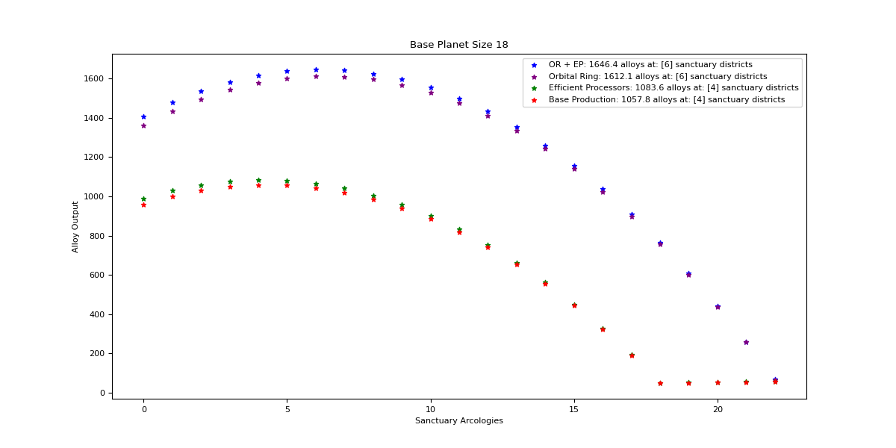

Orbital Ring + Efficient Processors

Optimal: 6

|  |  |  |  |  |
| --- | --- | --- | --- | --- |
| Sanctuary Districts | Alloys | Minerals | Food | Consumer Goods |
| 0 | 1407 | 2063.6 | 0 | 0 |
| 1 | 1478.4 | 1971.2 | 15 | 15 |
| 2 | 1537.2 | 1878.8 | 30 | 30 |
| 3 | 1583.4 | 1786.4 | 45 | 45 |
| 4 | 1617 | 1694 | 60 | 60 |
| 5 | 1638 | 1601.6 | 75 | 75 |
| 6 | 1646.4 | 1509.2 | 90 | 90 |
| 7 | 1642.2 | 1416.8 | 105 | 105 |
| 8 | 1625.4 | 1324.4 | 120 | 120 |
| 9 | 1596 | 1232 | 135 | 135 |
| 10 | 1554 | 1139.6 | 150 | 150 |
| 11 | 1499.4 | 1047.2 | 165 | 165 |
| 12 | 1432.2 | 954.8 | 180 | 180 |
| 13 | 1352.4 | 862.4 | 195 | 195 |
| 14 | 1260 | 770 | 210 | 210 |
| 15 | 1155 | 677.6 | 225 | 225 |
| 16 | 1037.4 | 585.2 | 240 | 240 |
| 17 | 907.2 | 492.8 | 255 | 255 |
| 18 | 764.4 | 400.4 | 270 | 270 |
| 19 | 609 | 308 | 285 | 285 |
| 20 | 441 | 215.6 | 300 | 300 |
| 21 | 260.4 | 123.2 | 315 | 315 |
| 22 | 67.2 | 30.8 | 330 | 330 |

Orbital Ring

Optimal: 6

|  |  |  |  |  |
| --- | --- | --- | --- | --- |
| Sanctuary Districts | Alloys | Minerals | Food | Consumer Goods |
| 0 | 1360.1 | 2063.6 | 0 | 0 |
| 1 | 1433.6 | 1971.2 | 15 | 15 |
| 2 | 1494.5 | 1878.8 | 30 | 30 |
| 3 | 1542.8 | 1786.4 | 45 | 45 |
| 4 | 1578.5 | 1694 | 60 | 60 |
| 5 | 1601.6 | 1601.6 | 75 | 75 |
| 6 | 1612.1 | 1509.2 | 90 | 90 |
| 7 | 1610 | 1416.8 | 105 | 105 |
| 8 | 1595.3 | 1324.4 | 120 | 120 |
| 9 | 1568 | 1232 | 135 | 135 |
| 10 | 1528.1 | 1139.6 | 150 | 150 |
| 11 | 1475.6 | 1047.2 | 165 | 165 |
| 12 | 1410.5 | 954.8 | 180 | 180 |
| 13 | 1332.8 | 862.4 | 195 | 195 |
| 14 | 1242.5 | 770 | 210 | 210 |
| 15 | 1139.6 | 677.6 | 225 | 225 |
| 16 | 1024.1 | 585.2 | 240 | 240 |
| 17 | 896 | 492.8 | 255 | 255 |
| 18 | 755.3 | 400.4 | 270 | 270 |
| 19 | 602 | 308 | 285 | 285 |
| 20 | 436.1 | 215.6 | 300 | 300 |
| 21 | 257.6 | 123.2 | 315 | 315 |
| 22 | 66.5 | 30.8 | 330 | 330 |

Efficient Processors

Optimal: 4

|  |  |  |  |  |
| --- | --- | --- | --- | --- |
| Sanctuary Districts | Alloys | Minerals | Food | Consumer Goods |
| 0 | 990 | 1452 | 0 | 0 |
| 1 | 1029.6 | 1372.8 | 15 | 15 |
| 2 | 1058.4 | 1293.6 | 30 | 30 |
| 3 | 1076.4 | 1214.4 | 45 | 45 |
| 4 | 1083.6 | 1135.2 | 60 | 60 |
| 5 | 1080 | 1056 | 75 | 75 |
| 6 | 1065.6 | 976.8 | 90 | 90 |
| 7 | 1040.4 | 897.6 | 105 | 105 |
| 8 | 1004.4 | 818.4 | 120 | 120 |
| 9 | 957.6 | 739.2 | 135 | 135 |
| 10 | 900 | 660 | 150 | 150 |
| 11 | 831.6 | 580.8 | 165 | 165 |
| 12 | 752.4 | 501.6 | 180 | 180 |
| 13 | 662.4 | 422.4 | 195 | 195 |
| 14 | 561.6 | 343.2 | 210 | 210 |
| 15 | 450 | 264 | 225 | 225 |
| 16 | 327.6 | 184.8 | 240 | 240 |
| 17 | 194.4 | 105.6 | 255 | 255 |
| 18 | 50.4 | 26.4 | 270 | 270 |

Base Production

Optimal: 4

|  |  |  |  |  |
| --- | --- | --- | --- | --- |
| Sanctuary Districts | Alloys | Minerals | Food | Consumer Goods |
| 0 | 957 | 1452 | 0 | 0 |
| 1 | 998.4 | 1372.8 | 15 | 15 |
| 2 | 1029 | 1293.6 | 30 | 30 |
| 3 | 1048.8 | 1214.4 | 45 | 45 |
| 4 | 1057.8 | 1135.2 | 60 | 60 |
| 5 | 1056 | 1056 | 75 | 75 |
| 6 | 1043.4 | 976.8 | 90 | 90 |
| 7 | 1020 | 897.6 | 105 | 105 |
| 8 | 985.8 | 818.4 | 120 | 120 |
| 9 | 940.8 | 739.2 | 135 | 135 |
| 10 | 885 | 660 | 150 | 150 |
| 11 | 818.4 | 580.8 | 165 | 165 |
| 12 | 741 | 501.6 | 180 | 180 |
| 13 | 652.8 | 422.4 | 195 | 195 |
| 14 | 553.8 | 343.2 | 210 | 210 |
| 15 | 444 | 264 | 225 | 225 |
| 16 | 323.4 | 184.8 | 240 | 240 |
| 17 | 192 | 105.6 | 255 | 255 |
| 18 | 49.8 | 26.4 | 270 | 270 |

## Size 19

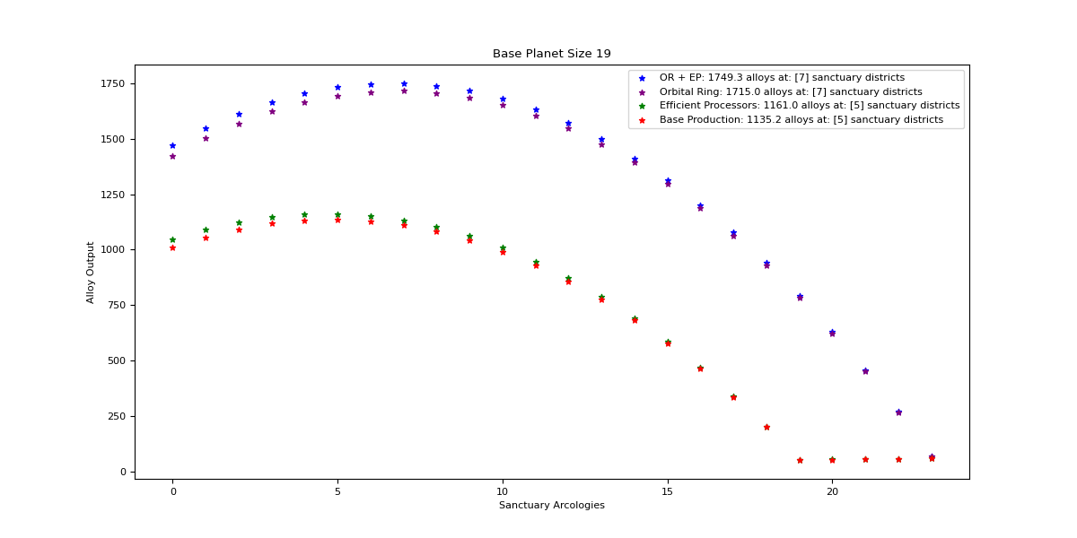

Orbital Ring + Efficient Processors

Optimal: 7

|  |  |  |  |  |
| --- | --- | --- | --- | --- |
| Sanctuary Districts | Alloys | Minerals | Food | Consumer Goods |
| 0 | 1470 | 2156 | 0 | 0 |
| 1 | 1547.7 | 2063.6 | 15 | 15 |
| 2 | 1612.8 | 1971.2 | 30 | 30 |
| 3 | 1665.3 | 1878.8 | 45 | 45 |
| 4 | 1705.2 | 1786.4 | 60 | 60 |
| 5 | 1732.5 | 1694 | 75 | 75 |
| 6 | 1747.2 | 1601.6 | 90 | 90 |
| 7 | 1749.3 | 1509.2 | 105 | 105 |
| 8 | 1738.8 | 1416.8 | 120 | 120 |
| 9 | 1715.7 | 1324.4 | 135 | 135 |
| 10 | 1680 | 1232 | 150 | 150 |
| 11 | 1631.7 | 1139.6 | 165 | 165 |
| 12 | 1570.8 | 1047.2 | 180 | 180 |
| 13 | 1497.3 | 954.8 | 195 | 195 |
| 14 | 1411.2 | 862.4 | 210 | 210 |
| 15 | 1312.5 | 770 | 225 | 225 |
| 16 | 1201.2 | 677.6 | 240 | 240 |
| 17 | 1077.3 | 585.2 | 255 | 255 |
| 18 | 940.8 | 492.8 | 270 | 270 |
| 19 | 791.7 | 400.4 | 285 | 285 |
| 20 | 630 | 308 | 300 | 300 |
| 21 | 455.7 | 215.6 | 315 | 315 |
| 22 | 268.8 | 123.2 | 330 | 330 |
| 23 | 69.3 | 30.8 | 345 | 345 |

Orbital Ring

Optimal: 7

|  |  |  |  |  |
| --- | --- | --- | --- | --- |
| Sanctuary Districts | Alloys | Minerals | Food | Consumer Goods |
| 0 | 1421 | 2156 | 0 | 0 |
| 1 | 1500.8 | 2063.6 | 15 | 15 |
| 2 | 1568 | 1971.2 | 30 | 30 |
| 3 | 1622.6 | 1878.8 | 45 | 45 |
| 4 | 1664.6 | 1786.4 | 60 | 60 |
| 5 | 1694 | 1694 | 75 | 75 |
| 6 | 1710.8 | 1601.6 | 90 | 90 |
| 7 | 1715 | 1509.2 | 105 | 105 |
| 8 | 1706.6 | 1416.8 | 120 | 120 |
| 9 | 1685.6 | 1324.4 | 135 | 135 |
| 10 | 1652 | 1232 | 150 | 150 |
| 11 | 1605.8 | 1139.6 | 165 | 165 |
| 12 | 1547 | 1047.2 | 180 | 180 |
| 13 | 1475.6 | 954.8 | 195 | 195 |
| 14 | 1391.6 | 862.4 | 210 | 210 |
| 15 | 1295 | 770 | 225 | 225 |
| 16 | 1185.8 | 677.6 | 240 | 240 |
| 17 | 1064 | 585.2 | 255 | 255 |
| 18 | 929.6 | 492.8 | 270 | 270 |
| 19 | 782.6 | 400.4 | 285 | 285 |
| 20 | 623 | 308 | 300 | 300 |
| 21 | 450.8 | 215.6 | 315 | 315 |
| 22 | 266 | 123.2 | 330 | 330 |
| 23 | 68.6 | 30.8 | 345 | 345 |

Efficient Processors

Optimal: 5

|  |  |  |  |  |
| --- | --- | --- | --- | --- |
| Sanctuary Districts | Alloys | Minerals | Food | Consumer Goods |
| 0 | 1044 | 1531.2 | 0 | 0 |
| 1 | 1089 | 1452 | 15 | 15 |
| 2 | 1123.2 | 1372.8 | 30 | 30 |
| 3 | 1146.6 | 1293.6 | 45 | 45 |
| 4 | 1159.2 | 1214.4 | 60 | 60 |
| 5 | 1161 | 1135.2 | 75 | 75 |
| 6 | 1152 | 1056 | 90 | 90 |
| 7 | 1132.2 | 976.8 | 105 | 105 |
| 8 | 1101.6 | 897.6 | 120 | 120 |
| 9 | 1060.2 | 818.4 | 135 | 135 |
| 10 | 1008 | 739.2 | 150 | 150 |
| 11 | 945 | 660 | 165 | 165 |
| 12 | 871.2 | 580.8 | 180 | 180 |
| 13 | 786.6 | 501.6 | 195 | 195 |
| 14 | 691.2 | 422.4 | 210 | 210 |
| 15 | 585 | 343.2 | 225 | 225 |
| 16 | 468 | 264 | 240 | 240 |
| 17 | 340.2 | 184.8 | 255 | 255 |
| 18 | 201.6 | 105.6 | 270 | 270 |
| 19 | 52.2 | 26.4 | 285 | 285 |

Base Production

Optimal: 5

|  |  |  |  |  |
| --- | --- | --- | --- | --- |
| Sanctuary Districts | Alloys | Minerals | Food | Consumer Goods |
| 0 | 1009.2 | 1531.2 | 0 | 0 |
| 1 | 1056 | 1452 | 15 | 15 |
| 2 | 1092 | 1372.8 | 30 | 30 |
| 3 | 1117.2 | 1293.6 | 45 | 45 |
| 4 | 1131.6 | 1214.4 | 60 | 60 |
| 5 | 1135.2 | 1135.2 | 75 | 75 |
| 6 | 1128 | 1056 | 90 | 90 |
| 7 | 1110 | 976.8 | 105 | 105 |
| 8 | 1081.2 | 897.6 | 120 | 120 |
| 9 | 1041.6 | 818.4 | 135 | 135 |
| 10 | 991.2 | 739.2 | 150 | 150 |
| 11 | 930 | 660 | 165 | 165 |
| 12 | 858 | 580.8 | 180 | 180 |
| 13 | 775.2 | 501.6 | 195 | 195 |
| 14 | 681.6 | 422.4 | 210 | 210 |
| 15 | 577.2 | 343.2 | 225 | 225 |
| 16 | 462 | 264 | 240 | 240 |
| 17 | 336 | 184.8 | 255 | 255 |
| 18 | 199.2 | 105.6 | 270 | 270 |
| 19 | 51.6 | 26.4 | 285 | 285 |

## Size 20

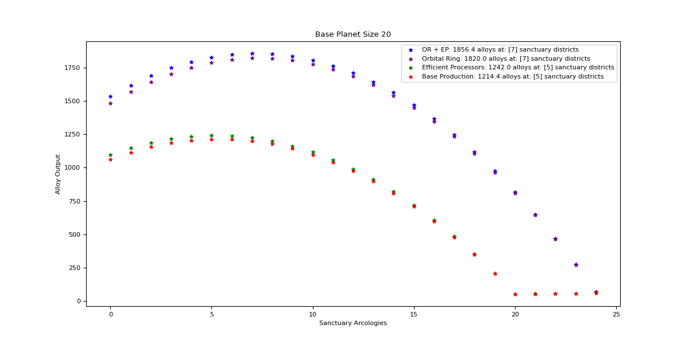

Orbital Ring + Efficient Processors

Optimal: 7

|  |  |  |  |  |
| --- | --- | --- | --- | --- |
| Sanctuary Districts | Alloys | Minerals | Food | Consumer Goods |
| 0 | 1533 | 2248.4 | 0 | 0 |
| 1 | 1617 | 2156 | 15 | 15 |
| 2 | 1688.4 | 2063.6 | 30 | 30 |
| 3 | 1747.2 | 1971.2 | 45 | 45 |
| 4 | 1793.4 | 1878.8 | 60 | 60 |
| 5 | 1827 | 1786.4 | 75 | 75 |
| 6 | 1848 | 1694 | 90 | 90 |
| 7 | 1856.4 | 1601.6 | 105 | 105 |
| 8 | 1852.2 | 1509.2 | 120 | 120 |
| 9 | 1835.4 | 1416.8 | 135 | 135 |
| 10 | 1806 | 1324.4 | 150 | 150 |
| 11 | 1764 | 1232 | 165 | 165 |
| 12 | 1709.4 | 1139.6 | 180 | 180 |
| 13 | 1642.2 | 1047.2 | 195 | 195 |
| 14 | 1562.4 | 954.8 | 210 | 210 |
| 15 | 1470 | 862.4 | 225 | 225 |
| 16 | 1365 | 770 | 240 | 240 |
| 17 | 1247.4 | 677.6 | 255 | 255 |
| 18 | 1117.2 | 585.2 | 270 | 270 |
| 19 | 974.4 | 492.8 | 285 | 285 |
| 20 | 819 | 400.4 | 300 | 300 |
| 21 | 651 | 308 | 315 | 315 |
| 22 | 470.4 | 215.6 | 330 | 330 |
| 23 | 277.2 | 123.2 | 345 | 345 |
| 24 | 71.4 | 30.8 | 360 | 360 |

Orbital Ring

Optimal: 7

|  |  |  |  |  |
| --- | --- | --- | --- | --- |
| Sanctuary Districts | Alloys | Minerals | Food | Consumer Goods |
| 0 | 1481.9 | 2248.4 | 0 | 0 |
| 1 | 1568 | 2156 | 15 | 15 |
| 2 | 1641.5 | 2063.6 | 30 | 30 |
| 3 | 1702.4 | 1971.2 | 45 | 45 |
| 4 | 1750.7 | 1878.8 | 60 | 60 |
| 5 | 1786.4 | 1786.4 | 75 | 75 |
| 6 | 1809.5 | 1694 | 90 | 90 |
| 7 | 1820 | 1601.6 | 105 | 105 |
| 8 | 1817.9 | 1509.2 | 120 | 120 |
| 9 | 1803.2 | 1416.8 | 135 | 135 |
| 10 | 1775.9 | 1324.4 | 150 | 150 |
| 11 | 1736 | 1232 | 165 | 165 |
| 12 | 1683.5 | 1139.6 | 180 | 180 |
| 13 | 1618.4 | 1047.2 | 195 | 195 |
| 14 | 1540.7 | 954.8 | 210 | 210 |
| 15 | 1450.4 | 862.4 | 225 | 225 |
| 16 | 1347.5 | 770 | 240 | 240 |
| 17 | 1232 | 677.6 | 255 | 255 |
| 18 | 1103.9 | 585.2 | 270 | 270 |
| 19 | 963.2 | 492.8 | 285 | 285 |
| 20 | 809.9 | 400.4 | 300 | 300 |
| 21 | 644 | 308 | 315 | 315 |
| 22 | 465.5 | 215.6 | 330 | 330 |
| 23 | 274.4 | 123.2 | 345 | 345 |
| 24 | 70.7 | 30.8 | 360 | 360 |

Efficient Processors

Optimal: 5

|  |  |  |  |  |
| --- | --- | --- | --- | --- |
| Sanctuary Districts | Alloys | Minerals | Food | Consumer Goods |
| 0 | 1098 | 1610.4 | 0 | 0 |
| 1 | 1148.4 | 1531.2 | 15 | 15 |
| 2 | 1188 | 1452 | 30 | 30 |
| 3 | 1216.8 | 1372.8 | 45 | 45 |
| 4 | 1234.8 | 1293.6 | 60 | 60 |
| 5 | 1242 | 1214.4 | 75 | 75 |
| 6 | 1238.4 | 1135.2 | 90 | 90 |
| 7 | 1224 | 1056 | 105 | 105 |
| 8 | 1198.8 | 976.8 | 120 | 120 |
| 9 | 1162.8 | 897.6 | 135 | 135 |
| 10 | 1116 | 818.4 | 150 | 150 |
| 11 | 1058.4 | 739.2 | 165 | 165 |
| 12 | 990 | 660 | 180 | 180 |
| 13 | 910.8 | 580.8 | 195 | 195 |
| 14 | 820.8 | 501.6 | 210 | 210 |
| 15 | 720 | 422.4 | 225 | 225 |
| 16 | 608.4 | 343.2 | 240 | 240 |
| 17 | 486 | 264 | 255 | 255 |
| 18 | 352.8 | 184.8 | 270 | 270 |
| 19 | 208.8 | 105.6 | 285 | 285 |
| 20 | 54 | 26.4 | 300 | 300 |

Base Production

Optimal: 5

|  |  |  |  |  |
| --- | --- | --- | --- | --- |
| Sanctuary Districts | Alloys | Minerals | Food | Consumer Goods |
| 0 | 1061.4 | 1610.4 | 0 | 0 |
| 1 | 1113.6 | 1531.2 | 15 | 15 |
| 2 | 1155 | 1452 | 30 | 30 |
| 3 | 1185.6 | 1372.8 | 45 | 45 |
| 4 | 1205.4 | 1293.6 | 60 | 60 |
| 5 | 1214.4 | 1214.4 | 75 | 75 |
| 6 | 1212.6 | 1135.2 | 90 | 90 |
| 7 | 1200 | 1056 | 105 | 105 |
| 8 | 1176.6 | 976.8 | 120 | 120 |
| 9 | 1142.4 | 897.6 | 135 | 135 |
| 10 | 1097.4 | 818.4 | 150 | 150 |
| 11 | 1041.6 | 739.2 | 165 | 165 |
| 12 | 975 | 660 | 180 | 180 |
| 13 | 897.6 | 580.8 | 195 | 195 |
| 14 | 809.4 | 501.6 | 210 | 210 |
| 15 | 710.4 | 422.4 | 225 | 225 |
| 16 | 600.6 | 343.2 | 240 | 240 |
| 17 | 480 | 264 | 255 | 255 |
| 18 | 348.6 | 184.8 | 270 | 270 |
| 19 | 206.4 | 105.6 | 285 | 285 |
| 20 | 53.4 | 26.4 | 300 | 300 |

## Size 21

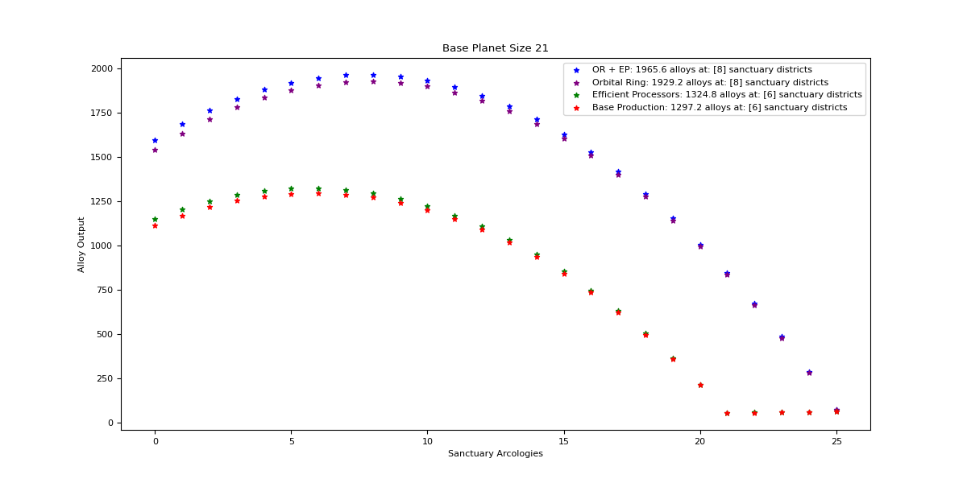

Orbital Ring + Efficient Processors

Optimal: 8

|  |  |  |  |  |
| --- | --- | --- | --- | --- |
| Sanctuary Districts | Alloys | Minerals | Food | Consumer Goods |
| 0 | 1596 | 2340.8 | 0 | 0 |
| 1 | 1686.3 | 2248.4 | 15 | 15 |
| 2 | 1764 | 2156 | 30 | 30 |
| 3 | 1829.1 | 2063.6 | 45 | 45 |
| 4 | 1881.6 | 1971.2 | 60 | 60 |
| 5 | 1921.5 | 1878.8 | 75 | 75 |
| 6 | 1948.8 | 1786.4 | 90 | 90 |
| 7 | 1963.5 | 1694 | 105 | 105 |
| 8 | 1965.6 | 1601.6 | 120 | 120 |
| 9 | 1955.1 | 1509.2 | 135 | 135 |
| 10 | 1932 | 1416.8 | 150 | 150 |
| 11 | 1896.3 | 1324.4 | 165 | 165 |
| 12 | 1848 | 1232 | 180 | 180 |
| 13 | 1787.1 | 1139.6 | 195 | 195 |
| 14 | 1713.6 | 1047.2 | 210 | 210 |
| 15 | 1627.5 | 954.8 | 225 | 225 |
| 16 | 1528.8 | 862.4 | 240 | 240 |
| 17 | 1417.5 | 770 | 255 | 255 |
| 18 | 1293.6 | 677.6 | 270 | 270 |
| 19 | 1157.1 | 585.2 | 285 | 285 |
| 20 | 1008 | 492.8 | 300 | 300 |
| 21 | 846.3 | 400.4 | 315 | 315 |
| 22 | 672 | 308 | 330 | 330 |
| 23 | 485.1 | 215.6 | 345 | 345 |
| 24 | 285.6 | 123.2 | 360 | 360 |
| 25 | 73.5 | 30.8 | 375 | 375 |

Orbital Ring

Optimal: 8

|  |  |  |  |  |
| --- | --- | --- | --- | --- |
| Sanctuary Districts | Alloys | Minerals | Food | Consumer Goods |
| 0 | 1542.8 | 2340.8 | 0 | 0 |
| 1 | 1635.2 | 2248.4 | 15 | 15 |
| 2 | 1715 | 2156 | 30 | 30 |
| 3 | 1782.2 | 2063.6 | 45 | 45 |
| 4 | 1836.8 | 1971.2 | 60 | 60 |
| 5 | 1878.8 | 1878.8 | 75 | 75 |
| 6 | 1908.2 | 1786.4 | 90 | 90 |
| 7 | 1925 | 1694 | 105 | 105 |
| 8 | 1929.2 | 1601.6 | 120 | 120 |
| 9 | 1920.8 | 1509.2 | 135 | 135 |
| 10 | 1899.8 | 1416.8 | 150 | 150 |
| 11 | 1866.2 | 1324.4 | 165 | 165 |
| 12 | 1820 | 1232 | 180 | 180 |
| 13 | 1761.2 | 1139.6 | 195 | 195 |
| 14 | 1689.8 | 1047.2 | 210 | 210 |
| 15 | 1605.8 | 954.8 | 225 | 225 |
| 16 | 1509.2 | 862.4 | 240 | 240 |
| 17 | 1400 | 770 | 255 | 255 |
| 18 | 1278.2 | 677.6 | 270 | 270 |
| 19 | 1143.8 | 585.2 | 285 | 285 |
| 20 | 996.8 | 492.8 | 300 | 300 |
| 21 | 837.2 | 400.4 | 315 | 315 |
| 22 | 665 | 308 | 330 | 330 |
| 23 | 480.2 | 215.6 | 345 | 345 |
| 24 | 282.8 | 123.2 | 360 | 360 |
| 25 | 72.8 | 30.8 | 375 | 375 |

Efficient Processors

Optimal: 6

|  |  |  |  |  |
| --- | --- | --- | --- | --- |
| Sanctuary Districts | Alloys | Minerals | Food | Consumer Goods |
| 0 | 1152 | 1689.6 | 0 | 0 |
| 1 | 1207.8 | 1610.4 | 15 | 15 |
| 2 | 1252.8 | 1531.2 | 30 | 30 |
| 3 | 1287 | 1452 | 45 | 45 |
| 4 | 1310.4 | 1372.8 | 60 | 60 |
| 5 | 1323 | 1293.6 | 75 | 75 |
| 6 | 1324.8 | 1214.4 | 90 | 90 |
| 7 | 1315.8 | 1135.2 | 105 | 105 |
| 8 | 1296 | 1056 | 120 | 120 |
| 9 | 1265.4 | 976.8 | 135 | 135 |
| 10 | 1224 | 897.6 | 150 | 150 |
| 11 | 1171.8 | 818.4 | 165 | 165 |
| 12 | 1108.8 | 739.2 | 180 | 180 |
| 13 | 1035 | 660 | 195 | 195 |
| 14 | 950.4 | 580.8 | 210 | 210 |
| 15 | 855 | 501.6 | 225 | 225 |
| 16 | 748.8 | 422.4 | 240 | 240 |
| 17 | 631.8 | 343.2 | 255 | 255 |
| 18 | 504 | 264 | 270 | 270 |
| 19 | 365.4 | 184.8 | 285 | 285 |
| 20 | 216 | 105.6 | 300 | 300 |
| 21 | 55.8 | 26.4 | 315 | 315 |

Base Production

Optimal: 6

|  |  |  |  |  |
| --- | --- | --- | --- | --- |
| Sanctuary Districts | Alloys | Minerals | Food | Consumer Goods |
| 0 | 1113.6 | 1689.6 | 0 | 0 |
| 1 | 1171.2 | 1610.4 | 15 | 15 |
| 2 | 1218 | 1531.2 | 30 | 30 |
| 3 | 1254 | 1452 | 45 | 45 |
| 4 | 1279.2 | 1372.8 | 60 | 60 |
| 5 | 1293.6 | 1293.6 | 75 | 75 |
| 6 | 1297.2 | 1214.4 | 90 | 90 |
| 7 | 1290 | 1135.2 | 105 | 105 |
| 8 | 1272 | 1056 | 120 | 120 |
| 9 | 1243.2 | 976.8 | 135 | 135 |
| 10 | 1203.6 | 897.6 | 150 | 150 |
| 11 | 1153.2 | 818.4 | 165 | 165 |
| 12 | 1092 | 739.2 | 180 | 180 |
| 13 | 1020 | 660 | 195 | 195 |
| 14 | 937.2 | 580.8 | 210 | 210 |
| 15 | 843.6 | 501.6 | 225 | 225 |
| 16 | 739.2 | 422.4 | 240 | 240 |
| 17 | 624 | 343.2 | 255 | 255 |
| 18 | 498 | 264 | 270 | 270 |
| 19 | 361.2 | 184.8 | 285 | 285 |
| 20 | 213.6 | 105.6 | 300 | 300 |
| 21 | 55.2 | 26.4 | 315 | 315 |

## 

## Size 22

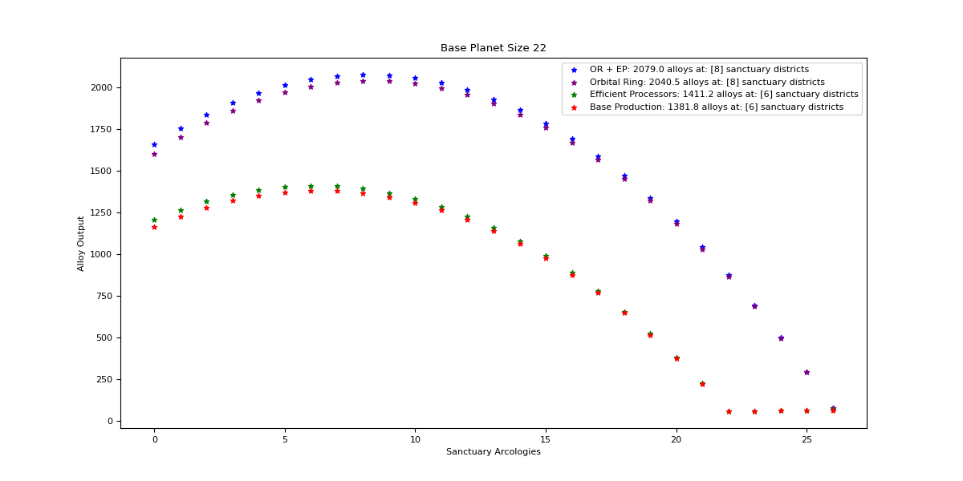

Orbital Ring + Efficient Processors

Optimal: 8

|  |  |  |  |  |
| --- | --- | --- | --- | --- |
| Sanctuary Districts | Alloys | Minerals | Food | Consumer Goods |
| 0 | 1659 | 2433.2 | 0 | 0 |
| 1 | 1755.6 | 2340.8 | 15 | 15 |
| 2 | 1839.6 | 2248.4 | 30 | 30 |
| 3 | 1911 | 2156 | 45 | 45 |
| 4 | 1969.8 | 2063.6 | 60 | 60 |
| 5 | 2016 | 1971.2 | 75 | 75 |
| 6 | 2049.6 | 1878.8 | 90 | 90 |
| 7 | 2070.6 | 1786.4 | 105 | 105 |
| 8 | 2079 | 1694 | 120 | 120 |
| 9 | 2074.8 | 1601.6 | 135 | 135 |
| 10 | 2058 | 1509.2 | 150 | 150 |
| 11 | 2028.6 | 1416.8 | 165 | 165 |
| 12 | 1986.6 | 1324.4 | 180 | 180 |
| 13 | 1932 | 1232 | 195 | 195 |
| 14 | 1864.8 | 1139.6 | 210 | 210 |
| 15 | 1785 | 1047.2 | 225 | 225 |
| 16 | 1692.6 | 954.8 | 240 | 240 |
| 17 | 1587.6 | 862.4 | 255 | 255 |
| 18 | 1470 | 770 | 270 | 270 |
| 19 | 1339.8 | 677.6 | 285 | 285 |
| 20 | 1197 | 585.2 | 300 | 300 |
| 21 | 1041.6 | 492.8 | 315 | 315 |
| 22 | 873.6 | 400.4 | 330 | 330 |
| 23 | 693 | 308 | 345 | 345 |
| 24 | 499.8 | 215.6 | 360 | 360 |
| 25 | 294 | 123.2 | 375 | 375 |
| 26 | 75.6 | 30.8 | 390 | 390 |

Orbital Ring

Optimal: 8

|  |  |  |  |  |
| --- | --- | --- | --- | --- |
| Sanctuary Districts | Alloys | Minerals | Food | Consumer Goods |
| 0 | 1603.7 | 2433.2 | 0 | 0 |
| 1 | 1702.4 | 2340.8 | 15 | 15 |
| 2 | 1788.5 | 2248.4 | 30 | 30 |
| 3 | 1862 | 2156 | 45 | 45 |
| 4 | 1922.9 | 2063.6 | 60 | 60 |
| 5 | 1971.2 | 1971.2 | 75 | 75 |
| 6 | 2006.9 | 1878.8 | 90 | 90 |
| 7 | 2030 | 1786.4 | 105 | 105 |
| 8 | 2040.5 | 1694 | 120 | 120 |
| 9 | 2038.4 | 1601.6 | 135 | 135 |
| 10 | 2023.7 | 1509.2 | 150 | 150 |
| 11 | 1996.4 | 1416.8 | 165 | 165 |
| 12 | 1956.5 | 1324.4 | 180 | 180 |
| 13 | 1904 | 1232 | 195 | 195 |
| 14 | 1838.9 | 1139.6 | 210 | 210 |
| 15 | 1761.2 | 1047.2 | 225 | 225 |
| 16 | 1670.9 | 954.8 | 240 | 240 |
| 17 | 1568 | 862.4 | 255 | 255 |
| 18 | 1452.5 | 770 | 270 | 270 |
| 19 | 1324.4 | 677.6 | 285 | 285 |
| 20 | 1183.7 | 585.2 | 300 | 300 |
| 21 | 1030.4 | 492.8 | 315 | 315 |
| 22 | 864.5 | 400.4 | 330 | 330 |
| 23 | 686 | 308 | 345 | 345 |
| 24 | 494.9 | 215.6 | 360 | 360 |
| 25 | 291.2 | 123.2 | 375 | 375 |
| 26 | 74.9 | 30.8 | 390 | 390 |

Efficient Processors

Optimal: 6

|  |  |  |  |  |
| --- | --- | --- | --- | --- |
| Sanctuary Districts | Alloys | Minerals | Food | Consumer Goods |
| 0 | 1206 | 1768.8 | 0 | 0 |
| 1 | 1267.2 | 1689.6 | 15 | 15 |
| 2 | 1317.6 | 1610.4 | 30 | 30 |
| 3 | 1357.2 | 1531.2 | 45 | 45 |
| 4 | 1386 | 1452 | 60 | 60 |
| 5 | 1404 | 1372.8 | 75 | 75 |
| 6 | 1411.2 | 1293.6 | 90 | 90 |
| 7 | 1407.6 | 1214.4 | 105 | 105 |
| 8 | 1393.2 | 1135.2 | 120 | 120 |
| 9 | 1368 | 1056 | 135 | 135 |
| 10 | 1332 | 976.8 | 150 | 150 |
| 11 | 1285.2 | 897.6 | 165 | 165 |
| 12 | 1227.6 | 818.4 | 180 | 180 |
| 13 | 1159.2 | 739.2 | 195 | 195 |
| 14 | 1080 | 660 | 210 | 210 |
| 15 | 990 | 580.8 | 225 | 225 |
| 16 | 889.2 | 501.6 | 240 | 240 |
| 17 | 777.6 | 422.4 | 255 | 255 |
| 18 | 655.2 | 343.2 | 270 | 270 |
| 19 | 522 | 264 | 285 | 285 |
| 20 | 378 | 184.8 | 300 | 300 |
| 21 | 223.2 | 105.6 | 315 | 315 |
| 22 | 57.6 | 26.4 | 330 | 330 |

Base Production

Optimal: 6

|  |  |  |  |  |
| --- | --- | --- | --- | --- |
| Sanctuary Districts | Alloys | Minerals | Food | Consumer Goods |
| 0 | 1165.8 | 1768.8 | 0 | 0 |
| 1 | 1228.8 | 1689.6 | 15 | 15 |
| 2 | 1281 | 1610.4 | 30 | 30 |
| 3 | 1322.4 | 1531.2 | 45 | 45 |
| 4 | 1353 | 1452 | 60 | 60 |
| 5 | 1372.8 | 1372.8 | 75 | 75 |
| 6 | 1381.8 | 1293.6 | 90 | 90 |
| 7 | 1380 | 1214.4 | 105 | 105 |
| 8 | 1367.4 | 1135.2 | 120 | 120 |
| 9 | 1344 | 1056 | 135 | 135 |
| 10 | 1309.8 | 976.8 | 150 | 150 |
| 11 | 1264.8 | 897.6 | 165 | 165 |
| 12 | 1209 | 818.4 | 180 | 180 |
| 13 | 1142.4 | 739.2 | 195 | 195 |
| 14 | 1065 | 660 | 210 | 210 |
| 15 | 976.8 | 580.8 | 225 | 225 |
| 16 | 877.8 | 501.6 | 240 | 240 |
| 17 | 768 | 422.4 | 255 | 255 |
| 18 | 647.4 | 343.2 | 270 | 270 |
| 19 | 516 | 264 | 285 | 285 |
| 20 | 373.8 | 184.8 | 300 | 300 |
| 21 | 220.8 | 105.6 | 315 | 315 |
| 22 | 57 | 26.4 | 330 | 330 |

## Size 23

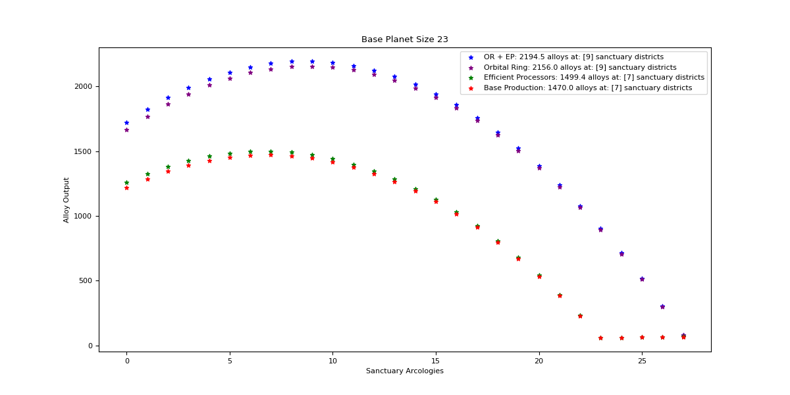

Orbital Ring + Efficient Processors

Optimal: 9

|  |  |  |  |  |
| --- | --- | --- | --- | --- |
| Sanctuary Districts | Alloys | Minerals | Food | Consumer Goods |
| 0 | 1722 | 2525.6 | 0 | 0 |
| 1 | 1824.9 | 2433.2 | 15 | 15 |
| 2 | 1915.2 | 2340.8 | 30 | 30 |
| 3 | 1992.9 | 2248.4 | 45 | 45 |
| 4 | 2058 | 2156 | 60 | 60 |
| 5 | 2110.5 | 2063.6 | 75 | 75 |
| 6 | 2150.4 | 1971.2 | 90 | 90 |
| 7 | 2177.7 | 1878.8 | 105 | 105 |
| 8 | 2192.4 | 1786.4 | 120 | 120 |
| 9 | 2194.5 | 1694 | 135 | 135 |
| 10 | 2184 | 1601.6 | 150 | 150 |
| 11 | 2160.9 | 1509.2 | 165 | 165 |
| 12 | 2125.2 | 1416.8 | 180 | 180 |
| 13 | 2076.9 | 1324.4 | 195 | 195 |
| 14 | 2016 | 1232 | 210 | 210 |
| 15 | 1942.5 | 1139.6 | 225 | 225 |
| 16 | 1856.4 | 1047.2 | 240 | 240 |
| 17 | 1757.7 | 954.8 | 255 | 255 |
| 18 | 1646.4 | 862.4 | 270 | 270 |
| 19 | 1522.5 | 770 | 285 | 285 |
| 20 | 1386 | 677.6 | 300 | 300 |
| 21 | 1236.9 | 585.2 | 315 | 315 |
| 22 | 1075.2 | 492.8 | 330 | 330 |
| 23 | 900.9 | 400.4 | 345 | 345 |
| 24 | 714 | 308 | 360 | 360 |
| 25 | 514.5 | 215.6 | 375 | 375 |
| 26 | 302.4 | 123.2 | 390 | 390 |
| 27 | 77.7 | 30.8 | 405 | 405 |

Orbital Ring

Optimal: 9

|  |  |  |  |  |
| --- | --- | --- | --- | --- |
| Sanctuary Districts | Alloys | Minerals | Food | Consumer Goods |
| 0 | 1664.6 | 2525.6 | 0 | 0 |
| 1 | 1769.6 | 2433.2 | 15 | 15 |
| 2 | 1862 | 2340.8 | 30 | 30 |
| 3 | 1941.8 | 2248.4 | 45 | 45 |
| 4 | 2009 | 2156 | 60 | 60 |
| 5 | 2063.6 | 2063.6 | 75 | 75 |
| 6 | 2105.6 | 1971.2 | 90 | 90 |
| 7 | 2135 | 1878.8 | 105 | 105 |
| 8 | 2151.8 | 1786.4 | 120 | 120 |
| 9 | 2156 | 1694 | 135 | 135 |
| 10 | 2147.6 | 1601.6 | 150 | 150 |
| 11 | 2126.6 | 1509.2 | 165 | 165 |
| 12 | 2093 | 1416.8 | 180 | 180 |
| 13 | 2046.8 | 1324.4 | 195 | 195 |
| 14 | 1988 | 1232 | 210 | 210 |
| 15 | 1916.6 | 1139.6 | 225 | 225 |
| 16 | 1832.6 | 1047.2 | 240 | 240 |
| 17 | 1736 | 954.8 | 255 | 255 |
| 18 | 1626.8 | 862.4 | 270 | 270 |
| 19 | 1505 | 770 | 285 | 285 |
| 20 | 1370.6 | 677.6 | 300 | 300 |
| 21 | 1223.6 | 585.2 | 315 | 315 |
| 22 | 1064 | 492.8 | 330 | 330 |
| 23 | 891.8 | 400.4 | 345 | 345 |
| 24 | 707 | 308 | 360 | 360 |
| 25 | 509.6 | 215.6 | 375 | 375 |
| 26 | 299.6 | 123.2 | 390 | 390 |
| 27 | 77 | 30.8 | 405 | 405 |

Efficient Processors

Optimal: 7

|  |  |  |  |  |
| --- | --- | --- | --- | --- |
| Sanctuary Districts | Alloys | Minerals | Food | Consumer Goods |
| 0 | 1260 | 1848 | 0 | 0 |
| 1 | 1326.6 | 1768.8 | 15 | 15 |
| 2 | 1382.4 | 1689.6 | 30 | 30 |
| 3 | 1427.4 | 1610.4 | 45 | 45 |
| 4 | 1461.6 | 1531.2 | 60 | 60 |
| 5 | 1485 | 1452 | 75 | 75 |
| 6 | 1497.6 | 1372.8 | 90 | 90 |
| 7 | 1499.4 | 1293.6 | 105 | 105 |
| 8 | 1490.4 | 1214.4 | 120 | 120 |
| 9 | 1470.6 | 1135.2 | 135 | 135 |
| 10 | 1440 | 1056 | 150 | 150 |
| 11 | 1398.6 | 976.8 | 165 | 165 |
| 12 | 1346.4 | 897.6 | 180 | 180 |
| 13 | 1283.4 | 818.4 | 195 | 195 |
| 14 | 1209.6 | 739.2 | 210 | 210 |
| 15 | 1125 | 660 | 225 | 225 |
| 16 | 1029.6 | 580.8 | 240 | 240 |
| 17 | 923.4 | 501.6 | 255 | 255 |
| 18 | 806.4 | 422.4 | 270 | 270 |
| 19 | 678.6 | 343.2 | 285 | 285 |
| 20 | 540 | 264 | 300 | 300 |
| 21 | 390.6 | 184.8 | 315 | 315 |
| 22 | 230.4 | 105.6 | 330 | 330 |
| 23 | 59.4 | 26.4 | 345 | 345 |

Base Production

Optimal: 7

|  |  |  |  |  |
| --- | --- | --- | --- | --- |
| Sanctuary Districts | Alloys | Minerals | Food | Consumer Goods |
| 0 | 1218 | 1848 | 0 | 0 |
| 1 | 1286.4 | 1768.8 | 15 | 15 |
| 2 | 1344 | 1689.6 | 30 | 30 |
| 3 | 1390.8 | 1610.4 | 45 | 45 |
| 4 | 1426.8 | 1531.2 | 60 | 60 |
| 5 | 1452 | 1452 | 75 | 75 |
| 6 | 1466.4 | 1372.8 | 90 | 90 |
| 7 | 1470 | 1293.6 | 105 | 105 |
| 8 | 1462.8 | 1214.4 | 120 | 120 |
| 9 | 1444.8 | 1135.2 | 135 | 135 |
| 10 | 1416 | 1056 | 150 | 150 |
| 11 | 1376.4 | 976.8 | 165 | 165 |
| 12 | 1326 | 897.6 | 180 | 180 |
| 13 | 1264.8 | 818.4 | 195 | 195 |
| 14 | 1192.8 | 739.2 | 210 | 210 |
| 15 | 1110 | 660 | 225 | 225 |
| 16 | 1016.4 | 580.8 | 240 | 240 |
| 17 | 912 | 501.6 | 255 | 255 |
| 18 | 796.8 | 422.4 | 270 | 270 |
| 19 | 670.8 | 343.2 | 285 | 285 |
| 20 | 534 | 264 | 300 | 300 |
| 21 | 386.4 | 184.8 | 315 | 315 |
| 22 | 228 | 105.6 | 330 | 330 |
| 23 | 58.8 | 26.4 | 345 | 345 |

## Size 24

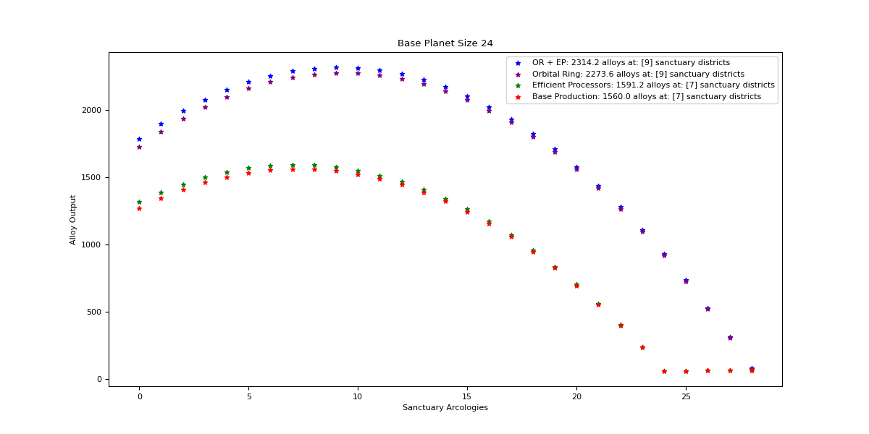

Orbital Ring + Efficient Processors

Optimal: 9

|  |  |  |  |  |
| --- | --- | --- | --- | --- |
| Sanctuary Districts | Alloys | Minerals | Food | Consumer Goods |
| 0 | 1785 | 2618 | 0 | 0 |
| 1 | 1894.2 | 2525.6 | 15 | 15 |
| 2 | 1990.8 | 2433.2 | 30 | 30 |
| 3 | 2074.8 | 2340.8 | 45 | 45 |
| 4 | 2146.2 | 2248.4 | 60 | 60 |
| 5 | 2205 | 2156 | 75 | 75 |
| 6 | 2251.2 | 2063.6 | 90 | 90 |
| 7 | 2284.8 | 1971.2 | 105 | 105 |
| 8 | 2305.8 | 1878.8 | 120 | 120 |
| 9 | 2314.2 | 1786.4 | 135 | 135 |
| 10 | 2310 | 1694 | 150 | 150 |
| 11 | 2293.2 | 1601.6 | 165 | 165 |
| 12 | 2263.8 | 1509.2 | 180 | 180 |
| 13 | 2221.8 | 1416.8 | 195 | 195 |
| 14 | 2167.2 | 1324.4 | 210 | 210 |
| 15 | 2100 | 1232 | 225 | 225 |
| 16 | 2020.2 | 1139.6 | 240 | 240 |
| 17 | 1927.8 | 1047.2 | 255 | 255 |
| 18 | 1822.8 | 954.8 | 270 | 270 |
| 19 | 1705.2 | 862.4 | 285 | 285 |
| 20 | 1575 | 770 | 300 | 300 |
| 21 | 1432.2 | 677.6 | 315 | 315 |
| 22 | 1276.8 | 585.2 | 330 | 330 |
| 23 | 1108.8 | 492.8 | 345 | 345 |
| 24 | 928.2 | 400.4 | 360 | 360 |
| 25 | 735 | 308 | 375 | 375 |
| 26 | 529.2 | 215.6 | 390 | 390 |
| 27 | 310.8 | 123.2 | 405 | 405 |
| 28 | 79.8 | 30.8 | 420 | 420 |

Orbital Ring

Optimal: 9

|  |  |  |  |  |
| --- | --- | --- | --- | --- |
| Sanctuary Districts | Alloys | Minerals | Food | Consumer Goods |
| 0 | 1725.5 | 2618 | 0 | 0 |
| 1 | 1836.8 | 2525.6 | 15 | 15 |
| 2 | 1935.5 | 2433.2 | 30 | 30 |
| 3 | 2021.6 | 2340.8 | 45 | 45 |
| 4 | 2095.1 | 2248.4 | 60 | 60 |
| 5 | 2156 | 2156 | 75 | 75 |
| 6 | 2204.3 | 2063.6 | 90 | 90 |
| 7 | 2240 | 1971.2 | 105 | 105 |
| 8 | 2263.1 | 1878.8 | 120 | 120 |
| 9 | 2273.6 | 1786.4 | 135 | 135 |
| 10 | 2271.5 | 1694 | 150 | 150 |
| 11 | 2256.8 | 1601.6 | 165 | 165 |
| 12 | 2229.5 | 1509.2 | 180 | 180 |
| 13 | 2189.6 | 1416.8 | 195 | 195 |
| 14 | 2137.1 | 1324.4 | 210 | 210 |
| 15 | 2072 | 1232 | 225 | 225 |
| 16 | 1994.3 | 1139.6 | 240 | 240 |
| 17 | 1904 | 1047.2 | 255 | 255 |
| 18 | 1801.1 | 954.8 | 270 | 270 |
| 19 | 1685.6 | 862.4 | 285 | 285 |
| 20 | 1557.5 | 770 | 300 | 300 |
| 21 | 1416.8 | 677.6 | 315 | 315 |
| 22 | 1263.5 | 585.2 | 330 | 330 |
| 23 | 1097.6 | 492.8 | 345 | 345 |
| 24 | 919.1 | 400.4 | 360 | 360 |
| 25 | 728 | 308 | 375 | 375 |
| 26 | 524.3 | 215.6 | 390 | 390 |
| 27 | 308 | 123.2 | 405 | 405 |
| 28 | 79.1 | 30.8 | 420 | 420 |

Efficient Processors

Optimal: 7

|  |  |  |  |  |
| --- | --- | --- | --- | --- |
| Sanctuary Districts | Alloys | Minerals | Food | Consumer Goods |
| 0 | 1314 | 1927.2 | 0 | 0 |
| 1 | 1386 | 1848 | 15 | 15 |
| 2 | 1447.2 | 1768.8 | 30 | 30 |
| 3 | 1497.6 | 1689.6 | 45 | 45 |
| 4 | 1537.2 | 1610.4 | 60 | 60 |
| 5 | 1566 | 1531.2 | 75 | 75 |
| 6 | 1584 | 1452 | 90 | 90 |
| 7 | 1591.2 | 1372.8 | 105 | 105 |
| 8 | 1587.6 | 1293.6 | 120 | 120 |
| 9 | 1573.2 | 1214.4 | 135 | 135 |
| 10 | 1548 | 1135.2 | 150 | 150 |
| 11 | 1512 | 1056 | 165 | 165 |
| 12 | 1465.2 | 976.8 | 180 | 180 |
| 13 | 1407.6 | 897.6 | 195 | 195 |
| 14 | 1339.2 | 818.4 | 210 | 210 |
| 15 | 1260 | 739.2 | 225 | 225 |
| 16 | 1170 | 660 | 240 | 240 |
| 17 | 1069.2 | 580.8 | 255 | 255 |
| 18 | 957.6 | 501.6 | 270 | 270 |
| 19 | 835.2 | 422.4 | 285 | 285 |
| 20 | 702 | 343.2 | 300 | 300 |
| 21 | 558 | 264 | 315 | 315 |
| 22 | 403.2 | 184.8 | 330 | 330 |
| 23 | 237.6 | 105.6 | 345 | 345 |
| 24 | 61.2 | 26.4 | 360 | 360 |

Base Production

Optimal: 7

|  |  |  |  |  |
| --- | --- | --- | --- | --- |
| Sanctuary Districts | Alloys | Minerals | Food | Consumer Goods |
| 0 | 1270.2 | 1927.2 | 0 | 0 |
| 1 | 1344 | 1848 | 15 | 15 |
| 2 | 1407 | 1768.8 | 30 | 30 |
| 3 | 1459.2 | 1689.6 | 45 | 45 |
| 4 | 1500.6 | 1610.4 | 60 | 60 |
| 5 | 1531.2 | 1531.2 | 75 | 75 |
| 6 | 1551 | 1452 | 90 | 90 |
| 7 | 1560 | 1372.8 | 105 | 105 |
| 8 | 1558.2 | 1293.6 | 120 | 120 |
| 9 | 1545.6 | 1214.4 | 135 | 135 |
| 10 | 1522.2 | 1135.2 | 150 | 150 |
| 11 | 1488 | 1056 | 165 | 165 |
| 12 | 1443 | 976.8 | 180 | 180 |
| 13 | 1387.2 | 897.6 | 195 | 195 |
| 14 | 1320.6 | 818.4 | 210 | 210 |
| 15 | 1243.2 | 739.2 | 225 | 225 |
| 16 | 1155 | 660 | 240 | 240 |
| 17 | 1056 | 580.8 | 255 | 255 |
| 18 | 946.2 | 501.6 | 270 | 270 |
| 19 | 825.6 | 422.4 | 285 | 285 |
| 20 | 694.2 | 343.2 | 300 | 300 |
| 21 | 552 | 264 | 315 | 315 |
| 22 | 399 | 184.8 | 330 | 330 |
| 23 | 235.2 | 105.6 | 345 | 345 |
| 24 | 60.6 | 26.4 | 360 | 360 |

## Size 25

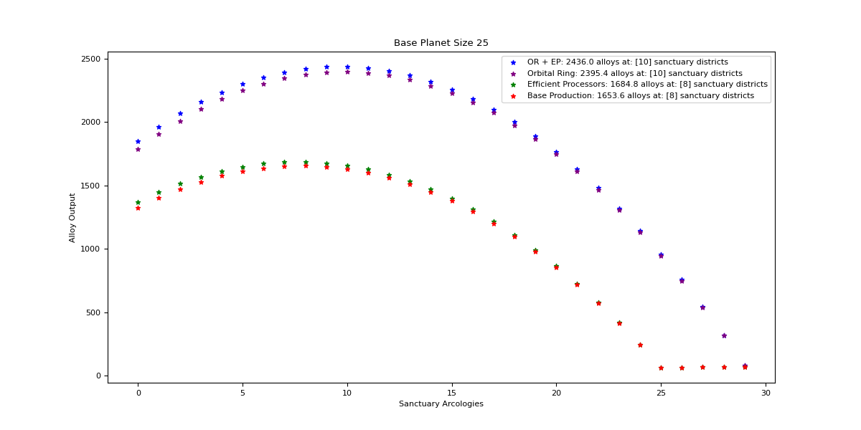

Orbital Ring + Efficient Processors

Optimal: 10

|  |  |  |  |  |
| --- | --- | --- | --- | --- |
| Sanctuary Districts | Alloys | Minerals | Food | Consumer Goods |
| 0 | 1848 | 2710.4 | 0 | 0 |
| 1 | 1963.5 | 2618 | 15 | 15 |
| 2 | 2066.4 | 2525.6 | 30 | 30 |
| 3 | 2156.7 | 2433.2 | 45 | 45 |
| 4 | 2234.4 | 2340.8 | 60 | 60 |
| 5 | 2299.5 | 2248.4 | 75 | 75 |
| 6 | 2352 | 2156 | 90 | 90 |
| 7 | 2391.9 | 2063.6 | 105 | 105 |
| 8 | 2419.2 | 1971.2 | 120 | 120 |
| 9 | 2433.9 | 1878.8 | 135 | 135 |
| 10 | 2436 | 1786.4 | 150 | 150 |
| 11 | 2425.5 | 1694 | 165 | 165 |
| 12 | 2402.4 | 1601.6 | 180 | 180 |
| 13 | 2366.7 | 1509.2 | 195 | 195 |
| 14 | 2318.4 | 1416.8 | 210 | 210 |
| 15 | 2257.5 | 1324.4 | 225 | 225 |
| 16 | 2184 | 1232 | 240 | 240 |
| 17 | 2097.9 | 1139.6 | 255 | 255 |
| 18 | 1999.2 | 1047.2 | 270 | 270 |
| 19 | 1887.9 | 954.8 | 285 | 285 |
| 20 | 1764 | 862.4 | 300 | 300 |
| 21 | 1627.5 | 770 | 315 | 315 |
| 22 | 1478.4 | 677.6 | 330 | 330 |
| 23 | 1316.7 | 585.2 | 345 | 345 |
| 24 | 1142.4 | 492.8 | 360 | 360 |
| 25 | 955.5 | 400.4 | 375 | 375 |
| 26 | 756 | 308 | 390 | 390 |
| 27 | 543.9 | 215.6 | 405 | 405 |
| 28 | 319.2 | 123.2 | 420 | 420 |
| 29 | 81.9 | 30.8 | 435 | 435 |

Orbital Ring

Optimal: 10

|  |  |  |  |  |
| --- | --- | --- | --- | --- |
| Sanctuary Districts | Alloys | Minerals | Food | Consumer Goods |
| 0 | 1786.4 | 2710.4 | 0 | 0 |
| 1 | 1904 | 2618 | 15 | 15 |
| 2 | 2009 | 2525.6 | 30 | 30 |
| 3 | 2101.4 | 2433.2 | 45 | 45 |
| 4 | 2181.2 | 2340.8 | 60 | 60 |
| 5 | 2248.4 | 2248.4 | 75 | 75 |
| 6 | 2303 | 2156 | 90 | 90 |
| 7 | 2345 | 2063.6 | 105 | 105 |
| 8 | 2374.4 | 1971.2 | 120 | 120 |
| 9 | 2391.2 | 1878.8 | 135 | 135 |
| 10 | 2395.4 | 1786.4 | 150 | 150 |
| 11 | 2387 | 1694 | 165 | 165 |
| 12 | 2366 | 1601.6 | 180 | 180 |
| 13 | 2332.4 | 1509.2 | 195 | 195 |
| 14 | 2286.2 | 1416.8 | 210 | 210 |
| 15 | 2227.4 | 1324.4 | 225 | 225 |
| 16 | 2156 | 1232 | 240 | 240 |
| 17 | 2072 | 1139.6 | 255 | 255 |
| 18 | 1975.4 | 1047.2 | 270 | 270 |
| 19 | 1866.2 | 954.8 | 285 | 285 |
| 20 | 1744.4 | 862.4 | 300 | 300 |
| 21 | 1610 | 770 | 315 | 315 |
| 22 | 1463 | 677.6 | 330 | 330 |
| 23 | 1303.4 | 585.2 | 345 | 345 |
| 24 | 1131.2 | 492.8 | 360 | 360 |
| 25 | 946.4 | 400.4 | 375 | 375 |
| 26 | 749 | 308 | 390 | 390 |
| 27 | 539 | 215.6 | 405 | 405 |
| 28 | 316.4 | 123.2 | 420 | 420 |
| 29 | 81.2 | 30.8 | 435 | 435 |

Efficient Processors

Optimal: 8

|  |  |  |  |  |
| --- | --- | --- | --- | --- |
| Sanctuary Districts | Alloys | Minerals | Food | Consumer Goods |
| 0 | 1368 | 2006.4 | 0 | 0 |
| 1 | 1445.4 | 1927.2 | 15 | 15 |
| 2 | 1512 | 1848 | 30 | 30 |
| 3 | 1567.8 | 1768.8 | 45 | 45 |
| 4 | 1612.8 | 1689.6 | 60 | 60 |
| 5 | 1647 | 1610.4 | 75 | 75 |
| 6 | 1670.4 | 1531.2 | 90 | 90 |
| 7 | 1683 | 1452 | 105 | 105 |
| 8 | 1684.8 | 1372.8 | 120 | 120 |
| 9 | 1675.8 | 1293.6 | 135 | 135 |
| 10 | 1656 | 1214.4 | 150 | 150 |
| 11 | 1625.4 | 1135.2 | 165 | 165 |
| 12 | 1584 | 1056 | 180 | 180 |
| 13 | 1531.8 | 976.8 | 195 | 195 |
| 14 | 1468.8 | 897.6 | 210 | 210 |
| 15 | 1395 | 818.4 | 225 | 225 |
| 16 | 1310.4 | 739.2 | 240 | 240 |
| 17 | 1215 | 660 | 255 | 255 |
| 18 | 1108.8 | 580.8 | 270 | 270 |
| 19 | 991.8 | 501.6 | 285 | 285 |
| 20 | 864 | 422.4 | 300 | 300 |
| 21 | 725.4 | 343.2 | 315 | 315 |
| 22 | 576 | 264 | 330 | 330 |
| 23 | 415.8 | 184.8 | 345 | 345 |
| 24 | 244.8 | 105.6 | 360 | 360 |
| 25 | 63 | 26.4 | 375 | 375 |

Base Production

Optimal: 8

|  |  |  |  |  |
| --- | --- | --- | --- | --- |
| Sanctuary Districts | Alloys | Minerals | Food | Consumer Goods |
| 0 | 1322.4 | 2006.4 | 0 | 0 |
| 1 | 1401.6 | 1927.2 | 15 | 15 |
| 2 | 1470 | 1848 | 30 | 30 |
| 3 | 1527.6 | 1768.8 | 45 | 45 |
| 4 | 1574.4 | 1689.6 | 60 | 60 |
| 5 | 1610.4 | 1610.4 | 75 | 75 |
| 6 | 1635.6 | 1531.2 | 90 | 90 |
| 7 | 1650 | 1452 | 105 | 105 |
| 8 | 1653.6 | 1372.8 | 120 | 120 |
| 9 | 1646.4 | 1293.6 | 135 | 135 |
| 10 | 1628.4 | 1214.4 | 150 | 150 |
| 11 | 1599.6 | 1135.2 | 165 | 165 |
| 12 | 1560 | 1056 | 180 | 180 |
| 13 | 1509.6 | 976.8 | 195 | 195 |
| 14 | 1448.4 | 897.6 | 210 | 210 |
| 15 | 1376.4 | 818.4 | 225 | 225 |
| 16 | 1293.6 | 739.2 | 240 | 240 |
| 17 | 1200 | 660 | 255 | 255 |
| 18 | 1095.6 | 580.8 | 270 | 270 |
| 19 | 980.4 | 501.6 | 285 | 285 |
| 20 | 854.4 | 422.4 | 300 | 300 |
| 21 | 717.6 | 343.2 | 315 | 315 |
| 22 | 570 | 264 | 330 | 330 |
| 23 | 411.6 | 184.8 | 345 | 345 |
| 24 | 242.4 | 105.6 | 360 | 360 |
| 25 | 62.4 | 26.4 | 375 | 375 |

## Size 26

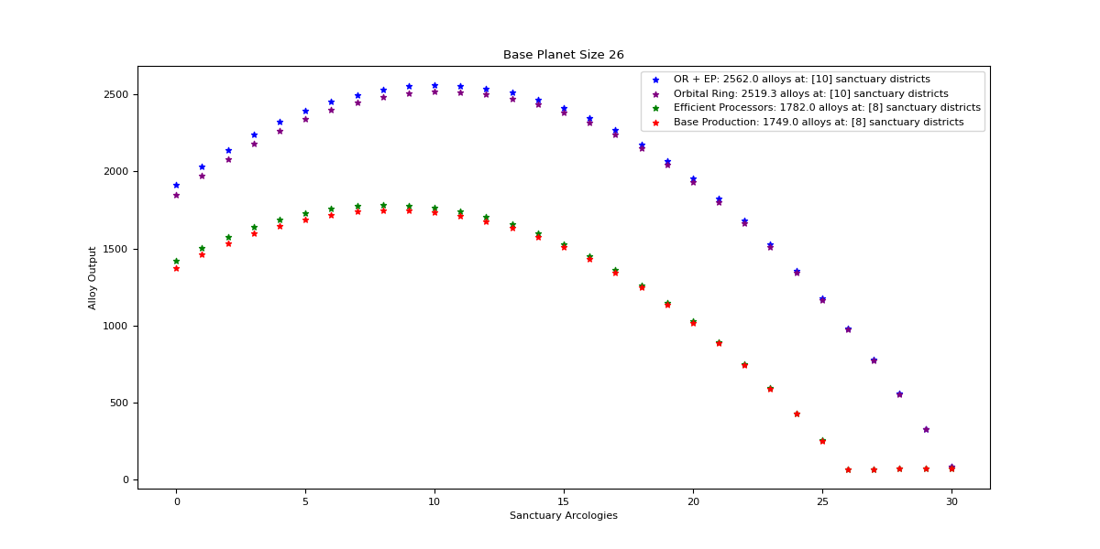

Orbital Ring + Efficient Processors

Optimal: 10

|  |  |  |  |  |
| --- | --- | --- | --- | --- |
| Sanctuary Districts | Alloys | Minerals | Food | Consumer Goods |
| 0 | 1911 | 2802.8 | 0 | 0 |
| 1 | 2032.8 | 2710.4 | 15 | 15 |
| 2 | 2142 | 2618 | 30 | 30 |
| 3 | 2238.6 | 2525.6 | 45 | 45 |
| 4 | 2322.6 | 2433.2 | 60 | 60 |
| 5 | 2394 | 2340.8 | 75 | 75 |
| 6 | 2452.8 | 2248.4 | 90 | 90 |
| 7 | 2499 | 2156 | 105 | 105 |
| 8 | 2532.6 | 2063.6 | 120 | 120 |
| 9 | 2553.6 | 1971.2 | 135 | 135 |
| 10 | 2562 | 1878.8 | 150 | 150 |
| 11 | 2557.8 | 1786.4 | 165 | 165 |
| 12 | 2541 | 1694 | 180 | 180 |
| 13 | 2511.6 | 1601.6 | 195 | 195 |
| 14 | 2469.6 | 1509.2 | 210 | 210 |
| 15 | 2415 | 1416.8 | 225 | 225 |
| 16 | 2347.8 | 1324.4 | 240 | 240 |
| 17 | 2268 | 1232 | 255 | 255 |
| 18 | 2175.6 | 1139.6 | 270 | 270 |
| 19 | 2070.6 | 1047.2 | 285 | 285 |
| 20 | 1953 | 954.8 | 300 | 300 |
| 21 | 1822.8 | 862.4 | 315 | 315 |
| 22 | 1680 | 770 | 330 | 330 |
| 23 | 1524.6 | 677.6 | 345 | 345 |
| 24 | 1356.6 | 585.2 | 360 | 360 |
| 25 | 1176 | 492.8 | 375 | 375 |
| 26 | 982.8 | 400.4 | 390 | 390 |
| 27 | 777 | 308 | 405 | 405 |
| 28 | 558.6 | 215.6 | 420 | 420 |
| 29 | 327.6 | 123.2 | 435 | 435 |
| 30 | 84 | 30.8 | 450 | 450 |

Orbital Ring

Optimal: 10

|  |  |  |  |  |
| --- | --- | --- | --- | --- |
| Sanctuary Districts | Alloys | Minerals | Food | Consumer Goods |
| 0 | 1847.3 | 2802.8 | 0 | 0 |
| 1 | 1971.2 | 2710.4 | 15 | 15 |
| 2 | 2082.5 | 2618 | 30 | 30 |
| 3 | 2181.2 | 2525.6 | 45 | 45 |
| 4 | 2267.3 | 2433.2 | 60 | 60 |
| 5 | 2340.8 | 2340.8 | 75 | 75 |
| 6 | 2401.7 | 2248.4 | 90 | 90 |
| 7 | 2450 | 2156 | 105 | 105 |
| 8 | 2485.7 | 2063.6 | 120 | 120 |
| 9 | 2508.8 | 1971.2 | 135 | 135 |
| 10 | 2519.3 | 1878.8 | 150 | 150 |
| 11 | 2517.2 | 1786.4 | 165 | 165 |
| 12 | 2502.5 | 1694 | 180 | 180 |
| 13 | 2475.2 | 1601.6 | 195 | 195 |
| 14 | 2435.3 | 1509.2 | 210 | 210 |
| 15 | 2382.8 | 1416.8 | 225 | 225 |
| 16 | 2317.7 | 1324.4 | 240 | 240 |
| 17 | 2240 | 1232 | 255 | 255 |
| 18 | 2149.7 | 1139.6 | 270 | 270 |
| 19 | 2046.8 | 1047.2 | 285 | 285 |
| 20 | 1931.3 | 954.8 | 300 | 300 |
| 21 | 1803.2 | 862.4 | 315 | 315 |
| 22 | 1662.5 | 770 | 330 | 330 |
| 23 | 1509.2 | 677.6 | 345 | 345 |
| 24 | 1343.3 | 585.2 | 360 | 360 |
| 25 | 1164.8 | 492.8 | 375 | 375 |
| 26 | 973.7 | 400.4 | 390 | 390 |
| 27 | 770 | 308 | 405 | 405 |
| 28 | 553.7 | 215.6 | 420 | 420 |
| 29 | 324.8 | 123.2 | 435 | 435 |
| 30 | 83.3 | 30.8 | 450 | 450 |

Efficient Processors

Optimal: 8

|  |  |  |  |  |
| --- | --- | --- | --- | --- |
| Sanctuary Districts | Alloys | Minerals | Food | Consumer Goods |
| 0 | 1422 | 2085.6 | 0 | 0 |
| 1 | 1504.8 | 2006.4 | 15 | 15 |
| 2 | 1576.8 | 1927.2 | 30 | 30 |
| 3 | 1638 | 1848 | 45 | 45 |
| 4 | 1688.4 | 1768.8 | 60 | 60 |
| 5 | 1728 | 1689.6 | 75 | 75 |
| 6 | 1756.8 | 1610.4 | 90 | 90 |
| 7 | 1774.8 | 1531.2 | 105 | 105 |
| 8 | 1782 | 1452 | 120 | 120 |
| 9 | 1778.4 | 1372.8 | 135 | 135 |
| 10 | 1764 | 1293.6 | 150 | 150 |
| 11 | 1738.8 | 1214.4 | 165 | 165 |
| 12 | 1702.8 | 1135.2 | 180 | 180 |
| 13 | 1656 | 1056 | 195 | 195 |
| 14 | 1598.4 | 976.8 | 210 | 210 |
| 15 | 1530 | 897.6 | 225 | 225 |
| 16 | 1450.8 | 818.4 | 240 | 240 |
| 17 | 1360.8 | 739.2 | 255 | 255 |
| 18 | 1260 | 660 | 270 | 270 |
| 19 | 1148.4 | 580.8 | 285 | 285 |
| 20 | 1026 | 501.6 | 300 | 300 |
| 21 | 892.8 | 422.4 | 315 | 315 |
| 22 | 748.8 | 343.2 | 330 | 330 |
| 23 | 594 | 264 | 345 | 345 |
| 24 | 428.4 | 184.8 | 360 | 360 |
| 25 | 252 | 105.6 | 375 | 375 |
| 26 | 64.8 | 26.4 | 390 | 390 |

Base Production

Optimal: 8

|  |  |  |  |  |
| --- | --- | --- | --- | --- |
| Sanctuary Districts | Alloys | Minerals | Food | Consumer Goods |
| 0 | 1374.6 | 2085.6 | 0 | 0 |
| 1 | 1459.2 | 2006.4 | 15 | 15 |
| 2 | 1533 | 1927.2 | 30 | 30 |
| 3 | 1596 | 1848 | 45 | 45 |
| 4 | 1648.2 | 1768.8 | 60 | 60 |
| 5 | 1689.6 | 1689.6 | 75 | 75 |
| 6 | 1720.2 | 1610.4 | 90 | 90 |
| 7 | 1740 | 1531.2 | 105 | 105 |
| 8 | 1749 | 1452 | 120 | 120 |
| 9 | 1747.2 | 1372.8 | 135 | 135 |
| 10 | 1734.6 | 1293.6 | 150 | 150 |
| 11 | 1711.2 | 1214.4 | 165 | 165 |
| 12 | 1677 | 1135.2 | 180 | 180 |
| 13 | 1632 | 1056 | 195 | 195 |
| 14 | 1576.2 | 976.8 | 210 | 210 |
| 15 | 1509.6 | 897.6 | 225 | 225 |
| 16 | 1432.2 | 818.4 | 240 | 240 |
| 17 | 1344 | 739.2 | 255 | 255 |
| 18 | 1245 | 660 | 270 | 270 |
| 19 | 1135.2 | 580.8 | 285 | 285 |
| 20 | 1014.6 | 501.6 | 300 | 300 |
| 21 | 883.2 | 422.4 | 315 | 315 |
| 22 | 741 | 343.2 | 330 | 330 |
| 23 | 588 | 264 | 345 | 345 |
| 24 | 424.2 | 184.8 | 360 | 360 |
| 25 | 249.6 | 105.6 | 375 | 375 |
| 26 | 64.2 | 26.4 | 390 | 390 |

## Size 27

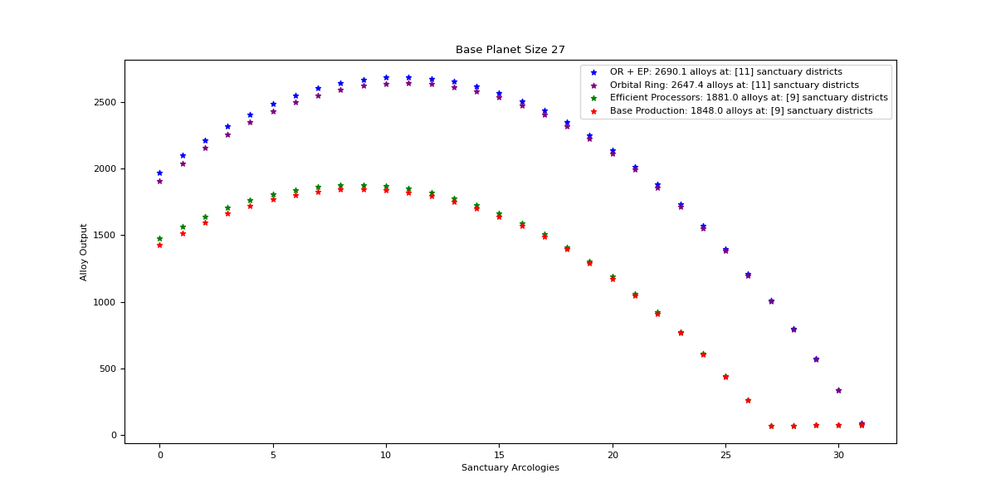

Orbital Ring + Efficient Processors

Optimal: 11

|  |  |  |  |  |
| --- | --- | --- | --- | --- |
| Sanctuary Districts | Alloys | Minerals | Food | Consumer Goods |
| 0 | 1974 | 2895.2 | 0 | 0 |
| 1 | 2102.1 | 2802.8 | 15 | 15 |
| 2 | 2217.6 | 2710.4 | 30 | 30 |
| 3 | 2320.5 | 2618 | 45 | 45 |
| 4 | 2410.8 | 2525.6 | 60 | 60 |
| 5 | 2488.5 | 2433.2 | 75 | 75 |
| 6 | 2553.6 | 2340.8 | 90 | 90 |
| 7 | 2606.1 | 2248.4 | 105 | 105 |
| 8 | 2646 | 2156 | 120 | 120 |
| 9 | 2673.3 | 2063.6 | 135 | 135 |
| 10 | 2688 | 1971.2 | 150 | 150 |
| 11 | 2690.1 | 1878.8 | 165 | 165 |
| 12 | 2679.6 | 1786.4 | 180 | 180 |
| 13 | 2656.5 | 1694 | 195 | 195 |
| 14 | 2620.8 | 1601.6 | 210 | 210 |
| 15 | 2572.5 | 1509.2 | 225 | 225 |
| 16 | 2511.6 | 1416.8 | 240 | 240 |
| 17 | 2438.1 | 1324.4 | 255 | 255 |
| 18 | 2352 | 1232 | 270 | 270 |
| 19 | 2253.3 | 1139.6 | 285 | 285 |
| 20 | 2142 | 1047.2 | 300 | 300 |
| 21 | 2018.1 | 954.8 | 315 | 315 |
| 22 | 1881.6 | 862.4 | 330 | 330 |
| 23 | 1732.5 | 770 | 345 | 345 |
| 24 | 1570.8 | 677.6 | 360 | 360 |
| 25 | 1396.5 | 585.2 | 375 | 375 |
| 26 | 1209.6 | 492.8 | 390 | 390 |
| 27 | 1010.1 | 400.4 | 405 | 405 |
| 28 | 798 | 308 | 420 | 420 |
| 29 | 573.3 | 215.6 | 435 | 435 |
| 30 | 336 | 123.2 | 450 | 450 |
| 31 | 86.1 | 30.8 | 465 | 465 |

Orbital Ring

Optimal: 11

|  |  |  |  |  |
| --- | --- | --- | --- | --- |
| Sanctuary Districts | Alloys | Minerals | Food | Consumer Goods |
| 0 | 1908.2 | 2895.2 | 0 | 0 |
| 1 | 2038.4 | 2802.8 | 15 | 15 |
| 2 | 2156 | 2710.4 | 30 | 30 |
| 3 | 2261 | 2618 | 45 | 45 |
| 4 | 2353.4 | 2525.6 | 60 | 60 |
| 5 | 2433.2 | 2433.2 | 75 | 75 |
| 6 | 2500.4 | 2340.8 | 90 | 90 |
| 7 | 2555 | 2248.4 | 105 | 105 |
| 8 | 2597 | 2156 | 120 | 120 |
| 9 | 2626.4 | 2063.6 | 135 | 135 |
| 10 | 2643.2 | 1971.2 | 150 | 150 |
| 11 | 2647.4 | 1878.8 | 165 | 165 |
| 12 | 2639 | 1786.4 | 180 | 180 |
| 13 | 2618 | 1694 | 195 | 195 |
| 14 | 2584.4 | 1601.6 | 210 | 210 |
| 15 | 2538.2 | 1509.2 | 225 | 225 |
| 16 | 2479.4 | 1416.8 | 240 | 240 |
| 17 | 2408 | 1324.4 | 255 | 255 |
| 18 | 2324 | 1232 | 270 | 270 |
| 19 | 2227.4 | 1139.6 | 285 | 285 |
| 20 | 2118.2 | 1047.2 | 300 | 300 |
| 21 | 1996.4 | 954.8 | 315 | 315 |
| 22 | 1862 | 862.4 | 330 | 330 |
| 23 | 1715 | 770 | 345 | 345 |
| 24 | 1555.4 | 677.6 | 360 | 360 |
| 25 | 1383.2 | 585.2 | 375 | 375 |
| 26 | 1198.4 | 492.8 | 390 | 390 |
| 27 | 1001 | 400.4 | 405 | 405 |
| 28 | 791 | 308 | 420 | 420 |
| 29 | 568.4 | 215.6 | 435 | 435 |
| 30 | 333.2 | 123.2 | 450 | 450 |
| 31 | 85.4 | 30.8 | 465 | 465 |

Efficient Processors

Optimal: 9

|  |  |  |  |  |
| --- | --- | --- | --- | --- |
| Sanctuary Districts | Alloys | Minerals | Food | Consumer Goods |
| 0 | 1476 | 2164.8 | 0 | 0 |
| 1 | 1564.2 | 2085.6 | 15 | 15 |
| 2 | 1641.6 | 2006.4 | 30 | 30 |
| 3 | 1708.2 | 1927.2 | 45 | 45 |
| 4 | 1764 | 1848 | 60 | 60 |
| 5 | 1809 | 1768.8 | 75 | 75 |
| 6 | 1843.2 | 1689.6 | 90 | 90 |
| 7 | 1866.6 | 1610.4 | 105 | 105 |
| 8 | 1879.2 | 1531.2 | 120 | 120 |
| 9 | 1881 | 1452 | 135 | 135 |
| 10 | 1872 | 1372.8 | 150 | 150 |
| 11 | 1852.2 | 1293.6 | 165 | 165 |
| 12 | 1821.6 | 1214.4 | 180 | 180 |
| 13 | 1780.2 | 1135.2 | 195 | 195 |
| 14 | 1728 | 1056 | 210 | 210 |
| 15 | 1665 | 976.8 | 225 | 225 |
| 16 | 1591.2 | 897.6 | 240 | 240 |
| 17 | 1506.6 | 818.4 | 255 | 255 |
| 18 | 1411.2 | 739.2 | 270 | 270 |
| 19 | 1305 | 660 | 285 | 285 |
| 20 | 1188 | 580.8 | 300 | 300 |
| 21 | 1060.2 | 501.6 | 315 | 315 |
| 22 | 921.6 | 422.4 | 330 | 330 |
| 23 | 772.2 | 343.2 | 345 | 345 |
| 24 | 612 | 264 | 360 | 360 |
| 25 | 441 | 184.8 | 375 | 375 |
| 26 | 259.2 | 105.6 | 390 | 390 |
| 27 | 66.6 | 26.4 | 405 | 405 |

Base Production

Optimal: 9

|  |  |  |  |  |
| --- | --- | --- | --- | --- |
| Sanctuary Districts | Alloys | Minerals | Food | Consumer Goods |
| 0 | 1426.8 | 2164.8 | 0 | 0 |
| 1 | 1516.8 | 2085.6 | 15 | 15 |
| 2 | 1596 | 2006.4 | 30 | 30 |
| 3 | 1664.4 | 1927.2 | 45 | 45 |
| 4 | 1722 | 1848 | 60 | 60 |
| 5 | 1768.8 | 1768.8 | 75 | 75 |
| 6 | 1804.8 | 1689.6 | 90 | 90 |
| 7 | 1830 | 1610.4 | 105 | 105 |
| 8 | 1844.4 | 1531.2 | 120 | 120 |
| 9 | 1848 | 1452 | 135 | 135 |
| 10 | 1840.8 | 1372.8 | 150 | 150 |
| 11 | 1822.8 | 1293.6 | 165 | 165 |
| 12 | 1794 | 1214.4 | 180 | 180 |
| 13 | 1754.4 | 1135.2 | 195 | 195 |
| 14 | 1704 | 1056 | 210 | 210 |
| 15 | 1642.8 | 976.8 | 225 | 225 |
| 16 | 1570.8 | 897.6 | 240 | 240 |
| 17 | 1488 | 818.4 | 255 | 255 |
| 18 | 1394.4 | 739.2 | 270 | 270 |
| 19 | 1290 | 660 | 285 | 285 |
| 20 | 1174.8 | 580.8 | 300 | 300 |
| 21 | 1048.8 | 501.6 | 315 | 315 |
| 22 | 912 | 422.4 | 330 | 330 |
| 23 | 764.4 | 343.2 | 345 | 345 |
| 24 | 606 | 264 | 360 | 360 |
| 25 | 436.8 | 184.8 | 375 | 375 |
| 26 | 256.8 | 105.6 | 390 | 390 |
| 27 | 66 | 26.4 | 405 | 405 |

## Size 28

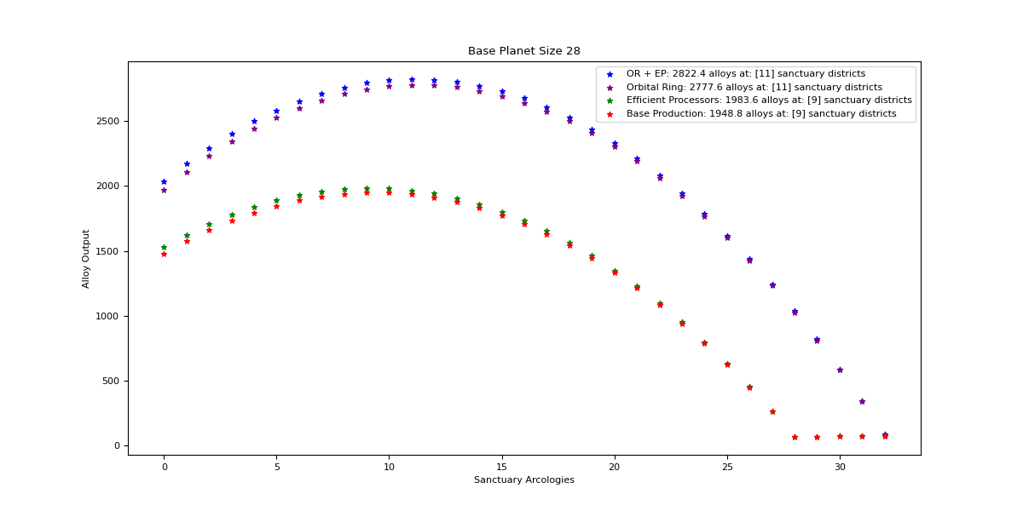

Orbital Ring + Efficient Processors

Optimal: 11

|  |  |  |  |  |
| --- | --- | --- | --- | --- |
| Sanctuary Districts | Alloys | Minerals | Food | Consumer Goods |
| 0 | 2037 | 2987.6 | 0 | 0 |
| 1 | 2171.4 | 2895.2 | 15 | 15 |
| 2 | 2293.2 | 2802.8 | 30 | 30 |
| 3 | 2402.4 | 2710.4 | 45 | 45 |
| 4 | 2499 | 2618 | 60 | 60 |
| 5 | 2583 | 2525.6 | 75 | 75 |
| 6 | 2654.4 | 2433.2 | 90 | 90 |
| 7 | 2713.2 | 2340.8 | 105 | 105 |
| 8 | 2759.4 | 2248.4 | 120 | 120 |
| 9 | 2793 | 2156 | 135 | 135 |
| 10 | 2814 | 2063.6 | 150 | 150 |
| 11 | 2822.4 | 1971.2 | 165 | 165 |
| 12 | 2818.2 | 1878.8 | 180 | 180 |
| 13 | 2801.4 | 1786.4 | 195 | 195 |
| 14 | 2772 | 1694 | 210 | 210 |
| 15 | 2730 | 1601.6 | 225 | 225 |
| 16 | 2675.4 | 1509.2 | 240 | 240 |
| 17 | 2608.2 | 1416.8 | 255 | 255 |
| 18 | 2528.4 | 1324.4 | 270 | 270 |
| 19 | 2436 | 1232 | 285 | 285 |
| 20 | 2331 | 1139.6 | 300 | 300 |
| 21 | 2213.4 | 1047.2 | 315 | 315 |
| 22 | 2083.2 | 954.8 | 330 | 330 |
| 23 | 1940.4 | 862.4 | 345 | 345 |
| 24 | 1785 | 770 | 360 | 360 |
| 25 | 1617 | 677.6 | 375 | 375 |
| 26 | 1436.4 | 585.2 | 390 | 390 |
| 27 | 1243.2 | 492.8 | 405 | 405 |
| 28 | 1037.4 | 400.4 | 420 | 420 |
| 29 | 819 | 308 | 435 | 435 |
| 30 | 588 | 215.6 | 450 | 450 |
| 31 | 344.4 | 123.2 | 465 | 465 |
| 32 | 88.2 | 30.8 | 480 | 480 |

Orbital Ring

Optimal: 11

|  |  |  |  |  |
| --- | --- | --- | --- | --- |
| Sanctuary Districts | Alloys | Minerals | Food | Consumer Goods |
| 0 | 1969.1 | 2987.6 | 0 | 0 |
| 1 | 2105.6 | 2895.2 | 15 | 15 |
| 2 | 2229.5 | 2802.8 | 30 | 30 |
| 3 | 2340.8 | 2710.4 | 45 | 45 |
| 4 | 2439.5 | 2618 | 60 | 60 |
| 5 | 2525.6 | 2525.6 | 75 | 75 |
| 6 | 2599.1 | 2433.2 | 90 | 90 |
| 7 | 2660 | 2340.8 | 105 | 105 |
| 8 | 2708.3 | 2248.4 | 120 | 120 |
| 9 | 2744 | 2156 | 135 | 135 |
| 10 | 2767.1 | 2063.6 | 150 | 150 |
| 11 | 2777.6 | 1971.2 | 165 | 165 |
| 12 | 2775.5 | 1878.8 | 180 | 180 |
| 13 | 2760.8 | 1786.4 | 195 | 195 |
| 14 | 2733.5 | 1694 | 210 | 210 |
| 15 | 2693.6 | 1601.6 | 225 | 225 |
| 16 | 2641.1 | 1509.2 | 240 | 240 |
| 17 | 2576 | 1416.8 | 255 | 255 |
| 18 | 2498.3 | 1324.4 | 270 | 270 |
| 19 | 2408 | 1232 | 285 | 285 |
| 20 | 2305.1 | 1139.6 | 300 | 300 |
| 21 | 2189.6 | 1047.2 | 315 | 315 |
| 22 | 2061.5 | 954.8 | 330 | 330 |
| 23 | 1920.8 | 862.4 | 345 | 345 |
| 24 | 1767.5 | 770 | 360 | 360 |
| 25 | 1601.6 | 677.6 | 375 | 375 |
| 26 | 1423.1 | 585.2 | 390 | 390 |
| 27 | 1232 | 492.8 | 405 | 405 |
| 28 | 1028.3 | 400.4 | 420 | 420 |
| 29 | 812 | 308 | 435 | 435 |
| 30 | 583.1 | 215.6 | 450 | 450 |
| 31 | 341.6 | 123.2 | 465 | 465 |
| 32 | 87.5 | 30.8 | 480 | 480 |

Efficient Processors

Optimal: 9

|  |  |  |  |  |
| --- | --- | --- | --- | --- |
| Sanctuary Districts | Alloys | Minerals | Food | Consumer Goods |
| 0 | 1530 | 2244 | 0 | 0 |
| 1 | 1623.6 | 2164.8 | 15 | 15 |
| 2 | 1706.4 | 2085.6 | 30 | 30 |
| 3 | 1778.4 | 2006.4 | 45 | 45 |
| 4 | 1839.6 | 1927.2 | 60 | 60 |
| 5 | 1890 | 1848 | 75 | 75 |
| 6 | 1929.6 | 1768.8 | 90 | 90 |
| 7 | 1958.4 | 1689.6 | 105 | 105 |
| 8 | 1976.4 | 1610.4 | 120 | 120 |
| 9 | 1983.6 | 1531.2 | 135 | 135 |
| 10 | 1980 | 1452 | 150 | 150 |
| 11 | 1965.6 | 1372.8 | 165 | 165 |
| 12 | 1940.4 | 1293.6 | 180 | 180 |
| 13 | 1904.4 | 1214.4 | 195 | 195 |
| 14 | 1857.6 | 1135.2 | 210 | 210 |
| 15 | 1800 | 1056 | 225 | 225 |
| 16 | 1731.6 | 976.8 | 240 | 240 |
| 17 | 1652.4 | 897.6 | 255 | 255 |
| 18 | 1562.4 | 818.4 | 270 | 270 |
| 19 | 1461.6 | 739.2 | 285 | 285 |
| 20 | 1350 | 660 | 300 | 300 |
| 21 | 1227.6 | 580.8 | 315 | 315 |
| 22 | 1094.4 | 501.6 | 330 | 330 |
| 23 | 950.4 | 422.4 | 345 | 345 |
| 24 | 795.6 | 343.2 | 360 | 360 |
| 25 | 630 | 264 | 375 | 375 |
| 26 | 453.6 | 184.8 | 390 | 390 |
| 27 | 266.4 | 105.6 | 405 | 405 |
| 28 | 68.4 | 26.4 | 420 | 420 |

Base Production

Optimal: 9

|  |  |  |  |  |
| --- | --- | --- | --- | --- |
| Sanctuary Districts | Alloys | Minerals | Food | Consumer Goods |
| 0 | 1479 | 2244 | 0 | 0 |
| 1 | 1574.4 | 2164.8 | 15 | 15 |
| 2 | 1659 | 2085.6 | 30 | 30 |
| 3 | 1732.8 | 2006.4 | 45 | 45 |
| 4 | 1795.8 | 1927.2 | 60 | 60 |
| 5 | 1848 | 1848 | 75 | 75 |
| 6 | 1889.4 | 1768.8 | 90 | 90 |
| 7 | 1920 | 1689.6 | 105 | 105 |
| 8 | 1939.8 | 1610.4 | 120 | 120 |
| 9 | 1948.8 | 1531.2 | 135 | 135 |
| 10 | 1947 | 1452 | 150 | 150 |
| 11 | 1934.4 | 1372.8 | 165 | 165 |
| 12 | 1911 | 1293.6 | 180 | 180 |
| 13 | 1876.8 | 1214.4 | 195 | 195 |
| 14 | 1831.8 | 1135.2 | 210 | 210 |
| 15 | 1776 | 1056 | 225 | 225 |
| 16 | 1709.4 | 976.8 | 240 | 240 |
| 17 | 1632 | 897.6 | 255 | 255 |
| 18 | 1543.8 | 818.4 | 270 | 270 |
| 19 | 1444.8 | 739.2 | 285 | 285 |
| 20 | 1335 | 660 | 300 | 300 |
| 21 | 1214.4 | 580.8 | 315 | 315 |
| 22 | 1083 | 501.6 | 330 | 330 |
| 23 | 940.8 | 422.4 | 345 | 345 |
| 24 | 787.8 | 343.2 | 360 | 360 |
| 25 | 624 | 264 | 375 | 375 |
| 26 | 449.4 | 184.8 | 390 | 390 |
| 27 | 264 | 105.6 | 405 | 405 |
| 28 | 67.8 | 26.4 | 420 | 420 |

## Size 29

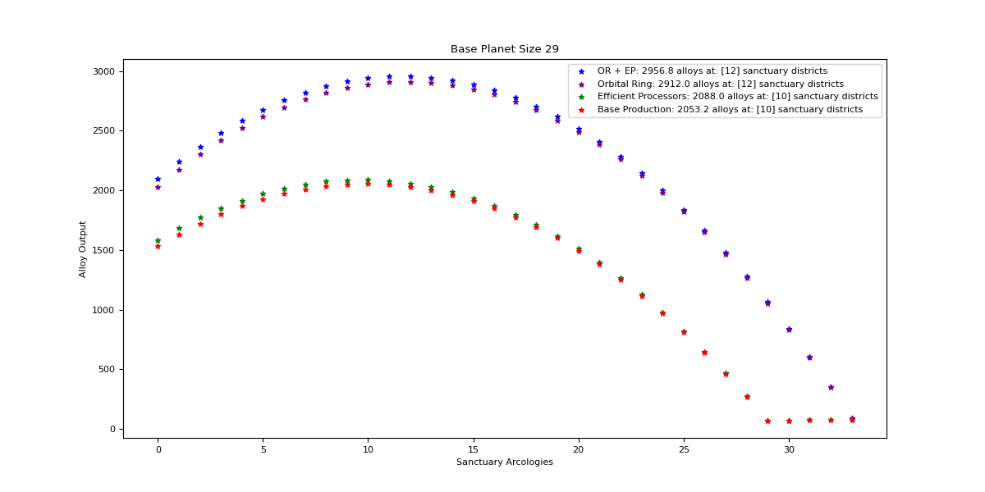

Orbital Ring + Efficient Processors

Optimal: 12

|  |  |  |  |  |
| --- | --- | --- | --- | --- |
| Sanctuary Districts | Alloys | Minerals | Food | Consumer Goods |
| 0 | 2100 | 3080 | 0 | 0 |
| 1 | 2240.7 | 2987.6 | 15 | 15 |
| 2 | 2368.8 | 2895.2 | 30 | 30 |
| 3 | 2484.3 | 2802.8 | 45 | 45 |
| 4 | 2587.2 | 2710.4 | 60 | 60 |
| 5 | 2677.5 | 2618 | 75 | 75 |
| 6 | 2755.2 | 2525.6 | 90 | 90 |
| 7 | 2820.3 | 2433.2 | 105 | 105 |
| 8 | 2872.8 | 2340.8 | 120 | 120 |
| 9 | 2912.7 | 2248.4 | 135 | 135 |
| 10 | 2940 | 2156 | 150 | 150 |
| 11 | 2954.7 | 2063.6 | 165 | 165 |
| 12 | 2956.8 | 1971.2 | 180 | 180 |
| 13 | 2946.3 | 1878.8 | 195 | 195 |
| 14 | 2923.2 | 1786.4 | 210 | 210 |
| 15 | 2887.5 | 1694 | 225 | 225 |
| 16 | 2839.2 | 1601.6 | 240 | 240 |
| 17 | 2778.3 | 1509.2 | 255 | 255 |
| 18 | 2704.8 | 1416.8 | 270 | 270 |
| 19 | 2618.7 | 1324.4 | 285 | 285 |
| 20 | 2520 | 1232 | 300 | 300 |
| 21 | 2408.7 | 1139.6 | 315 | 315 |
| 22 | 2284.8 | 1047.2 | 330 | 330 |
| 23 | 2148.3 | 954.8 | 345 | 345 |
| 24 | 1999.2 | 862.4 | 360 | 360 |
| 25 | 1837.5 | 770 | 375 | 375 |
| 26 | 1663.2 | 677.6 | 390 | 390 |
| 27 | 1476.3 | 585.2 | 405 | 405 |
| 28 | 1276.8 | 492.8 | 420 | 420 |
| 29 | 1064.7 | 400.4 | 435 | 435 |
| 30 | 840 | 308 | 450 | 450 |
| 31 | 602.7 | 215.6 | 465 | 465 |
| 32 | 352.8 | 123.2 | 480 | 480 |
| 33 | 90.3 | 30.8 | 495 | 495 |

Orbital Ring

Optimal: 12

|  |  |  |  |  |
| --- | --- | --- | --- | --- |
| Sanctuary Districts | Alloys | Minerals | Food | Consumer Goods |
| 0 | 2030 | 3080 | 0 | 0 |
| 1 | 2172.8 | 2987.6 | 15 | 15 |
| 2 | 2303 | 2895.2 | 30 | 30 |
| 3 | 2420.6 | 2802.8 | 45 | 45 |
| 4 | 2525.6 | 2710.4 | 60 | 60 |
| 5 | 2618 | 2618 | 75 | 75 |
| 6 | 2697.8 | 2525.6 | 90 | 90 |
| 7 | 2765 | 2433.2 | 105 | 105 |
| 8 | 2819.6 | 2340.8 | 120 | 120 |
| 9 | 2861.6 | 2248.4 | 135 | 135 |
| 10 | 2891 | 2156 | 150 | 150 |
| 11 | 2907.8 | 2063.6 | 165 | 165 |
| 12 | 2912 | 1971.2 | 180 | 180 |
| 13 | 2903.6 | 1878.8 | 195 | 195 |
| 14 | 2882.6 | 1786.4 | 210 | 210 |
| 15 | 2849 | 1694 | 225 | 225 |
| 16 | 2802.8 | 1601.6 | 240 | 240 |
| 17 | 2744 | 1509.2 | 255 | 255 |
| 18 | 2672.6 | 1416.8 | 270 | 270 |
| 19 | 2588.6 | 1324.4 | 285 | 285 |
| 20 | 2492 | 1232 | 300 | 300 |
| 21 | 2382.8 | 1139.6 | 315 | 315 |
| 22 | 2261 | 1047.2 | 330 | 330 |
| 23 | 2126.6 | 954.8 | 345 | 345 |
| 24 | 1979.6 | 862.4 | 360 | 360 |
| 25 | 1820 | 770 | 375 | 375 |
| 26 | 1647.8 | 677.6 | 390 | 390 |
| 27 | 1463 | 585.2 | 405 | 405 |
| 28 | 1265.6 | 492.8 | 420 | 420 |
| 29 | 1055.6 | 400.4 | 435 | 435 |
| 30 | 833 | 308 | 450 | 450 |
| 31 | 597.8 | 215.6 | 465 | 465 |
| 32 | 350 | 123.2 | 480 | 480 |
| 33 | 89.6 | 30.8 | 495 | 495 |

Efficient Processors

Optimal: 10

|  |  |  |  |  |
| --- | --- | --- | --- | --- |
| Sanctuary Districts | Alloys | Minerals | Food | Consumer Goods |
| 0 | 1584 | 2323.2 | 0 | 0 |
| 1 | 1683 | 2244 | 15 | 15 |
| 2 | 1771.2 | 2164.8 | 30 | 30 |
| 3 | 1848.6 | 2085.6 | 45 | 45 |
| 4 | 1915.2 | 2006.4 | 60 | 60 |
| 5 | 1971 | 1927.2 | 75 | 75 |
| 6 | 2016 | 1848 | 90 | 90 |
| 7 | 2050.2 | 1768.8 | 105 | 105 |
| 8 | 2073.6 | 1689.6 | 120 | 120 |
| 9 | 2086.2 | 1610.4 | 135 | 135 |
| 10 | 2088 | 1531.2 | 150 | 150 |
| 11 | 2079 | 1452 | 165 | 165 |
| 12 | 2059.2 | 1372.8 | 180 | 180 |
| 13 | 2028.6 | 1293.6 | 195 | 195 |
| 14 | 1987.2 | 1214.4 | 210 | 210 |
| 15 | 1935 | 1135.2 | 225 | 225 |
| 16 | 1872 | 1056 | 240 | 240 |
| 17 | 1798.2 | 976.8 | 255 | 255 |
| 18 | 1713.6 | 897.6 | 270 | 270 |
| 19 | 1618.2 | 818.4 | 285 | 285 |
| 20 | 1512 | 739.2 | 300 | 300 |
| 21 | 1395 | 660 | 315 | 315 |
| 22 | 1267.2 | 580.8 | 330 | 330 |
| 23 | 1128.6 | 501.6 | 345 | 345 |
| 24 | 979.2 | 422.4 | 360 | 360 |
| 25 | 819 | 343.2 | 375 | 375 |
| 26 | 648 | 264 | 390 | 390 |
| 27 | 466.2 | 184.8 | 405 | 405 |
| 28 | 273.6 | 105.6 | 420 | 420 |
| 29 | 70.2 | 26.4 | 435 | 435 |

Base Production

Optimal: 10

|  |  |  |  |  |
| --- | --- | --- | --- | --- |
| Sanctuary Districts | Alloys | Minerals | Food | Consumer Goods |
| 0 | 1531.2 | 2323.2 | 0 | 0 |
| 1 | 1632 | 2244 | 15 | 15 |
| 2 | 1722 | 2164.8 | 30 | 30 |
| 3 | 1801.2 | 2085.6 | 45 | 45 |
| 4 | 1869.6 | 2006.4 | 60 | 60 |
| 5 | 1927.2 | 1927.2 | 75 | 75 |
| 6 | 1974 | 1848 | 90 | 90 |
| 7 | 2010 | 1768.8 | 105 | 105 |
| 8 | 2035.2 | 1689.6 | 120 | 120 |
| 9 | 2049.6 | 1610.4 | 135 | 135 |
| 10 | 2053.2 | 1531.2 | 150 | 150 |
| 11 | 2046 | 1452 | 165 | 165 |
| 12 | 2028 | 1372.8 | 180 | 180 |
| 13 | 1999.2 | 1293.6 | 195 | 195 |
| 14 | 1959.6 | 1214.4 | 210 | 210 |
| 15 | 1909.2 | 1135.2 | 225 | 225 |
| 16 | 1848 | 1056 | 240 | 240 |
| 17 | 1776 | 976.8 | 255 | 255 |
| 18 | 1693.2 | 897.6 | 270 | 270 |
| 19 | 1599.6 | 818.4 | 285 | 285 |
| 20 | 1495.2 | 739.2 | 300 | 300 |
| 21 | 1380 | 660 | 315 | 315 |
| 22 | 1254 | 580.8 | 330 | 330 |
| 23 | 1117.2 | 501.6 | 345 | 345 |
| 24 | 969.6 | 422.4 | 360 | 360 |
| 25 | 811.2 | 343.2 | 375 | 375 |
| 26 | 642 | 264 | 390 | 390 |
| 27 | 462 | 184.8 | 405 | 405 |
| 28 | 271.2 | 105.6 | 420 | 420 |
| 29 | 69.6 | 26.4 | 435 | 435 |

## Size 30

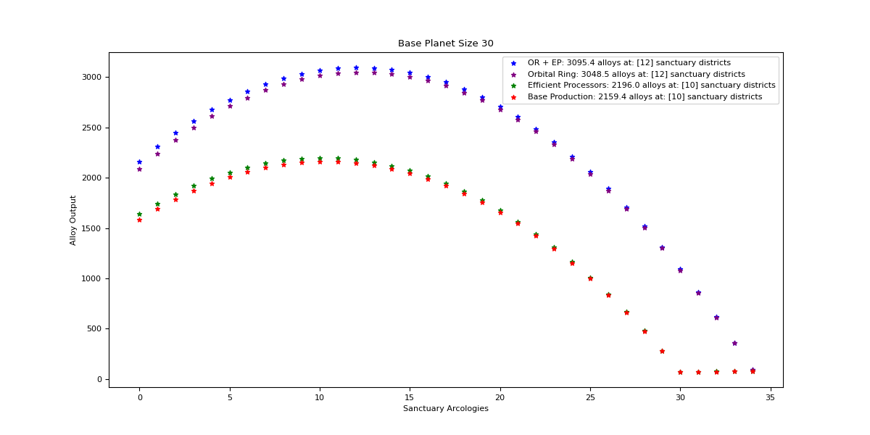

Orbital Ring + Efficient Processors

Optimal: 12

|  |  |  |  |  |
| --- | --- | --- | --- | --- |
| Sanctuary Districts | Alloys | Minerals | Food | Consumer Goods |
| 0 | 2163 | 3172.4 | 0 | 0 |
| 1 | 2310 | 3080 | 15 | 15 |
| 2 | 2444.4 | 2987.6 | 30 | 30 |
| 3 | 2566.2 | 2895.2 | 45 | 45 |
| 4 | 2675.4 | 2802.8 | 60 | 60 |
| 5 | 2772 | 2710.4 | 75 | 75 |
| 6 | 2856 | 2618 | 90 | 90 |
| 7 | 2927.4 | 2525.6 | 105 | 105 |
| 8 | 2986.2 | 2433.2 | 120 | 120 |
| 9 | 3032.4 | 2340.8 | 135 | 135 |
| 10 | 3066 | 2248.4 | 150 | 150 |
| 11 | 3087 | 2156 | 165 | 165 |
| 12 | 3095.4 | 2063.6 | 180 | 180 |
| 13 | 3091.2 | 1971.2 | 195 | 195 |
| 14 | 3074.4 | 1878.8 | 210 | 210 |
| 15 | 3045 | 1786.4 | 225 | 225 |
| 16 | 3003 | 1694 | 240 | 240 |
| 17 | 2948.4 | 1601.6 | 255 | 255 |
| 18 | 2881.2 | 1509.2 | 270 | 270 |
| 19 | 2801.4 | 1416.8 | 285 | 285 |
| 20 | 2709 | 1324.4 | 300 | 300 |
| 21 | 2604 | 1232 | 315 | 315 |
| 22 | 2486.4 | 1139.6 | 330 | 330 |
| 23 | 2356.2 | 1047.2 | 345 | 345 |
| 24 | 2213.4 | 954.8 | 360 | 360 |
| 25 | 2058 | 862.4 | 375 | 375 |
| 26 | 1890 | 770 | 390 | 390 |
| 27 | 1709.4 | 677.6 | 405 | 405 |
| 28 | 1516.2 | 585.2 | 420 | 420 |
| 29 | 1310.4 | 492.8 | 435 | 435 |
| 30 | 1092 | 400.4 | 450 | 450 |
| 31 | 861 | 308 | 465 | 465 |
| 32 | 617.4 | 215.6 | 480 | 480 |
| 33 | 361.2 | 123.2 | 495 | 495 |
| 34 | 92.4 | 30.8 | 510 | 510 |

Orbital Ring

Optimal: 12

|  |  |  |  |  |
| --- | --- | --- | --- | --- |
| Sanctuary Districts | Alloys | Minerals | Food | Consumer Goods |
| 0 | 2090.9 | 3172.4 | 0 | 0 |
| 1 | 2240 | 3080 | 15 | 15 |
| 2 | 2376.5 | 2987.6 | 30 | 30 |
| 3 | 2500.4 | 2895.2 | 45 | 45 |
| 4 | 2611.7 | 2802.8 | 60 | 60 |
| 5 | 2710.4 | 2710.4 | 75 | 75 |
| 6 | 2796.5 | 2618 | 90 | 90 |
| 7 | 2870 | 2525.6 | 105 | 105 |
| 8 | 2930.9 | 2433.2 | 120 | 120 |
| 9 | 2979.2 | 2340.8 | 135 | 135 |
| 10 | 3014.9 | 2248.4 | 150 | 150 |
| 11 | 3038 | 2156 | 165 | 165 |
| 12 | 3048.5 | 2063.6 | 180 | 180 |
| 13 | 3046.4 | 1971.2 | 195 | 195 |
| 14 | 3031.7 | 1878.8 | 210 | 210 |
| 15 | 3004.4 | 1786.4 | 225 | 225 |
| 16 | 2964.5 | 1694 | 240 | 240 |
| 17 | 2912 | 1601.6 | 255 | 255 |
| 18 | 2846.9 | 1509.2 | 270 | 270 |
| 19 | 2769.2 | 1416.8 | 285 | 285 |
| 20 | 2678.9 | 1324.4 | 300 | 300 |
| 21 | 2576 | 1232 | 315 | 315 |
| 22 | 2460.5 | 1139.6 | 330 | 330 |
| 23 | 2332.4 | 1047.2 | 345 | 345 |
| 24 | 2191.7 | 954.8 | 360 | 360 |
| 25 | 2038.4 | 862.4 | 375 | 375 |
| 26 | 1872.5 | 770 | 390 | 390 |
| 27 | 1694 | 677.6 | 405 | 405 |
| 28 | 1502.9 | 585.2 | 420 | 420 |
| 29 | 1299.2 | 492.8 | 435 | 435 |
| 30 | 1082.9 | 400.4 | 450 | 450 |
| 31 | 854 | 308 | 465 | 465 |
| 32 | 612.5 | 215.6 | 480 | 480 |
| 33 | 358.4 | 123.2 | 495 | 495 |
| 34 | 91.7 | 30.8 | 510 | 510 |

Efficient Processors

Optimal: 10

|  |  |  |  |  |
| --- | --- | --- | --- | --- |
| Sanctuary Districts | Alloys | Minerals | Food | Consumer Goods |
| 0 | 1638 | 2402.4 | 0 | 0 |
| 1 | 1742.4 | 2323.2 | 15 | 15 |
| 2 | 1836 | 2244 | 30 | 30 |
| 3 | 1918.8 | 2164.8 | 45 | 45 |
| 4 | 1990.8 | 2085.6 | 60 | 60 |
| 5 | 2052 | 2006.4 | 75 | 75 |
| 6 | 2102.4 | 1927.2 | 90 | 90 |
| 7 | 2142 | 1848 | 105 | 105 |
| 8 | 2170.8 | 1768.8 | 120 | 120 |
| 9 | 2188.8 | 1689.6 | 135 | 135 |
| 10 | 2196 | 1610.4 | 150 | 150 |
| 11 | 2192.4 | 1531.2 | 165 | 165 |
| 12 | 2178 | 1452 | 180 | 180 |
| 13 | 2152.8 | 1372.8 | 195 | 195 |
| 14 | 2116.8 | 1293.6 | 210 | 210 |
| 15 | 2070 | 1214.4 | 225 | 225 |
| 16 | 2012.4 | 1135.2 | 240 | 240 |
| 17 | 1944 | 1056 | 255 | 255 |
| 18 | 1864.8 | 976.8 | 270 | 270 |
| 19 | 1774.8 | 897.6 | 285 | 285 |
| 20 | 1674 | 818.4 | 300 | 300 |
| 21 | 1562.4 | 739.2 | 315 | 315 |
| 22 | 1440 | 660 | 330 | 330 |
| 23 | 1306.8 | 580.8 | 345 | 345 |
| 24 | 1162.8 | 501.6 | 360 | 360 |
| 25 | 1008 | 422.4 | 375 | 375 |
| 26 | 842.4 | 343.2 | 390 | 390 |
| 27 | 666 | 264 | 405 | 405 |
| 28 | 478.8 | 184.8 | 420 | 420 |
| 29 | 280.8 | 105.6 | 435 | 435 |
| 30 | 72 | 26.4 | 450 | 450 |

Base Production

Optimal: 10

|  |  |  |  |  |
| --- | --- | --- | --- | --- |
| Sanctuary Districts | Alloys | Minerals | Food | Consumer Goods |
| 0 | 1583.4 | 2402.4 | 0 | 0 |
| 1 | 1689.6 | 2323.2 | 15 | 15 |
| 2 | 1785 | 2244 | 30 | 30 |
| 3 | 1869.6 | 2164.8 | 45 | 45 |
| 4 | 1943.4 | 2085.6 | 60 | 60 |
| 5 | 2006.4 | 2006.4 | 75 | 75 |
| 6 | 2058.6 | 1927.2 | 90 | 90 |
| 7 | 2100 | 1848 | 105 | 105 |
| 8 | 2130.6 | 1768.8 | 120 | 120 |
| 9 | 2150.4 | 1689.6 | 135 | 135 |
| 10 | 2159.4 | 1610.4 | 150 | 150 |
| 11 | 2157.6 | 1531.2 | 165 | 165 |
| 12 | 2145 | 1452 | 180 | 180 |
| 13 | 2121.6 | 1372.8 | 195 | 195 |
| 14 | 2087.4 | 1293.6 | 210 | 210 |
| 15 | 2042.4 | 1214.4 | 225 | 225 |
| 16 | 1986.6 | 1135.2 | 240 | 240 |
| 17 | 1920 | 1056 | 255 | 255 |
| 18 | 1842.6 | 976.8 | 270 | 270 |
| 19 | 1754.4 | 897.6 | 285 | 285 |
| 20 | 1655.4 | 818.4 | 300 | 300 |
| 21 | 1545.6 | 739.2 | 315 | 315 |
| 22 | 1425 | 660 | 330 | 330 |
| 23 | 1293.6 | 580.8 | 345 | 345 |
| 24 | 1151.4 | 501.6 | 360 | 360 |
| 25 | 998.4 | 422.4 | 375 | 375 |
| 26 | 834.6 | 343.2 | 390 | 390 |
| 27 | 660 | 264 | 405 | 405 |
| 28 | 474.6 | 184.8 | 420 | 420 |
| 29 | 278.4 | 105.6 | 435 | 435 |
| 30 | 71.4 | 26.4 | 450 | 450 |

## Size 31

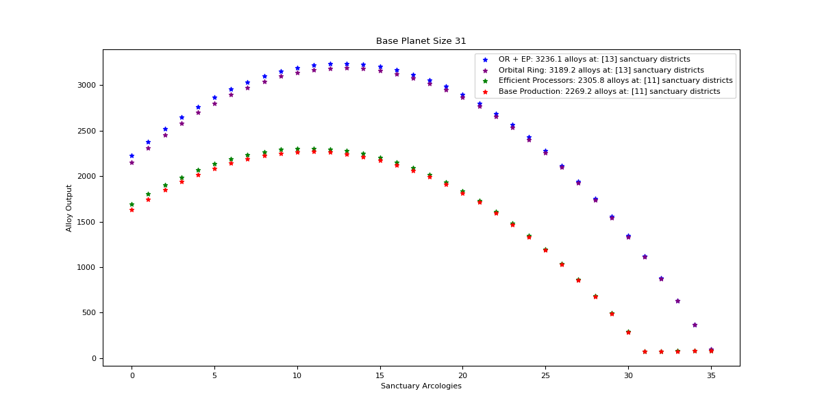

Orbital Ring + Efficient Processors

Optimal: 13

|  |  |  |  |  |
| --- | --- | --- | --- | --- |
| Sanctuary Districts | Alloys | Minerals | Food | Consumer Goods |
| 0 | 2226 | 3264.8 | 0 | 0 |
| 1 | 2379.3 | 3172.4 | 15 | 15 |
| 2 | 2520 | 3080 | 30 | 30 |
| 3 | 2648.1 | 2987.6 | 45 | 45 |
| 4 | 2763.6 | 2895.2 | 60 | 60 |
| 5 | 2866.5 | 2802.8 | 75 | 75 |
| 6 | 2956.8 | 2710.4 | 90 | 90 |
| 7 | 3034.5 | 2618 | 105 | 105 |
| 8 | 3099.6 | 2525.6 | 120 | 120 |
| 9 | 3152.1 | 2433.2 | 135 | 135 |
| 10 | 3192 | 2340.8 | 150 | 150 |
| 11 | 3219.3 | 2248.4 | 165 | 165 |
| 12 | 3234 | 2156 | 180 | 180 |
| 13 | 3236.1 | 2063.6 | 195 | 195 |
| 14 | 3225.6 | 1971.2 | 210 | 210 |
| 15 | 3202.5 | 1878.8 | 225 | 225 |
| 16 | 3166.8 | 1786.4 | 240 | 240 |
| 17 | 3118.5 | 1694 | 255 | 255 |
| 18 | 3057.6 | 1601.6 | 270 | 270 |
| 19 | 2984.1 | 1509.2 | 285 | 285 |
| 20 | 2898 | 1416.8 | 300 | 300 |
| 21 | 2799.3 | 1324.4 | 315 | 315 |
| 22 | 2688 | 1232 | 330 | 330 |
| 23 | 2564.1 | 1139.6 | 345 | 345 |
| 24 | 2427.6 | 1047.2 | 360 | 360 |
| 25 | 2278.5 | 954.8 | 375 | 375 |
| 26 | 2116.8 | 862.4 | 390 | 390 |
| 27 | 1942.5 | 770 | 405 | 405 |
| 28 | 1755.6 | 677.6 | 420 | 420 |
| 29 | 1556.1 | 585.2 | 435 | 435 |
| 30 | 1344 | 492.8 | 450 | 450 |
| 31 | 1119.3 | 400.4 | 465 | 465 |
| 32 | 882 | 308 | 480 | 480 |
| 33 | 632.1 | 215.6 | 495 | 495 |
| 34 | 369.6 | 123.2 | 510 | 510 |
| 35 | 94.5 | 30.8 | 525 | 525 |

Orbital Ring

Optimal: 13

|  |  |  |  |  |
| --- | --- | --- | --- | --- |
| Sanctuary Districts | Alloys | Minerals | Food | Consumer Goods |
| 0 | 2151.8 | 3264.8 | 0 | 0 |
| 1 | 2307.2 | 3172.4 | 15 | 15 |
| 2 | 2450 | 3080 | 30 | 30 |
| 3 | 2580.2 | 2987.6 | 45 | 45 |
| 4 | 2697.8 | 2895.2 | 60 | 60 |
| 5 | 2802.8 | 2802.8 | 75 | 75 |
| 6 | 2895.2 | 2710.4 | 90 | 90 |
| 7 | 2975 | 2618 | 105 | 105 |
| 8 | 3042.2 | 2525.6 | 120 | 120 |
| 9 | 3096.8 | 2433.2 | 135 | 135 |
| 10 | 3138.8 | 2340.8 | 150 | 150 |
| 11 | 3168.2 | 2248.4 | 165 | 165 |
| 12 | 3185 | 2156 | 180 | 180 |
| 13 | 3189.2 | 2063.6 | 195 | 195 |
| 14 | 3180.8 | 1971.2 | 210 | 210 |
| 15 | 3159.8 | 1878.8 | 225 | 225 |
| 16 | 3126.2 | 1786.4 | 240 | 240 |
| 17 | 3080 | 1694 | 255 | 255 |
| 18 | 3021.2 | 1601.6 | 270 | 270 |
| 19 | 2949.8 | 1509.2 | 285 | 285 |
| 20 | 2865.8 | 1416.8 | 300 | 300 |
| 21 | 2769.2 | 1324.4 | 315 | 315 |
| 22 | 2660 | 1232 | 330 | 330 |
| 23 | 2538.2 | 1139.6 | 345 | 345 |
| 24 | 2403.8 | 1047.2 | 360 | 360 |
| 25 | 2256.8 | 954.8 | 375 | 375 |
| 26 | 2097.2 | 862.4 | 390 | 390 |
| 27 | 1925 | 770 | 405 | 405 |
| 28 | 1740.2 | 677.6 | 420 | 420 |
| 29 | 1542.8 | 585.2 | 435 | 435 |
| 30 | 1332.8 | 492.8 | 450 | 450 |
| 31 | 1110.2 | 400.4 | 465 | 465 |
| 32 | 875 | 308 | 480 | 480 |
| 33 | 627.2 | 215.6 | 495 | 495 |
| 34 | 366.8 | 123.2 | 510 | 510 |
| 35 | 93.8 | 30.8 | 525 | 525 |

Efficient Processors

Optimal: 11

|  |  |  |  |  |
| --- | --- | --- | --- | --- |
| Sanctuary Districts | Alloys | Minerals | Food | Consumer Goods |
| 0 | 1692 | 2481.6 | 0 | 0 |
| 1 | 1801.8 | 2402.4 | 15 | 15 |
| 2 | 1900.8 | 2323.2 | 30 | 30 |
| 3 | 1989 | 2244 | 45 | 45 |
| 4 | 2066.4 | 2164.8 | 60 | 60 |
| 5 | 2133 | 2085.6 | 75 | 75 |
| 6 | 2188.8 | 2006.4 | 90 | 90 |
| 7 | 2233.8 | 1927.2 | 105 | 105 |
| 8 | 2268 | 1848 | 120 | 120 |
| 9 | 2291.4 | 1768.8 | 135 | 135 |
| 10 | 2304 | 1689.6 | 150 | 150 |
| 11 | 2305.8 | 1610.4 | 165 | 165 |
| 12 | 2296.8 | 1531.2 | 180 | 180 |
| 13 | 2277 | 1452 | 195 | 195 |
| 14 | 2246.4 | 1372.8 | 210 | 210 |
| 15 | 2205 | 1293.6 | 225 | 225 |
| 16 | 2152.8 | 1214.4 | 240 | 240 |
| 17 | 2089.8 | 1135.2 | 255 | 255 |
| 18 | 2016 | 1056 | 270 | 270 |
| 19 | 1931.4 | 976.8 | 285 | 285 |
| 20 | 1836 | 897.6 | 300 | 300 |
| 21 | 1729.8 | 818.4 | 315 | 315 |
| 22 | 1612.8 | 739.2 | 330 | 330 |
| 23 | 1485 | 660 | 345 | 345 |
| 24 | 1346.4 | 580.8 | 360 | 360 |
| 25 | 1197 | 501.6 | 375 | 375 |
| 26 | 1036.8 | 422.4 | 390 | 390 |
| 27 | 865.8 | 343.2 | 405 | 405 |
| 28 | 684 | 264 | 420 | 420 |
| 29 | 491.4 | 184.8 | 435 | 435 |
| 30 | 288 | 105.6 | 450 | 450 |
| 31 | 73.8 | 26.4 | 465 | 465 |

Base Production

Optimal: 11

|  |  |  |  |  |
| --- | --- | --- | --- | --- |
| Sanctuary Districts | Alloys | Minerals | Food | Consumer Goods |
| 0 | 1635.6 | 2481.6 | 0 | 0 |
| 1 | 1747.2 | 2402.4 | 15 | 15 |
| 2 | 1848 | 2323.2 | 30 | 30 |
| 3 | 1938 | 2244 | 45 | 45 |
| 4 | 2017.2 | 2164.8 | 60 | 60 |
| 5 | 2085.6 | 2085.6 | 75 | 75 |
| 6 | 2143.2 | 2006.4 | 90 | 90 |
| 7 | 2190 | 1927.2 | 105 | 105 |
| 8 | 2226 | 1848 | 120 | 120 |
| 9 | 2251.2 | 1768.8 | 135 | 135 |
| 10 | 2265.6 | 1689.6 | 150 | 150 |
| 11 | 2269.2 | 1610.4 | 165 | 165 |
| 12 | 2262 | 1531.2 | 180 | 180 |
| 13 | 2244 | 1452 | 195 | 195 |
| 14 | 2215.2 | 1372.8 | 210 | 210 |
| 15 | 2175.6 | 1293.6 | 225 | 225 |
| 16 | 2125.2 | 1214.4 | 240 | 240 |
| 17 | 2064 | 1135.2 | 255 | 255 |
| 18 | 1992 | 1056 | 270 | 270 |
| 19 | 1909.2 | 976.8 | 285 | 285 |
| 20 | 1815.6 | 897.6 | 300 | 300 |
| 21 | 1711.2 | 818.4 | 315 | 315 |
| 22 | 1596 | 739.2 | 330 | 330 |
| 23 | 1470 | 660 | 345 | 345 |
| 24 | 1333.2 | 580.8 | 360 | 360 |
| 25 | 1185.6 | 501.6 | 375 | 375 |
| 26 | 1027.2 | 422.4 | 390 | 390 |
| 27 | 858 | 343.2 | 405 | 405 |
| 28 | 678 | 264 | 420 | 420 |
| 29 | 487.2 | 184.8 | 435 | 435 |
| 30 | 285.6 | 105.6 | 450 | 450 |
| 31 | 73.2 | 26.4 | 465 | 465 |

## Size 32

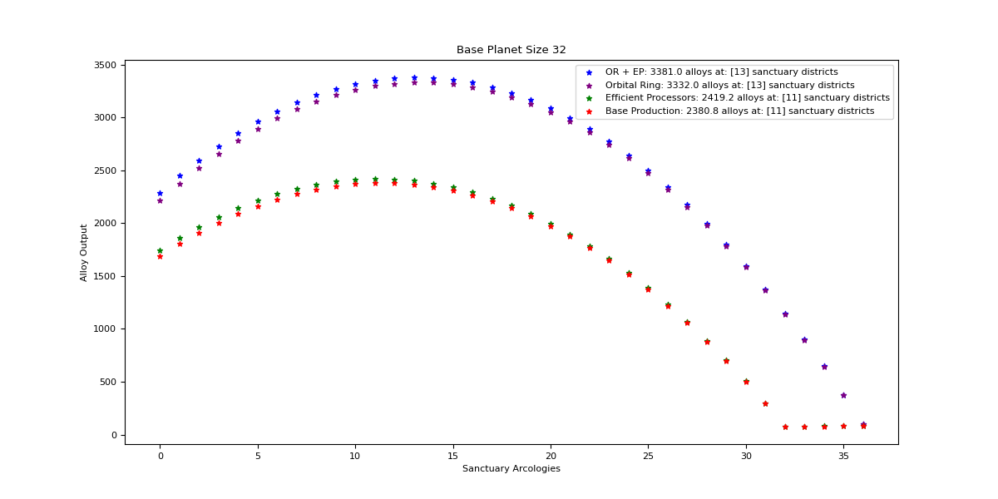

Orbital Ring + Efficient Processors

Optimal: 13

|  |  |  |  |  |
| --- | --- | --- | --- | --- |
| Sanctuary Districts | Alloys | Minerals | Food | Consumer Goods |
| 0 | 2289 | 3357.2 | 0 | 0 |
| 1 | 2448.6 | 3264.8 | 15 | 15 |
| 2 | 2595.6 | 3172.4 | 30 | 30 |
| 3 | 2730 | 3080 | 45 | 45 |
| 4 | 2851.8 | 2987.6 | 60 | 60 |
| 5 | 2961 | 2895.2 | 75 | 75 |
| 6 | 3057.6 | 2802.8 | 90 | 90 |
| 7 | 3141.6 | 2710.4 | 105 | 105 |
| 8 | 3213 | 2618 | 120 | 120 |
| 9 | 3271.8 | 2525.6 | 135 | 135 |
| 10 | 3318 | 2433.2 | 150 | 150 |
| 11 | 3351.6 | 2340.8 | 165 | 165 |
| 12 | 3372.6 | 2248.4 | 180 | 180 |
| 13 | 3381 | 2156 | 195 | 195 |
| 14 | 3376.8 | 2063.6 | 210 | 210 |
| 15 | 3360 | 1971.2 | 225 | 225 |
| 16 | 3330.6 | 1878.8 | 240 | 240 |
| 17 | 3288.6 | 1786.4 | 255 | 255 |
| 18 | 3234 | 1694 | 270 | 270 |
| 19 | 3166.8 | 1601.6 | 285 | 285 |
| 20 | 3087 | 1509.2 | 300 | 300 |
| 21 | 2994.6 | 1416.8 | 315 | 315 |
| 22 | 2889.6 | 1324.4 | 330 | 330 |
| 23 | 2772 | 1232 | 345 | 345 |
| 24 | 2641.8 | 1139.6 | 360 | 360 |
| 25 | 2499 | 1047.2 | 375 | 375 |
| 26 | 2343.6 | 954.8 | 390 | 390 |
| 27 | 2175.6 | 862.4 | 405 | 405 |
| 28 | 1995 | 770 | 420 | 420 |
| 29 | 1801.8 | 677.6 | 435 | 435 |
| 30 | 1596 | 585.2 | 450 | 450 |
| 31 | 1377.6 | 492.8 | 465 | 465 |
| 32 | 1146.6 | 400.4 | 480 | 480 |
| 33 | 903 | 308 | 495 | 495 |
| 34 | 646.8 | 215.6 | 510 | 510 |
| 35 | 378 | 123.2 | 525 | 525 |
| 36 | 96.6 | 30.8 | 540 | 540 |

Orbital Ring

Optimal: 13

|  |  |  |  |  |
| --- | --- | --- | --- | --- |
| Sanctuary Districts | Alloys | Minerals | Food | Consumer Goods |
| 0 | 2212.7 | 3357.2 | 0 | 0 |
| 1 | 2374.4 | 3264.8 | 15 | 15 |
| 2 | 2523.5 | 3172.4 | 30 | 30 |
| 3 | 2660 | 3080 | 45 | 45 |
| 4 | 2783.9 | 2987.6 | 60 | 60 |
| 5 | 2895.2 | 2895.2 | 75 | 75 |
| 6 | 2993.9 | 2802.8 | 90 | 90 |
| 7 | 3080 | 2710.4 | 105 | 105 |
| 8 | 3153.5 | 2618 | 120 | 120 |
| 9 | 3214.4 | 2525.6 | 135 | 135 |
| 10 | 3262.7 | 2433.2 | 150 | 150 |
| 11 | 3298.4 | 2340.8 | 165 | 165 |
| 12 | 3321.5 | 2248.4 | 180 | 180 |
| 13 | 3332 | 2156 | 195 | 195 |
| 14 | 3329.9 | 2063.6 | 210 | 210 |
| 15 | 3315.2 | 1971.2 | 225 | 225 |
| 16 | 3287.9 | 1878.8 | 240 | 240 |
| 17 | 3248 | 1786.4 | 255 | 255 |
| 18 | 3195.5 | 1694 | 270 | 270 |
| 19 | 3130.4 | 1601.6 | 285 | 285 |
| 20 | 3052.7 | 1509.2 | 300 | 300 |
| 21 | 2962.4 | 1416.8 | 315 | 315 |
| 22 | 2859.5 | 1324.4 | 330 | 330 |
| 23 | 2744 | 1232 | 345 | 345 |
| 24 | 2615.9 | 1139.6 | 360 | 360 |
| 25 | 2475.2 | 1047.2 | 375 | 375 |
| 26 | 2321.9 | 954.8 | 390 | 390 |
| 27 | 2156 | 862.4 | 405 | 405 |
| 28 | 1977.5 | 770 | 420 | 420 |
| 29 | 1786.4 | 677.6 | 435 | 435 |
| 30 | 1582.7 | 585.2 | 450 | 450 |
| 31 | 1366.4 | 492.8 | 465 | 465 |
| 32 | 1137.5 | 400.4 | 480 | 480 |
| 33 | 896 | 308 | 495 | 495 |
| 34 | 641.9 | 215.6 | 510 | 510 |
| 35 | 375.2 | 123.2 | 525 | 525 |
| 36 | 95.9 | 30.8 | 540 | 540 |

Efficient Processors

Optimal: 11

|  |  |  |  |  |
| --- | --- | --- | --- | --- |
| Sanctuary Districts | Alloys | Minerals | Food | Consumer Goods |
| 0 | 1746 | 2560.8 | 0 | 0 |
| 1 | 1861.2 | 2481.6 | 15 | 15 |
| 2 | 1965.6 | 2402.4 | 30 | 30 |
| 3 | 2059.2 | 2323.2 | 45 | 45 |
| 4 | 2142 | 2244 | 60 | 60 |
| 5 | 2214 | 2164.8 | 75 | 75 |
| 6 | 2275.2 | 2085.6 | 90 | 90 |
| 7 | 2325.6 | 2006.4 | 105 | 105 |
| 8 | 2365.2 | 1927.2 | 120 | 120 |
| 9 | 2394 | 1848 | 135 | 135 |
| 10 | 2412 | 1768.8 | 150 | 150 |
| 11 | 2419.2 | 1689.6 | 165 | 165 |
| 12 | 2415.6 | 1610.4 | 180 | 180 |
| 13 | 2401.2 | 1531.2 | 195 | 195 |
| 14 | 2376 | 1452 | 210 | 210 |
| 15 | 2340 | 1372.8 | 225 | 225 |
| 16 | 2293.2 | 1293.6 | 240 | 240 |
| 17 | 2235.6 | 1214.4 | 255 | 255 |
| 18 | 2167.2 | 1135.2 | 270 | 270 |
| 19 | 2088 | 1056 | 285 | 285 |
| 20 | 1998 | 976.8 | 300 | 300 |
| 21 | 1897.2 | 897.6 | 315 | 315 |
| 22 | 1785.6 | 818.4 | 330 | 330 |
| 23 | 1663.2 | 739.2 | 345 | 345 |
| 24 | 1530 | 660 | 360 | 360 |
| 25 | 1386 | 580.8 | 375 | 375 |
| 26 | 1231.2 | 501.6 | 390 | 390 |
| 27 | 1065.6 | 422.4 | 405 | 405 |
| 28 | 889.2 | 343.2 | 420 | 420 |
| 29 | 702 | 264 | 435 | 435 |
| 30 | 504 | 184.8 | 450 | 450 |
| 31 | 295.2 | 105.6 | 465 | 465 |
| 32 | 75.6 | 26.4 | 480 | 480 |

Base Production

Optimal: 11

|  |  |  |  |  |
| --- | --- | --- | --- | --- |
| Sanctuary Districts | Alloys | Minerals | Food | Consumer Goods |
| 0 | 1687.8 | 2560.8 | 0 | 0 |
| 1 | 1804.8 | 2481.6 | 15 | 15 |
| 2 | 1911 | 2402.4 | 30 | 30 |
| 3 | 2006.4 | 2323.2 | 45 | 45 |
| 4 | 2091 | 2244 | 60 | 60 |
| 5 | 2164.8 | 2164.8 | 75 | 75 |
| 6 | 2227.8 | 2085.6 | 90 | 90 |
| 7 | 2280 | 2006.4 | 105 | 105 |
| 8 | 2321.4 | 1927.2 | 120 | 120 |
| 9 | 2352 | 1848 | 135 | 135 |
| 10 | 2371.8 | 1768.8 | 150 | 150 |
| 11 | 2380.8 | 1689.6 | 165 | 165 |
| 12 | 2379 | 1610.4 | 180 | 180 |
| 13 | 2366.4 | 1531.2 | 195 | 195 |
| 14 | 2343 | 1452 | 210 | 210 |
| 15 | 2308.8 | 1372.8 | 225 | 225 |
| 16 | 2263.8 | 1293.6 | 240 | 240 |
| 17 | 2208 | 1214.4 | 255 | 255 |
| 18 | 2141.4 | 1135.2 | 270 | 270 |
| 19 | 2064 | 1056 | 285 | 285 |
| 20 | 1975.8 | 976.8 | 300 | 300 |
| 21 | 1876.8 | 897.6 | 315 | 315 |
| 22 | 1767 | 818.4 | 330 | 330 |
| 23 | 1646.4 | 739.2 | 345 | 345 |
| 24 | 1515 | 660 | 360 | 360 |
| 25 | 1372.8 | 580.8 | 375 | 375 |
| 26 | 1219.8 | 501.6 | 390 | 390 |
| 27 | 1056 | 422.4 | 405 | 405 |
| 28 | 881.4 | 343.2 | 420 | 420 |
| 29 | 696 | 264 | 435 | 435 |
| 30 | 499.8 | 184.8 | 450 | 450 |
| 31 | 292.8 | 105.6 | 465 | 465 |
| 32 | 75 | 26.4 | 480 | 480 |

## 

## Size 33

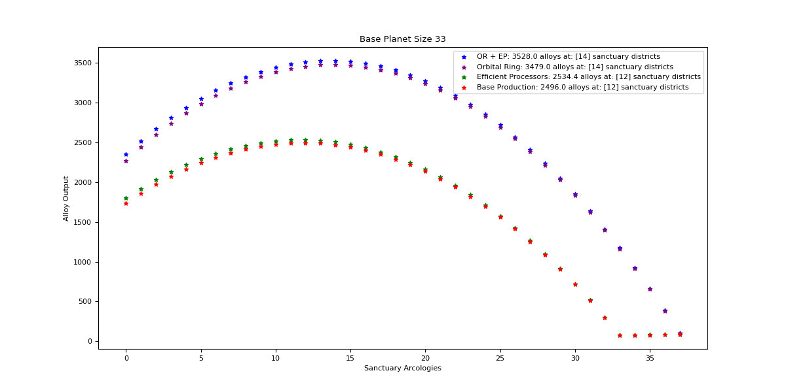

Orbital Ring + Efficient Processors

Optimal: 14

|  |  |  |  |  |
| --- | --- | --- | --- | --- |
| Sanctuary Districts | Alloys | Minerals | Food | Consumer Goods |
| 0 | 2352 | 3449.6 | 0 | 0 |
| 1 | 2517.9 | 3357.2 | 15 | 15 |
| 2 | 2671.2 | 3264.8 | 30 | 30 |
| 3 | 2811.9 | 3172.4 | 45 | 45 |
| 4 | 2940 | 3080 | 60 | 60 |
| 5 | 3055.5 | 2987.6 | 75 | 75 |
| 6 | 3158.4 | 2895.2 | 90 | 90 |
| 7 | 3248.7 | 2802.8 | 105 | 105 |
| 8 | 3326.4 | 2710.4 | 120 | 120 |
| 9 | 3391.5 | 2618 | 135 | 135 |
| 10 | 3444 | 2525.6 | 150 | 150 |
| 11 | 3483.9 | 2433.2 | 165 | 165 |
| 12 | 3511.2 | 2340.8 | 180 | 180 |
| 13 | 3525.9 | 2248.4 | 195 | 195 |
| 14 | 3528 | 2156 | 210 | 210 |
| 15 | 3517.5 | 2063.6 | 225 | 225 |
| 16 | 3494.4 | 1971.2 | 240 | 240 |
| 17 | 3458.7 | 1878.8 | 255 | 255 |
| 18 | 3410.4 | 1786.4 | 270 | 270 |
| 19 | 3349.5 | 1694 | 285 | 285 |
| 20 | 3276 | 1601.6 | 300 | 300 |
| 21 | 3189.9 | 1509.2 | 315 | 315 |
| 22 | 3091.2 | 1416.8 | 330 | 330 |
| 23 | 2979.9 | 1324.4 | 345 | 345 |
| 24 | 2856 | 1232 | 360 | 360 |
| 25 | 2719.5 | 1139.6 | 375 | 375 |
| 26 | 2570.4 | 1047.2 | 390 | 390 |
| 27 | 2408.7 | 954.8 | 405 | 405 |
| 28 | 2234.4 | 862.4 | 420 | 420 |
| 29 | 2047.5 | 770 | 435 | 435 |
| 30 | 1848 | 677.6 | 450 | 450 |
| 31 | 1635.9 | 585.2 | 465 | 465 |
| 32 | 1411.2 | 492.8 | 480 | 480 |
| 33 | 1173.9 | 400.4 | 495 | 495 |
| 34 | 924 | 308 | 510 | 510 |
| 35 | 661.5 | 215.6 | 525 | 525 |
| 36 | 386.4 | 123.2 | 540 | 540 |
| 37 | 98.7 | 30.8 | 555 | 555 |

Orbital Ring

Optimal: 14

|  |  |  |  |  |
| --- | --- | --- | --- | --- |
| Sanctuary Districts | Alloys | Minerals | Food | Consumer Goods |
| 0 | 2273.6 | 3449.6 | 0 | 0 |
| 1 | 2441.6 | 3357.2 | 15 | 15 |
| 2 | 2597 | 3264.8 | 30 | 30 |
| 3 | 2739.8 | 3172.4 | 45 | 45 |
| 4 | 2870 | 3080 | 60 | 60 |
| 5 | 2987.6 | 2987.6 | 75 | 75 |
| 6 | 3092.6 | 2895.2 | 90 | 90 |
| 7 | 3185 | 2802.8 | 105 | 105 |
| 8 | 3264.8 | 2710.4 | 120 | 120 |
| 9 | 3332 | 2618 | 135 | 135 |
| 10 | 3386.6 | 2525.6 | 150 | 150 |
| 11 | 3428.6 | 2433.2 | 165 | 165 |
| 12 | 3458 | 2340.8 | 180 | 180 |
| 13 | 3474.8 | 2248.4 | 195 | 195 |
| 14 | 3479 | 2156 | 210 | 210 |
| 15 | 3470.6 | 2063.6 | 225 | 225 |
| 16 | 3449.6 | 1971.2 | 240 | 240 |
| 17 | 3416 | 1878.8 | 255 | 255 |
| 18 | 3369.8 | 1786.4 | 270 | 270 |
| 19 | 3311 | 1694 | 285 | 285 |
| 20 | 3239.6 | 1601.6 | 300 | 300 |
| 21 | 3155.6 | 1509.2 | 315 | 315 |
| 22 | 3059 | 1416.8 | 330 | 330 |
| 23 | 2949.8 | 1324.4 | 345 | 345 |
| 24 | 2828 | 1232 | 360 | 360 |
| 25 | 2693.6 | 1139.6 | 375 | 375 |
| 26 | 2546.6 | 1047.2 | 390 | 390 |
| 27 | 2387 | 954.8 | 405 | 405 |
| 28 | 2214.8 | 862.4 | 420 | 420 |
| 29 | 2030 | 770 | 435 | 435 |
| 30 | 1832.6 | 677.6 | 450 | 450 |
| 31 | 1622.6 | 585.2 | 465 | 465 |
| 32 | 1400 | 492.8 | 480 | 480 |
| 33 | 1164.8 | 400.4 | 495 | 495 |
| 34 | 917 | 308 | 510 | 510 |
| 35 | 656.6 | 215.6 | 525 | 525 |
| 36 | 383.6 | 123.2 | 540 | 540 |
| 37 | 98 | 30.8 | 555 | 555 |

Efficient Processors

Optimal: 12

|  |  |  |  |  |
| --- | --- | --- | --- | --- |
| Sanctuary Districts | Alloys | Minerals | Food | Consumer Goods |
| 0 | 1800 | 2640 | 0 | 0 |
| 1 | 1920.6 | 2560.8 | 15 | 15 |
| 2 | 2030.4 | 2481.6 | 30 | 30 |
| 3 | 2129.4 | 2402.4 | 45 | 45 |
| 4 | 2217.6 | 2323.2 | 60 | 60 |
| 5 | 2295 | 2244 | 75 | 75 |
| 6 | 2361.6 | 2164.8 | 90 | 90 |
| 7 | 2417.4 | 2085.6 | 105 | 105 |
| 8 | 2462.4 | 2006.4 | 120 | 120 |
| 9 | 2496.6 | 1927.2 | 135 | 135 |
| 10 | 2520 | 1848 | 150 | 150 |
| 11 | 2532.6 | 1768.8 | 165 | 165 |
| 12 | 2534.4 | 1689.6 | 180 | 180 |
| 13 | 2525.4 | 1610.4 | 195 | 195 |
| 14 | 2505.6 | 1531.2 | 210 | 210 |
| 15 | 2475 | 1452 | 225 | 225 |
| 16 | 2433.6 | 1372.8 | 240 | 240 |
| 17 | 2381.4 | 1293.6 | 255 | 255 |
| 18 | 2318.4 | 1214.4 | 270 | 270 |
| 19 | 2244.6 | 1135.2 | 285 | 285 |
| 20 | 2160 | 1056 | 300 | 300 |
| 21 | 2064.6 | 976.8 | 315 | 315 |
| 22 | 1958.4 | 897.6 | 330 | 330 |
| 23 | 1841.4 | 818.4 | 345 | 345 |
| 24 | 1713.6 | 739.2 | 360 | 360 |
| 25 | 1575 | 660 | 375 | 375 |
| 26 | 1425.6 | 580.8 | 390 | 390 |
| 27 | 1265.4 | 501.6 | 405 | 405 |
| 28 | 1094.4 | 422.4 | 420 | 420 |
| 29 | 912.6 | 343.2 | 435 | 435 |
| 30 | 720 | 264 | 450 | 450 |
| 31 | 516.6 | 184.8 | 465 | 465 |
| 32 | 302.4 | 105.6 | 480 | 480 |
| 33 | 77.4 | 26.4 | 495 | 495 |

Base Production

Optimal: 12

|  |  |  |  |  |
| --- | --- | --- | --- | --- |
| Sanctuary Districts | Alloys | Minerals | Food | Consumer Goods |
| 0 | 1740 | 2640 | 0 | 0 |
| 1 | 1862.4 | 2560.8 | 15 | 15 |
| 2 | 1974 | 2481.6 | 30 | 30 |
| 3 | 2074.8 | 2402.4 | 45 | 45 |
| 4 | 2164.8 | 2323.2 | 60 | 60 |
| 5 | 2244 | 2244 | 75 | 75 |
| 6 | 2312.4 | 2164.8 | 90 | 90 |
| 7 | 2370 | 2085.6 | 105 | 105 |
| 8 | 2416.8 | 2006.4 | 120 | 120 |
| 9 | 2452.8 | 1927.2 | 135 | 135 |
| 10 | 2478 | 1848 | 150 | 150 |
| 11 | 2492.4 | 1768.8 | 165 | 165 |
| 12 | 2496 | 1689.6 | 180 | 180 |
| 13 | 2488.8 | 1610.4 | 195 | 195 |
| 14 | 2470.8 | 1531.2 | 210 | 210 |
| 15 | 2442 | 1452 | 225 | 225 |
| 16 | 2402.4 | 1372.8 | 240 | 240 |
| 17 | 2352 | 1293.6 | 255 | 255 |
| 18 | 2290.8 | 1214.4 | 270 | 270 |
| 19 | 2218.8 | 1135.2 | 285 | 285 |
| 20 | 2136 | 1056 | 300 | 300 |
| 21 | 2042.4 | 976.8 | 315 | 315 |
| 22 | 1938 | 897.6 | 330 | 330 |
| 23 | 1822.8 | 818.4 | 345 | 345 |
| 24 | 1696.8 | 739.2 | 360 | 360 |
| 25 | 1560 | 660 | 375 | 375 |
| 26 | 1412.4 | 580.8 | 390 | 390 |
| 27 | 1254 | 501.6 | 405 | 405 |
| 28 | 1084.8 | 422.4 | 420 | 420 |
| 29 | 904.8 | 343.2 | 435 | 435 |
| 30 | 714 | 264 | 450 | 450 |
| 31 | 512.4 | 184.8 | 465 | 465 |
| 32 | 300 | 105.6 | 480 | 480 |
| 33 | 76.8 | 26.4 | 495 | 495 |

## Size 34

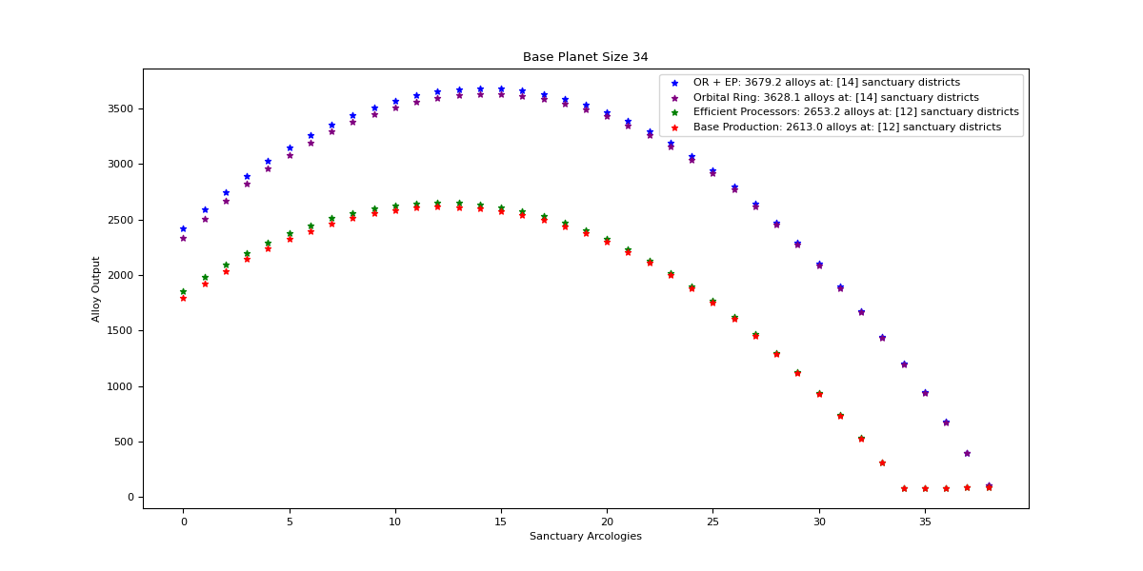

Orbital Ring + Efficient Processor

Optimal: 14

|  |  |  |  |  |
| --- | --- | --- | --- | --- |
| Sanctuary Districts | Alloys | Minerals | Food | Consumer Goods |
| 0 | 2352 | 3449.6 | 0 | 0 |
| 1 | 2517.9 | 3357.2 | 15 | 15 |
| 2 | 2671.2 | 3264.8 | 30 | 30 |
| 3 | 2811.9 | 3172.4 | 45 | 45 |
| 4 | 2940 | 3080 | 60 | 60 |
| 5 | 3055.5 | 2987.6 | 75 | 75 |
| 6 | 3158.4 | 2895.2 | 90 | 90 |
| 7 | 3248.7 | 2802.8 | 105 | 105 |
| 8 | 3326.4 | 2710.4 | 120 | 120 |
| 9 | 3391.5 | 2618 | 135 | 135 |
| 10 | 3444 | 2525.6 | 150 | 150 |
| 11 | 3483.9 | 2433.2 | 165 | 165 |
| 12 | 3511.2 | 2340.8 | 180 | 180 |
| 13 | 3525.9 | 2248.4 | 195 | 195 |
| 14 | 3528 | 2156 | 210 | 210 |
| 15 | 3517.5 | 2063.6 | 225 | 225 |
| 16 | 3494.4 | 1971.2 | 240 | 240 |
| 17 | 3458.7 | 1878.8 | 255 | 255 |
| 18 | 3410.4 | 1786.4 | 270 | 270 |
| 19 | 3349.5 | 1694 | 285 | 285 |
| 20 | 3276 | 1601.6 | 300 | 300 |
| 21 | 3189.9 | 1509.2 | 315 | 315 |
| 22 | 3091.2 | 1416.8 | 330 | 330 |
| 23 | 2979.9 | 1324.4 | 345 | 345 |
| 24 | 2856 | 1232 | 360 | 360 |
| 25 | 2719.5 | 1139.6 | 375 | 375 |
| 26 | 2570.4 | 1047.2 | 390 | 390 |
| 27 | 2408.7 | 954.8 | 405 | 405 |
| 28 | 2234.4 | 862.4 | 420 | 420 |
| 29 | 2047.5 | 770 | 435 | 435 |
| 30 | 1848 | 677.6 | 450 | 450 |
| 31 | 1635.9 | 585.2 | 465 | 465 |
| 32 | 1411.2 | 492.8 | 480 | 480 |
| 33 | 1173.9 | 400.4 | 495 | 495 |
| 34 | 924 | 308 | 510 | 510 |
| 35 | 661.5 | 215.6 | 525 | 525 |
| 36 | 386.4 | 123.2 | 540 | 540 |
| 37 | 98.7 | 30.8 | 555 | 555 |
| 38 | 100.8 | 30.8 | 570 | 570 |

Orbital Ring

Optimal: 14

|  |  |  |  |  |
| --- | --- | --- | --- | --- |
| Sanctuary Districts | Alloys | Minerals | Food | Consumer Goods |
| 0 | 2273.6 | 3449.6 | 0 | 0 |
| 1 | 2441.6 | 3357.2 | 15 | 15 |
| 2 | 2597 | 3264.8 | 30 | 30 |
| 3 | 2739.8 | 3172.4 | 45 | 45 |
| 4 | 2870 | 3080 | 60 | 60 |
| 5 | 2987.6 | 2987.6 | 75 | 75 |
| 6 | 3092.6 | 2895.2 | 90 | 90 |
| 7 | 3185 | 2802.8 | 105 | 105 |
| 8 | 3264.8 | 2710.4 | 120 | 120 |
| 9 | 3332 | 2618 | 135 | 135 |
| 10 | 3386.6 | 2525.6 | 150 | 150 |
| 11 | 3428.6 | 2433.2 | 165 | 165 |
| 12 | 3458 | 2340.8 | 180 | 180 |
| 13 | 3474.8 | 2248.4 | 195 | 195 |
| 14 | 3479 | 2156 | 210 | 210 |
| 15 | 3470.6 | 2063.6 | 225 | 225 |
| 16 | 3449.6 | 1971.2 | 240 | 240 |
| 17 | 3416 | 1878.8 | 255 | 255 |
| 18 | 3369.8 | 1786.4 | 270 | 270 |
| 19 | 3311 | 1694 | 285 | 285 |
| 20 | 3239.6 | 1601.6 | 300 | 300 |
| 21 | 3155.6 | 1509.2 | 315 | 315 |
| 22 | 3059 | 1416.8 | 330 | 330 |
| 23 | 2949.8 | 1324.4 | 345 | 345 |
| 24 | 2828 | 1232 | 360 | 360 |
| 25 | 2693.6 | 1139.6 | 375 | 375 |
| 26 | 2546.6 | 1047.2 | 390 | 390 |
| 27 | 2387 | 954.8 | 405 | 405 |
| 28 | 2214.8 | 862.4 | 420 | 420 |
| 29 | 2030 | 770 | 435 | 435 |
| 30 | 1832.6 | 677.6 | 450 | 450 |
| 31 | 1622.6 | 585.2 | 465 | 465 |
| 32 | 1400 | 492.8 | 480 | 480 |
| 33 | 1164.8 | 400.4 | 495 | 495 |
| 34 | 917 | 308 | 510 | 510 |
| 35 | 656.6 | 215.6 | 525 | 525 |
| 36 | 383.6 | 123.2 | 540 | 540 |
| 37 | 98 | 30.8 | 555 | 555 |
| 38 | 100.1 | 30.8 | 570 | 570 |

Efficient Processors

Optimal: 12

|  |  |  |  |  |
| --- | --- | --- | --- | --- |
| Sanctuary Districts | Alloys | Minerals | Food | Consumer Goods |
| 0 | 1800 | 2640 | 0 | 0 |
| 1 | 1920.6 | 2560.8 | 15 | 15 |
| 2 | 2030.4 | 2481.6 | 30 | 30 |
| 3 | 2129.4 | 2402.4 | 45 | 45 |
| 4 | 2217.6 | 2323.2 | 60 | 60 |
| 5 | 2295 | 2244 | 75 | 75 |
| 6 | 2361.6 | 2164.8 | 90 | 90 |
| 7 | 2417.4 | 2085.6 | 105 | 105 |
| 8 | 2462.4 | 2006.4 | 120 | 120 |
| 9 | 2496.6 | 1927.2 | 135 | 135 |
| 10 | 2520 | 1848 | 150 | 150 |
| 11 | 2532.6 | 1768.8 | 165 | 165 |
| 12 | 2534.4 | 1689.6 | 180 | 180 |
| 13 | 2525.4 | 1610.4 | 195 | 195 |
| 14 | 2505.6 | 1531.2 | 210 | 210 |
| 15 | 2475 | 1452 | 225 | 225 |
| 16 | 2433.6 | 1372.8 | 240 | 240 |
| 17 | 2381.4 | 1293.6 | 255 | 255 |
| 18 | 2318.4 | 1214.4 | 270 | 270 |
| 19 | 2244.6 | 1135.2 | 285 | 285 |
| 20 | 2160 | 1056 | 300 | 300 |
| 21 | 2064.6 | 976.8 | 315 | 315 |
| 22 | 1958.4 | 897.6 | 330 | 330 |
| 23 | 1841.4 | 818.4 | 345 | 345 |
| 24 | 1713.6 | 739.2 | 360 | 360 |
| 25 | 1575 | 660 | 375 | 375 |
| 26 | 1425.6 | 580.8 | 390 | 390 |
| 27 | 1265.4 | 501.6 | 405 | 405 |
| 28 | 1094.4 | 422.4 | 420 | 420 |
| 29 | 912.6 | 343.2 | 435 | 435 |
| 30 | 720 | 264 | 450 | 450 |
| 31 | 516.6 | 184.8 | 465 | 465 |
| 32 | 302.4 | 105.6 | 480 | 480 |
| 33 | 77.4 | 26.4 | 495 | 495 |
| 34 | 79.2 | 26.4 | 510 | 510 |

Base Production

Optimal: 12

|  |  |  |  |  |
| --- | --- | --- | --- | --- |
| Sanctuary Districts | Alloys | Minerals | Food | Consumer Goods |
| 0 | 1740 | 2640 | 0 | 0 |
| 1 | 1862.4 | 2560.8 | 15 | 15 |
| 2 | 1974 | 2481.6 | 30 | 30 |
| 3 | 2074.8 | 2402.4 | 45 | 45 |
| 4 | 2164.8 | 2323.2 | 60 | 60 |
| 5 | 2244 | 2244 | 75 | 75 |
| 6 | 2312.4 | 2164.8 | 90 | 90 |
| 7 | 2370 | 2085.6 | 105 | 105 |
| 8 | 2416.8 | 2006.4 | 120 | 120 |
| 9 | 2452.8 | 1927.2 | 135 | 135 |
| 10 | 2478 | 1848 | 150 | 150 |
| 11 | 2492.4 | 1768.8 | 165 | 165 |
| 12 | 2496 | 1689.6 | 180 | 180 |
| 13 | 2488.8 | 1610.4 | 195 | 195 |
| 14 | 2470.8 | 1531.2 | 210 | 210 |
| 15 | 2442 | 1452 | 225 | 225 |
| 16 | 2402.4 | 1372.8 | 240 | 240 |
| 17 | 2352 | 1293.6 | 255 | 255 |
| 18 | 2290.8 | 1214.4 | 270 | 270 |
| 19 | 2218.8 | 1135.2 | 285 | 285 |
| 20 | 2136 | 1056 | 300 | 300 |
| 21 | 2042.4 | 976.8 | 315 | 315 |
| 22 | 1938 | 897.6 | 330 | 330 |
| 23 | 1822.8 | 818.4 | 345 | 345 |
| 24 | 1696.8 | 739.2 | 360 | 360 |
| 25 | 1560 | 660 | 375 | 375 |
| 26 | 1412.4 | 580.8 | 390 | 390 |
| 27 | 1254 | 501.6 | 405 | 405 |
| 28 | 1084.8 | 422.4 | 420 | 420 |
| 29 | 904.8 | 343.2 | 435 | 435 |
| 30 | 714 | 264 | 450 | 450 |
| 31 | 512.4 | 184.8 | 465 | 465 |
| 32 | 300 | 105.6 | 480 | 480 |
| 33 | 76.8 | 26.4 | 495 | 495 |
| 34 | 78.6 | 26.4 | 510 | 510 |

## Extra Information: Size 39

I labeled this one special, because it is a special case. To get a size 39 world, you either need to be playing multiplayer with a friend OR get really lucky with aquatic empires taking the hydrocentric ascension perk AND actually using the “expand planetary sea” decision, and the mastery of nature ascension perk, then you either need to trade with a friend, or conquer the planet and take it from an AI or said friend. BOOM! You now have a size 39 world, was it worth it? In order to calculate this special case, I set the planet size to 35, which with the orbital ring districts makes a size 39 world.

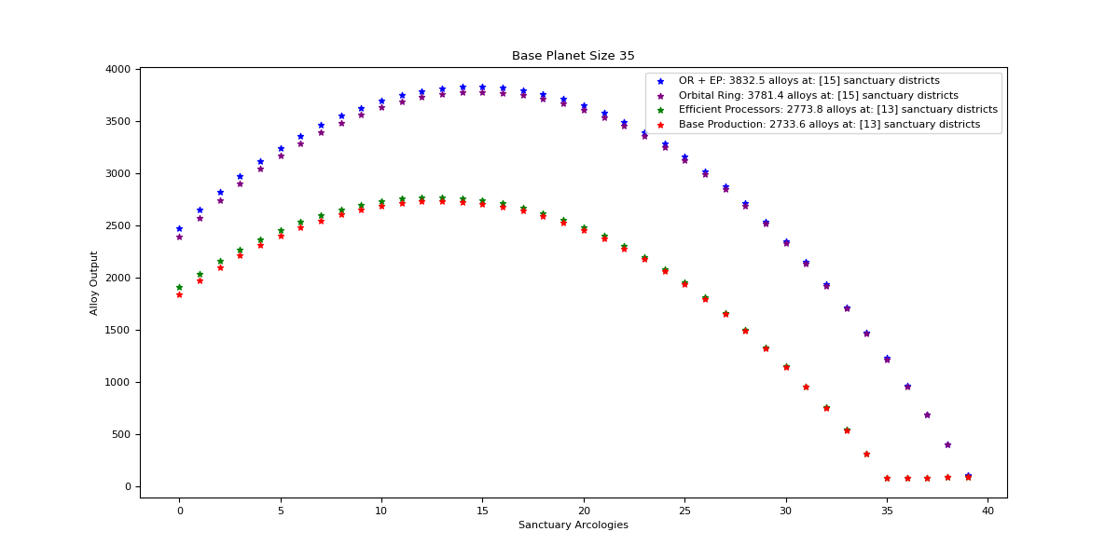

Orbital Ring + Efficient Processors:

Optimal: 15

|  |  |  |  |  |
| --- | --- | --- | --- | --- |
| Sanctuary Districts | Alloys | Minerals | Food | Consumer Goods |
| 0 | 2478 | 3115.2 | 0 | 0 |
| 1 | 2656.5 | 3036 | 15 | 15 |
| 2 | 2822.4 | 2956.8 | 30 | 30 |
| 3 | 2975.7 | 2877.6 | 45 | 45 |
| 4 | 3116.4 | 2798.4 | 60 | 60 |
| 5 | 3244.5 | 2719.2 | 75 | 75 |
| 6 | 3360 | 2640 | 90 | 90 |
| 7 | 3462.9 | 2560.8 | 105 | 105 |
| 8 | 3553.2 | 2481.6 | 120 | 120 |
| 9 | 3630.9 | 2402.4 | 135 | 135 |
| 10 | 3696 | 2323.2 | 150 | 150 |
| 11 | 3748.5 | 2244 | 165 | 165 |
| 12 | 3788.4 | 2164.8 | 180 | 180 |
| 13 | 3815.7 | 2085.6 | 195 | 195 |
| 14 | 3830.4 | 2006.4 | 210 | 210 |
| 15 | 3832.5 | 1927.2 | 225 | 225 |
| 16 | 3822 | 1848 | 240 | 240 |
| 17 | 3798.9 | 1768.8 | 255 | 255 |
| 18 | 3763.2 | 1689.6 | 270 | 270 |
| 19 | 3714.9 | 1610.4 | 285 | 285 |
| 20 | 3654 | 1531.2 | 300 | 300 |
| 21 | 3580.5 | 1452 | 315 | 315 |
| 22 | 3494.4 | 1372.8 | 330 | 330 |
| 23 | 3395.7 | 1293.6 | 345 | 345 |
| 24 | 3284.4 | 1214.4 | 360 | 360 |
| 25 | 3160.5 | 1135.2 | 375 | 375 |
| 26 | 3024 | 1056 | 390 | 390 |
| 27 | 2874.9 | 976.8 | 405 | 405 |
| 28 | 2713.2 | 897.6 | 420 | 420 |
| 29 | 2538.9 | 818.4 | 435 | 435 |
| 30 | 2352 | 739.2 | 450 | 450 |
| 31 | 2152.5 | 660 | 465 | 465 |
| 32 | 1940.4 | 580.8 | 480 | 480 |
| 33 | 1715.7 | 501.6 | 495 | 495 |
| 34 | 1478.4 | 422.4 | 510 | 510 |
| 35 | 1228.5 | 343.2 | 525 | 525 |
| 36 | 966 | 264 | 540 | 540 |
| 37 | 690.9 | 184.8 | 555 | 555 |
| 38 | 403.2 | 105.6 | 570 | 570 |
| 39 | 102.9 | 26.4 | 585 | 585 |

Orbital Ring:

Optimal: 15

|  |  |  |  |  |
| --- | --- | --- | --- | --- |
| Sanctuary Districts | Alloys | Minerals | Food | Consumer Goods |
| 0 | 2395.4 | 3115.2 | 0 | 0 |
| 1 | 2576 | 3036 | 15 | 15 |
| 2 | 2744 | 2956.8 | 30 | 30 |
| 3 | 2899.4 | 2877.6 | 45 | 45 |
| 4 | 3042.2 | 2798.4 | 60 | 60 |
| 5 | 3172.4 | 2719.2 | 75 | 75 |
| 6 | 3290 | 2640 | 90 | 90 |
| 7 | 3395 | 2560.8 | 105 | 105 |
| 8 | 3487.4 | 2481.6 | 120 | 120 |
| 9 | 3567.2 | 2402.4 | 135 | 135 |
| 10 | 3634.4 | 2323.2 | 150 | 150 |
| 11 | 3689 | 2244 | 165 | 165 |
| 12 | 3731 | 2164.8 | 180 | 180 |
| 13 | 3760.4 | 2085.6 | 195 | 195 |
| 14 | 3777.2 | 2006.4 | 210 | 210 |
| 15 | 3781.4 | 1927.2 | 225 | 225 |
| 16 | 3773 | 1848 | 240 | 240 |
| 17 | 3752 | 1768.8 | 255 | 255 |
| 18 | 3718.4 | 1689.6 | 270 | 270 |
| 19 | 3672.2 | 1610.4 | 285 | 285 |
| 20 | 3613.4 | 1531.2 | 300 | 300 |
| 21 | 3542 | 1452 | 315 | 315 |
| 22 | 3458 | 1372.8 | 330 | 330 |
| 23 | 3361.4 | 1293.6 | 345 | 345 |
| 24 | 3252.2 | 1214.4 | 360 | 360 |
| 25 | 3130.4 | 1135.2 | 375 | 375 |
| 26 | 2996 | 1056 | 390 | 390 |
| 27 | 2849 | 976.8 | 405 | 405 |
| 28 | 2689.4 | 897.6 | 420 | 420 |
| 29 | 2517.2 | 818.4 | 435 | 435 |
| 30 | 2332.4 | 739.2 | 450 | 450 |
| 31 | 2135 | 660 | 465 | 465 |
| 32 | 1925 | 580.8 | 480 | 480 |
| 33 | 1702.4 | 501.6 | 495 | 495 |
| 34 | 1467.2 | 422.4 | 510 | 510 |
| 35 | 1219.4 | 343.2 | 525 | 525 |
| 36 | 959 | 264 | 540 | 540 |
| 37 | 686 | 184.8 | 555 | 555 |
| 38 | 400.4 | 105.6 | 570 | 570 |
| 39 | 102.2 | 26.4 | 585 | 585 |

Efficient Processors

Optimal: 13

|  |  |  |  |  |
| --- | --- | --- | --- | --- |
| Sanctuary Districts | Alloys | Minerals | Food | Consumer Goods |
| 0 | 1908 | 2798.4 | 0 | 0 |
| 1 | 2039.4 | 2719.2 | 15 | 15 |
| 2 | 2160 | 2640 | 30 | 30 |
| 3 | 2269.8 | 2560.8 | 45 | 45 |
| 4 | 2368.8 | 2481.6 | 60 | 60 |
| 5 | 2457 | 2402.4 | 75 | 75 |
| 6 | 2534.4 | 2323.2 | 90 | 90 |
| 7 | 2601 | 2244 | 105 | 105 |
| 8 | 2656.8 | 2164.8 | 120 | 120 |
| 9 | 2701.8 | 2085.6 | 135 | 135 |
| 10 | 2736 | 2006.4 | 150 | 150 |
| 11 | 2759.4 | 1927.2 | 165 | 165 |
| 12 | 2772 | 1848 | 180 | 180 |
| 13 | 2773.8 | 1768.8 | 195 | 195 |
| 14 | 2764.8 | 1689.6 | 210 | 210 |
| 15 | 2745 | 1610.4 | 225 | 225 |
| 16 | 2714.4 | 1531.2 | 240 | 240 |
| 17 | 2673 | 1452 | 255 | 255 |
| 18 | 2620.8 | 1372.8 | 270 | 270 |
| 19 | 2557.8 | 1293.6 | 285 | 285 |
| 20 | 2484 | 1214.4 | 300 | 300 |
| 21 | 2399.4 | 1135.2 | 315 | 315 |
| 22 | 2304 | 1056 | 330 | 330 |
| 23 | 2197.8 | 976.8 | 345 | 345 |
| 24 | 2080.8 | 897.6 | 360 | 360 |
| 25 | 1953 | 818.4 | 375 | 375 |
| 26 | 1814.4 | 739.2 | 390 | 390 |
| 27 | 1665 | 660 | 405 | 405 |
| 28 | 1504.8 | 580.8 | 420 | 420 |
| 29 | 1333.8 | 501.6 | 435 | 435 |
| 30 | 1152 | 422.4 | 450 | 450 |
| 31 | 959.4 | 343.2 | 465 | 465 |
| 32 | 756 | 264 | 480 | 480 |
| 33 | 541.8 | 184.8 | 495 | 495 |
| 34 | 316.8 | 105.6 | 510 | 510 |
| 35 | 81 | 26.4 | 525 | 525 |

Base Production

Optimal: 13

|  |  |  |  |  |
| --- | --- | --- | --- | --- |
| Sanctuary Districts | Alloys | Minerals | Food | Consumer Goods |
| 0 | 1844.4 | 2798.4 | 0 | 0 |
| 1 | 1977.6 | 2719.2 | 15 | 15 |
| 2 | 2100 | 2640 | 30 | 30 |
| 3 | 2211.6 | 2560.8 | 45 | 45 |
| 4 | 2312.4 | 2481.6 | 60 | 60 |
| 5 | 2402.4 | 2402.4 | 75 | 75 |
| 6 | 2481.6 | 2323.2 | 90 | 90 |
| 7 | 2550 | 2244 | 105 | 105 |
| 8 | 2607.6 | 2164.8 | 120 | 120 |
| 9 | 2654.4 | 2085.6 | 135 | 135 |
| 10 | 2690.4 | 2006.4 | 150 | 150 |
| 11 | 2715.6 | 1927.2 | 165 | 165 |
| 12 | 2730 | 1848 | 180 | 180 |
| 13 | 2733.6 | 1768.8 | 195 | 195 |
| 14 | 2726.4 | 1689.6 | 210 | 210 |
| 15 | 2708.4 | 1610.4 | 225 | 225 |
| 16 | 2679.6 | 1531.2 | 240 | 240 |
| 17 | 2640 | 1452 | 255 | 255 |
| 18 | 2589.6 | 1372.8 | 270 | 270 |
| 19 | 2528.4 | 1293.6 | 285 | 285 |
| 20 | 2456.4 | 1214.4 | 300 | 300 |
| 21 | 2373.6 | 1135.2 | 315 | 315 |
| 22 | 2280 | 1056 | 330 | 330 |
| 23 | 2175.6 | 976.8 | 345 | 345 |
| 24 | 2060.4 | 897.6 | 360 | 360 |
| 25 | 1934.4 | 818.4 | 375 | 375 |
| 26 | 1797.6 | 739.2 | 390 | 390 |
| 27 | 1650 | 660 | 405 | 405 |
| 28 | 1491.6 | 580.8 | 420 | 420 |
| 29 | 1322.4 | 501.6 | 435 | 435 |
| 30 | 1142.4 | 422.4 | 450 | 450 |
| 31 | 951.6 | 343.2 | 465 | 465 |
| 32 | 750 | 264 | 480 | 480 |
| 33 | 537.6 | 184.8 | 495 | 495 |
| 34 | 314.4 | 105.6 | 510 | 510 |
| 35 | 80.4 | 26.4 | 525 | 525 |

## Ringworld

Ringworlds don’t have special districts for Bio trophies, so the math for the maximum is much simpler. This is optimized for alloy production specifically, and unlike the ecumenopoli this does not have extra building slots to add functionality (such as a robot assembly plant)

Max Bio Trophy Jobs: 180 (9xOrganic Paradises, each with 20 bio-trophy jobs)

Fabricator Jobs: 100 (10 districts, with 10 jobs each)

Machines produce a base of 4, the Alloy Nano-plant adds an additional +2, +15% RPC, +30% from production tech

100 * ((4 + 2) * (1 + .15 + .3 + (180*0.01)))

= 100 * (6 * (1.45 + 1.80))

= 100 * (6 * 3.25)

= 100 * 19.5

= 1950 Alloys per month PER RING SECTION

= 7800 Alloys per month per ring world

Like the Ecumenopoli, this does not account for stability, but unlike Ecumenopoli you’re more likely to face housing and amenity issues and stability issues due to said lack of housing and amenities, so expect this number to be far lower in practice.

## The Calculations Used and Code Explained

### Foundations

The basic foundations of how modifiers are calculated in Stellaris are an important stepping stone to understanding why these numbers. In its simplest form, Stellaris job modifiers are additive, meaning they add % on top of each other, rather than multiplicative (which would make the modifier grow much quicker).

An example of this is as follows: with the tier 3 production tech, +30% is added to all jobs, and +30% is added to resource consumption. With the resource production center, all fabricators get a +15% bonus to production, this total ends up +45% (15%+30%). If the total was multiplicative, it would be 1*1.15*1.30 = 1.495, or +49.5%.

### Calculations

The basic calculation for production is reliant on a few variables, described below:

* mineralUpkeep1 = 8 (base) + 4 (from building) = 12
* mineralUpkeep2 = 8 + 4 + 2 (orbital ring building) = 14
* bioTrophyJobs = 15 per district
* bioTrophyProd = 0.01 per bioTrophyJob (+1% production per bio trophy)
* fabricatorOutput = 6 (7 with orbital ring building)
* Total output = fabricatorOutput * (1 + 0.3 + 0.15 + (bioTrophyProd*bioTrophyJobs))
* totalMineralUpkeep = mineralUpkeep1/2 * fabricatorJobs * (1+ 0.3-0.20)
  + 0.3 comes from production bonus tech, -.2 comes from planet specialization
* foodUpkeep = bioTrophyJobs
* consumerGoodsUpkeep = bioTrophyJobs

## Final Observations and Notes

First of all, due to the additive effects of bonuses, the production techs are bad in comparison to the increase in upkeep, but if all you care about is raw output then go for it!

At higher pops, efficient processors have an incredible benefit, but it’s generally negligible compared to boost provided by bio-trophies.

There is a pattern to the difference an orbital ring makes, planets with an orbital ring do better to have 2 extra Sanctuary Arcologies when compared to planets without an orbital ring, and every +2 to planet size add 1 additional Sanctuary, starting with 1 at a planet with 11 districts (size 11 world OR size 7 world with orbital ring)

Final formula for number of sanctuary arcologies to maximize output:

## **y=1/2x-9/2**

where x represents the number of districts and y represents the number of sanctuary arcologies to build.

## Future Plans

I do not intend to work further on this project, but I do hope to work on other stellaris based calculations.

If you are interested in the code that generated all of the above data, here is the link to the github repository: <https://github.com/Julia-Makes-Games/rogueServitorCalculation>

Notice any mistakes or inefficiencies? Please let me know either via reddit u/CuteAndTabletop or on my github repository. Thank you!

### 